DISTRICT HEALTH ACTION PLAN
ZUNHEBOTO
(2021-2022)

CONTENTS

Sl.No | PARTICULARS | Page No.
1 | Background
2 | District Map
3 | Planning Process
4 | Functional Delivery Point
5 | Human Resourse
6 | Untied Fund
7 | Child Health
8 | Health and Wellness
9 | Physical Infrastructure
10 | Facility Survey
13 | VHAP

BACKGROUND

BRIEF PROFILE OF THE DISTRICT

Zunheboto District also called “The Land Of Warriors” was carved out from Mokokchung District. It is geographically located in the centre of the State covering an area of 1255 Square Kilometers. It is bounded in the East by Tuensang District, in the west by Wokha District and by Mokokchung District in the north while Phek District lies in the South. The district has a total of seven towns and 191 villages. Like the rest of the state, the terrain of the district is predominantly rugged and mountainous covered with lush and verdant greenery. Three major rivers, Tizu, Doyang and Tsutha traverses through the district. It is connected with the rest of the state by two state highways and one national highway.

SOME BASIC FACT OF THE DISTRICT

1. Area | 1255 Sq.Kms
2. Population | 140,757 (2011 census) | Female- 69,540, Male -71,217
3. Sex Ratio | 981 Females/1000 males.
4. Density | 112/Sq Km
5. Literacy Rate (%) | 94% | Female- 93.36%, Male- 95.51%
6. Major Festivals | Tuluni 8th July | Ahuna 14th November

PEOPLE OF THE DISTRICT

The district is home to the Sumi, one of the major tribes of Nagaland. The Sumi belong to the mongoloid racial stock and they are known to be adventurous, brave and fearless and renowned for their skill as warriors. In the past, prior to the advent of Christianity in the latter part of the 19th century they practiced headhunting. However, with the spread of Christianity and with modern education, within a time span of a few decade radical changes came about and today they are considered to be an advanced tribe among the Nagas. The main occupation of the people is agriculture with around 70-80 percent of the population engaged in farming. But given the rugged contour and terrain of the landscape, agriculture is not a profitable occupation and is of a subsistence nature. The larger bulk of the population lives in rural areas and the district has a total of 191 villages.

PHYSICAL/GEOGRAPHICAL FEATURES

The Terrain of the district is mostly hilly and mountainous covered with dense vegetation with a mean elevation of 3000-4500fts above Sea Level. Summers are cool and pleasant with temperatures between 20-30 degrees Celsius while winters are harsh and cold with temperatures below zero to eighteen degrees Celsius. The average rainfall is around 200-250 centimetres and the monsoon starts from May and lasts till September. The district has an abundance of forest cover and a variety of wildlife. A unique feature of the District is that the rare bird Tragopan is found in Satoi Area of the District which is still a remote and inaccessible area.

TRANSPORTATION AND COMMUNICATION

The District is connected with the rest of the state by two state highways which are being maintained by the BRO, a national highway (no 61) also passes through VK area which is under Akuluto Block of the District .Apart from that, there is also a helicopter service twice a week. As far as intra district connectivity is concerned, due to the hilly terrain the road infrastructure is poorly developed and there are still some areas which do not have all weather road communication. Satoi and Tizu Island Areas are the most difficult and inaccessible areas in the district.

HEALTH INFRASTRUCTURE

The district has 63 Health Centres, one FRU DH named Hezukhu Memorial Hospital, 2 -24x7 CHCs Pughoboto & Aghunato, 4-24x7 PHCs Atoizu, Akuluto, Satakha & Suruhuto, 9 PHCs and 50 Sub-centres, which provides Health Services to the entire populace of the district.

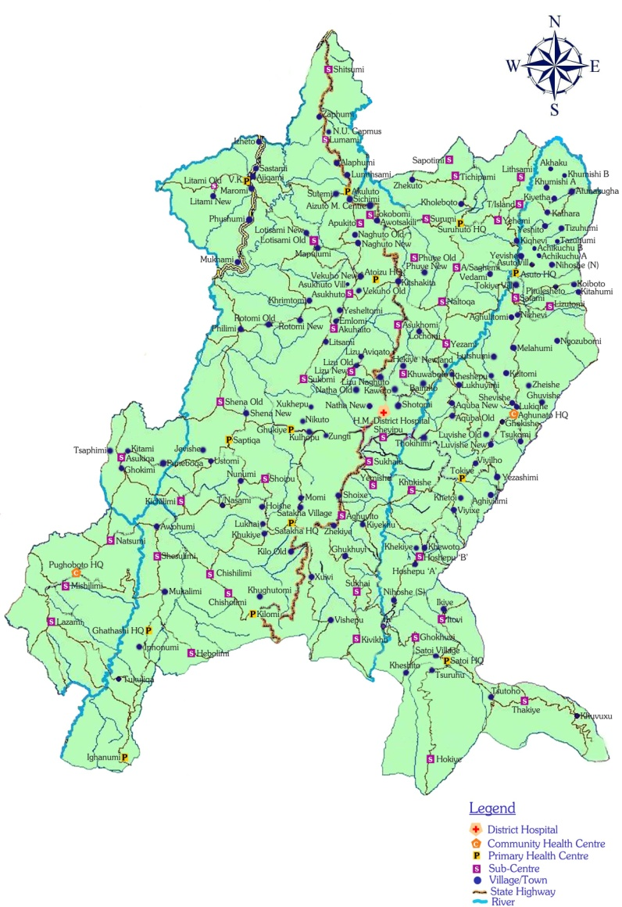
DISTRICT MAP

PLANNING PROCESS

The Zunheboto District Health Action Plan (2013- 2014) adhering to the guidelines laid down by the NRHM in the planning process, came about as a team effort.

District Planning Team (First appraisal draft) comprised of:

1. Chief Medical Officer (CMO)
2. Dy. Chief Medical Officer (DY.CMO)
3. District Programme Officer (RCH & UIP)
4. District Programme Manager (DPM)
5. District Media Officer (DMO)
6. District Community Mobilizer (DCM)

A meeting of all the Zunheboto District Vertical Programme Officers, Senior Medical Officers, Medical Officers, BPMs, ASHA-Coordinators was held in CMO’s Office on 8th November 2012. During the meeting briefing on how to go about in preparing the plan was given in details by DPO(RCH&UIP) Zunheboto, SMO Aghunato CHC and DPM Zunheboto who had earlier attended the meeting held at IDSP Conference Hall DH&FW, Kohima for DHAP 2013-14. Stressing on the need for decentralization, bottom up and need based approach in the planning process. The requirement for better health delivery care and system being demanding, great emphasis has been deliberated in all the major areas that requires attention. Consultative meetings with the concerned Medical Officers along with the BPM’s and ASHA Co-ordinators were held so as to get an insight into the actual need of the community at the grass root level and the plan was prepared accordingly for the first appraisal.

As per the state guideline requirement the plan was deliberated in contextual to the district of Zunheboto. The Planning team as far as possible had carefully incorporated all the necessary components as per the guidelines provided. The data for DHAP 2013-14 have been referred from various sources namely, HMIS, Facility Survey reports and need based assessments which was carried out block wise.

FUNCTIONAL DELIVERY POINT

Total functional delivery points in Public Health Facilities of the Districts Annexure-I
Date: (Monthly Avg of (Q1 + Q2) of 2015-16 i.e. April 2016 to dec, 2016 to be taken for calculation purposes)

S.No | Indicator | Number
1 | Total No. of SCs | 50
A | No. of SCs conducting >3 deliveries/month | 0
2 | Total No. of 24X7 PHCs | 5
A | No. of 24X7 PHCs conducting > 10 deliveries /month | 0
3 | Total No. of any other PHCs | 8
A | No. of any other PHCs conducting > 10 deliveries/ month | 0
4 | Total No. of CHCs ( Non- FRU) | 2
A | No. of CHCs ( Non- FRU) conducting > 10 deliveries /month | 0
5 | Total No. of CHCs ( FRU) | NA
A | No. of CHCs (FRU) conducting > 20 deliveries /month | NA
B | No. of CHCs (FRU) conducting C-sections | NA
6 | Total No. of any other FRUs (excluding CHC-FRUs) | NA
A | No. of any other FRUs (excluding CHC-FRUs) conducting > 20 deliveries /month | NA
B | No. of any other FRUs (excluding CHC-FRUs) conducting C-sections | NA
7 | Total No. of DH | 1
A | No. of DH conducting > 50 deliveries /month | 1
B | No. of DH conducting C-section | 1
8 | Total No. of District Women And Children hospital (if separate from DH) | NA
A | No. of District Women And Children hospital (if separate from DH) conducting > 50 deliveries /month | NA
B | No. of District Women And Children hospital (if separate from DH) conducting C-section | NA
9 | Total No. of Medical colleges | NA
A | No. of Medical colleges conducting > 50 deliveries per month | NA
B | No. of Medical colleges conducting C-section | NA
10 | Total No. of Accredited PHF | NA
A | No. of Accredited PHF conducting > 10 deliveries per month | NA
B | No. of Accredited PHF conducting C-sections | NA

District Health Action Plan Format/Framework

Sl.No | Particulars | Numbers/ Remarks
1 | Name of the Block./ Villages | 45
2 | Geographical Location (district)
3 | Total Population of the Block | 50395
4 | Road connectivity and transport/ Referral systems | Details in (ANNEXURE-I)
5 | No./Name of Health Units & HR status | Details in (ANNEXURE-II) & (ANNEXURE-XI)
6 | Socio-Economic status/ main occupation of the people | Farming
7 | Anganwadi centres | 97
8 | Water supply | Details in (ANNEXURE-III)
9 | Sanitation status | Details in (ANNEXURE-IV)
10 | No. of Village Health Committees/ VHSNCs | Details in (ANNEXURE-V)
11 | SBI Account status | Details in (ANNEXURE-VI)
12 | No. of schools (PUBLIC/PRIVATE) | Details in (ANNEXURE-VII)
13 | VHND status | Details in (ANNEXURE-VIII)
14 | Eligible couple | Details in (ANNEXURE-IX)
15 | ANC/ Immunization status | Details in (ANNEXURE-X)
16 | Main Health concerns in the Block

Road Connectivity & Transport/ Referral systems: ANNEXURE-I

Sl. No | Name of Health Units | Status of Road connectivity | Transport/ Referral status
1 | District Hospital | Poor | Yes
2 | Pughoboto CHC | GOOD | YES
3 | Aghunato CHC | GOOD | YES
4 | Atoizu PHC | Poor | Yes
5 | Tokiye PHC | GOOD | NO
6 | Ghathashi PHC | AVERAGE | YES
7 | Ighanumi PHC | AVERAGE | NO
8 | Kilomi PHC | AVERAGE | NO
9 | Satakha PHC | GOOD | YES
10 | Satoi PHC | AVERAGE | NO
11 | Ghukiye PHC | GOOD | NO
12 | Akuluto PHC | GOOD | YES
13 | VK PHC | AVERAGE | YES
14 | Suruhuto PHC | Average | Yes
15 | Asuto PHC | Bad | No
16 | Hoshepu SC | FAIR | NO
17 | Khukishe SC | FAIR | NO
18 | Lizutomi SC | FAIR | NO
19 | Satami S C | GOOD | NO
20 | Asukiqa HWC | AVERAGE | NO
21 | Chishilimi HWC | AVERAGE | NO
22 | Chisholimi SC | AVERAGE | NO
23 | Hebolimi HWC | AVERAGE | NO
24 | Kichilimi SC | AVERAGE | NO
25 | Lazami HWC | AVERAGE | NO
26 | Mishilimi SC | GOOD | NO
27 | Natsumi HWC | AVERAGE | NO
28 | Shesulimi HWC | AVERAGE | NO
29 | Aghuito SC | GOOD | NO
30 | Kivikhu SC | AVERAGE | NO
31 | Shoipu SC | GOOD | NO
32 | Sukhai SC | GOOD | NO
33 | Hokiye SC | POOR | NO
34 | Ghokhuvi SC | GOOD | NO
35 | Itovi SC | POOR | NO
36 | THAKIYE SC | POOR | NO
37 | LOTISSA SC | AVERAGE | NO
38 | SEMA SETTSU SC | GOOD | NO
39 | LUMAMI SC | GOOD | NO
40 | LITTAMI SC | GOOD | NO
41 | Sapotimi Sc | Good | No
42 | Tichipami Sc | Good | No
43 | Surumi Sc | Good | No
44 | Phuye Old Sc | Good | No
45 | Naltoqa Sc | Average | No
46 | Aichi Saghemi Sc | Average | No
47 | Yehemi Sc | Good | No
48 | Lithsami Sc | Bad | No
49 | Tizu Island Sc | Bad | No
50 | Kathara Sc | Bad | No

No./ Name of Health units in the Block ANNEXURE-II
Sl. No | Name of Health Units | DH/ CHC/ PHC/ SC
1 | Hezukhu Memorial District Hospital | DH
2 | Aghunato CHC | 24 X7 CHC
3 | Pughoboto CHC | CHC
4 | Atoizu PHC | PHC
5 | Saptiqa PHC | PHC
6 | Tokiye PHC | PHC
7 | Ghathashi PHC | PHC
8 | Ighanumi PHC | PHC
9 | Kilomi PHC | PHC
10 | Satakha PHC | PHC
11 | Satoi PHC | PHC
12 | Ghukiye PHC | PHC
13 | Akuluto PHC | PHC
14 | VK PHC | PHC
15 | Suruhuto PHC | PHC
16 | Asuto PHC | PHC
17 | Akuhaito SC | SC
18 | Apukito SC | SC
19 | Asukhomi SC | SC
20 | Asukhuto SC | SC
21 | Khuwaboto SC | SC
22 | Lizumi SC | SC
23 | Lokobomi SC | SC
24 | Sheipu SC | SC
25 | Shena Old SC | SC
26 | Sukhalu SC | SC
27 | Sukomi SC | SC
28 | Yemishe SC | SC
29 | Yezami | SC
30 | HOSHEPU SC | SC
31 | KHUKISHE SC | SC
32 | LIZUTOMI SC | SC
33 | SATAMI SC | SC
34 | Asukiqa | HWC
35 | Chishilimi | HWC
36 | Chisholimi | SC
37 | Hebolimi | HWC
38 | Kichilimi | SC
39 | Lazami | HWC
40 | Mishilimi | SC
41 | Natsumi | HWC
42 | Shesulimi | HWC
43 | AGHUITO | SC
44 | KIVIKHU | SC
45 | SHOIPU | SC
46 | SUKHAI | SC
47 | HOKIYE | SC
48 | GHOKHUVI | SC
49 | ITOVI | SC
50 | THAKIYE | SC
51 | LOTISSAMI | SC
52 | SUMI-SETTSU | SC
53 | LUMAMI | SC
54 | LITAMI | SC
55 | Sapotimi | SC
56 | Tichipami | SC
57 | Surumi | SC
58 | Phuye Old | SC
59 | Naltoqa | SC
60 | Aichi Saghemi | SC
61 | Yehemi | SC
62 | Lithsami | SC
63 | Tizu Island | SC
64 | Kathara | SC

Water Supply : ANNEXURE-III

Sl. No | Name of Health Units | Status of Water Supply | Specify Source (Govt.Supply/ Rainwater/ Pond/ Spring/ Others
1 | Hezukhu Memorial District Hospital | Yes | Govt. Supply
2 | CHC AGHUNATO | YES | OTHERS/RAINWATER
3 | Pughoboto CHC | GOOD | GOVT SUPPLY
4 | Atoizu PHC | Yes | Spring
5 | Saptiqa PHC | No | Others
6 | PHC TOKIYE | YES | OTHERS
7 | Ghathashi PHC | GOOD | OTHERS
8 | Ighanumi PHC | GOOD | OTHERS
9 | KilomiPhc | GOOD | OTHERS
10 | SATAKHA PHC | GOOD | GOVT SUPPLY
11 | SATOI PHC | GOOD | OTHERS
12 | GHUKIYE PHC | GOOD | OTHERS
13 | AKULUTO PHC | GOOD | GOVT SUPPLY
14 | VK PHC | GOOD | GOVT SUPPLY
15 | Suruhuto PHC | YES | Govt. Supply
16 | Asuto PHC | NO | Govt. Supply
17 | Akuhaito | No | Others
18 | Apukito | No | Others
19 | Asukhomi | No | Others
20 | Asukhuto | No | Others
21 | Khuwaboto | No | Others
22 | Lizumi | No | Others
23 | Lokobomi | No | Others
24 | Sheipu | No | Others
25 | Shena Old | No | Others
26 | Sukhalu | No | Others
27 | Sukomi | No | Others
28 | Yemishe | No | Others
29 | Yezami | No | Others
30 | HOSHEPU SC | YES | OTHERS
31 | KHUKISHE SC | YES | OTHERS
32 | LIZUTOMI SC | YES | OTHERS
33 | SATAMI SC | YES | OTHERS
34 | Asukiqa HWC | GOOD | RAIN WATER
35 | Chishilimi HWC | GOOD | RAIN WATER
36 | Chisholimi SC | GOOD | RAIN WATER
37 | Hebolimi HWC | GOOD | RAIN WATER
38 | Kichilimi SC | GOOD | RAIN WATER
39 | Lazami HWC | GOOD | RAIN WATER
40 | Mishilimi SC | GOOD | RAIN WATER
41 | Natsumi HWC | GOOD | RAIN WATER
42 | Shesulimi HWC | GOOD | RAIN WATER
43 | AGHUITO SC | GOOD | POND
44 | KIVIKHU SC | GOOD | RAIN WATER
45 | SHOIPU SC | GOOD | GOVT SUPPLY
46 | SUKHAI SC | GOOD | GOVT SUPPLY
47 | HOKIYE SC | GOOD | GOVT SUPPLY
48 | GHOKHUVI SC | GOOD | OTHERS
49 | ITOVI SC | GOOD | OTHERS
50 | THAKIYE SC | GOOD | RAIN WATER
51 | LOTISSAMI SC | GOOD | OTHERS
52 | SUMI SETTSU SC | GOOD | POND
53 | LUMAMI SC | GOOD | RAIN WATER
54 | LITAMI SC | GOOD | GOVT SUPPLY
55 | Sapotimi SC | NO | Govt. Supply
56 | Tichipami SC | NO | Govt. Supply
57 | Surumi SC | NO | Govt. Supply
58 | Phuye Old SC | NO | Govt. Supply
59 | Naltoqa SC | NO | Govt. Supply
60 | Aichi Saghemi SC | NO | Pond
61 | Yehemi SC | NO | Govt. Supply
62 | Lithsami SC | NO | Govt. Supply
63 | Tizu Island SC | NO | Govt. Supply
64 | Kathara SC | NO | Govt. Supply

Sanitation Status: ANNEXURE-IV

Sl. No | Name of Health Units | Status (Very Good/ Good/ Average/ Bad/ Very Bad) | Reason (If Any)
1 | Hezukhu Memorial District Hospital | Average
2 | CHC AGHUNATO | GOOD
3 | Pughoboto CHC | GOOD
4 | Atoizu PHC | Average
5 | Saptiqa PHC | Average
6 | PHC TOKIYE | GOOD
7 | Ghathashi PHC | GOOD
8 | Ighanumi PHC | GOOD
9 | KilomiPhc | AVERAGE
10 | SATAKHA PHC | GOOD
11 | SATOI PHC | GOOD
12 | GHUKIYE PHC | GOOD
13 | AKULUTO PHC | GOOD
14 | VK PHC | GOOD
15 | Suruhuto PHC | Very Good
16 | Asuto PHC | Bad
17 | Akuhaito | Average
18 | Apukito | Average
19 | Asukhomi | Average
20 | Asukhuto | Average
21 | Khuwaboto | Average
22 | Lizumi | Good
23 | Lokobomi | Average
24 | Sheipu | Average
25 | Shena Old | Average
26 | Sukhalu | Average
27 | Sukomi | Good
28 | Yemishe | Average
29 | Yezami | Average
30 | HOSHEPU SC | AVERAGE
31 | KHUKISHE SC | AVERAGE
32 | LIZUTOMI SC | AVERAGE
33 | SATAMI SC | AVERAGE
34 | Asukiqa HWC | GOOD
35 | Chishilimi HWC | GOOD
36 | Chisholimi SC | AVERAGE
37 | Hebolimi HWC | GOOD
38 | Kichilimi SC | AVERAGE
39 | Lazami HWC | AVERAGE
40 | Mishilimi SC | GOOD
41 | Natsumi HWC | GOOD
42 | Shesulimi HWC | AVERAGE
43 | AGHUITO SC | GOOD
44 | KIVIKHU SC | GOOD
45 | SHOIPU SC | AVERAGE
46 | SUKHAI SC | GOOD
47 | HOKIYE SC | GOOD
48 | GHOKHUVI SC | AVERAGE
49 | ITOVI SC | AVERAGE
50 | THAKIYE SC | AVERAGE
51 | LOTISSAMI SC | AVERAGE
52 | SUMI-SETTSU SC | AVERAGE
53 | LUMAMI SC | GOOD
54 | LITAMI SC | GOOD
55 | Sapotimi SC | Good
56 | Tichipami SC | Good
57 | Surumi SC | Good | Yet to start functioning
58 | Phuye Old SC | Average
59 | Naltoqa SC | Average
60 | Aichi Saghemi SC | Bad
61 | Yehemi SC | Average
62 | Lithsami SC | Average
63 | Tizu Island SC | Bad
64 | Kathara SC | Average | Yet to start functioning

Source: FS

No. of VHC/VHSNC ANNEXURE-V

Sl. No | Name of Health Units | Status of VHC | Status of VHSNC | If NO (Specify)
1 | Hezukhu Memorial District Hospital |  | Active
2 | CHC AGHUNATO | YES | YES
3 | Pughoboto CHC | YES | YES
4 | Atoizu PHC |  | Active
5 | Saptiqa PHC |  | Active
6 | PHC TOKIYE | YES | YES
7 | Ghathashi PHC | YES | YES
8 | Ighanumi PHC | YES | NO
9 | KilomiPhc | YES | NO
10 | SATAKHA PHC | YES | YES
11 | SATOI PHC | YES | YES
12 | GHUKIYE PHC | YES
13 | AKULUTO PHC | YES | YES
14 | VK PHC | YES | YES
15 | Suruhuto PHC | yes | yes
16 | Asuto PHC | yes | yes
17 | Akuhaito | Active
18 | Apukito | Active
19 | Asukhomi | Active
20 | Asukhuto | Active
21 | Khuwaboto | Active
22 | Lizumi | Active
23 | Lokobomi | Active
24 | Sheipu | Active
25 | Shena Old | Active
26 | Sukhalu | Active
27 | Sukomi | Active
28 | Yemishe | Active
29 | Yezami | Active
30 | HOSHEPU SC | YES | YES
31 | KHUKISHE SC | YES | YES
32 | LIZUTOMI SC | YES | YES
33 | SATAMI SC | YES | YES
34 | Asukiqa HWC | YES | NO
35 | Chishilimi HWC | YES | NO
36 | Chisholimi SC | YES | NO
37 | Hebolimi HWC | YES | NO
38 | Kichilimi SC | YES | NO
39 | Lazami HWC | YES | NO
40 | Mishilimi SC | YES | NO
41 | Natsumi HWC | YES | NO
42 | Shesulimi HWC | YES | NO
43 | AGHUITO SC | YES
44 | KIVIKHU SC | YES
45 | SHOIPU SC | YES
46 | SUKHAI SC | YES
47 | HOKIYE SC | YES
48 | GHOKHUVI SC | YES
49 | ITOVI SC | YES
50 | THAKIYE SC | YES
51 | LOTISSAMI SC | YES | NO
52 | SUMI SETTSU SC | YES | NO
53 | LUMAMI SC | YES | NO
54 | LITAMI SC | YES | NO
55 | Sapotimi SC | yes | yes
56 | Tichipami SC | yes | yes
57 | Surumi SC | yes | yes
58 | Phuye Old SC | yes | yes
59 | Naltoqa SC | yes | yes
60 | Aichi Saghemi SC | yes | yes
61 | Yehemi SC | yes | yes
62 | Lithsami SC | yes | yes
63 | Tizu Island SC | yes | yes
64 | Kathara SC | no | yes | Yet to form
Source: FS

SBI Account Status ANNEXURE-VI
Sl. No | Name of Health Units | VHC Account status | Remarks (If Any)
1 | Hezukhu Memorial District Hospital | Yes
2 | CHC AGHUNATO | YES ACTIVE
3 | Pughoboto CHC | ACTIVE
4 | Atoizu PHC | Yes
5 | Saptiqa PHC | Yes
6 | PHC TOKIYE | YES ACTIVE
7 | Ghathashi PHC | ACTIVE
8 | Ighanumi PHC | ACTIVE
9 | KilomiPhc | ACTIVE
10 | SATAKHA PHC | ACTIVE
11 | SATOI PHC | ACTIVE
12 | GHUKIYE PHC | ACTIVE
13 | AKULUTO PHC | ACTIVE
14 | VK PHC | ACTIVE
15 | Suruhuto PHC | Yes
16 | Asuto PHC | Yes
17 | Akuhaito | Yes
18 | Apukito | Yes
19 | Asukhomi | Yes
20 | Asukhuto | Yes
21 | Khuwaboto | Yes
22 | Lizumi | Yes
23 | Lokobomi | Yes
24 | Sheipu | Yes
25 | Shena Old | Yes
26 | Sukhalu | Yes
27 | Sukomi | Yes
28 | Yemishe | Yes
29 | Yezami | Yes
30 | HOSHEPU SC | YES ACTIVE
31 | KHUKISHE SC | YES ACTIVE
32 | LIZUTOMI SC | YES ACTIVE
33 | SATAMI SC | YES ACTIVE
34 | Asukiqa HWC | ACTIVE
35 | Chishilimi HWC | ACTIVE
36 | Chisholimi SC | ACTIVE
37 | Hebolimi HWC | ACTIVE
38 | Kichilimi SC | ACTIVE
39 | Lazami HWC | ACTIVE
40 | Mishilimi SC | ACTIVE
41 | Natsumi HWC | ACTIVE
42 | Shesulimi HWC | ACTIVE
43 | AGHUITO SC | ACTIVE
44 | KIVIKHU SC | ACTIVE
45 | SHOIPU SC | ACTIVE
46 | SUKHAI SC | ACTIVE
47 | HOKIYE SC | ACTIVE
48 | GHOKHUVI SC | ACTIVE
49 | ITOVI SC | ACTIVE
50 | THAKIYE SC | ACTIVE
51 | LOTISSAMI SC | ACTIVE
52 | SUMI SETTSU SC | ACTIVE
53 | LUMAMI SC | ACTIVE
54 | LITAMI SC | ACTIVE
55 | Sapotimi SC | Yes
56 | Tichipami SC | Yes
57 | Surumi SC | Yes
58 | Phuye Old SC | Yes
59 | Naltoqa SC | Yes
60 | Aichi Saghemi SC | Yes
61 | Yehemi SC | Yes
62 | Lithsami SC | Yes
63 | Tizu Island SC | Yes
64 | Kathara SC | Yes

No of schools (Public/ Private) ANNEXURE-VII
Sl. No | Name of Health Units | No. of Public schools | No. of Private Schools
1 | Hezukhu Memorial District Hospital | 21 | 22
2 | CHC AGHUNATO | 23 | 5
3 | Pughoboto CHC | 3 | 2
4 | Atoizu PHC | 4 | 2
5 | Saptiqa PHC | 3 | 1
6 | PHC TOKIYE | 7 | 1
7 | Ghathashi PHC | 6 | 2
8 | Ighanumi PHC | 3 | 1
9 | KilomiPhc | 3
10 | SATAKHA PHC | 8 | 7
11 | SATOI PHC | 2 | 0
12 | GHUKIYE PHC | 5 | 0
13 | AKULUTO PHC | 7 | 3
14 | VK PHC | 8 | 2
15 | Suruhuto PHC | 4 | 3
16 | Asuto PHC | 11 | 0
17 | Akuhaito | 5 | 2
18 | Apukito | 3 | 0
19 | Asukhomi | 3 | 0
20 | Asukhuto | 4 | 2
21 | Khuwaboto | 7 | 1
22 | Lizumi | 3 | 0
23 | Lokobomi | 3 | 0
24 | Sheipu | 2 | 0
25 | Shena Old | 2 | 0
26 | Sukhalu | 3 | 0
27 | Sukomi | 2 | 0
28 | Yemishe | 1 | 0
29 | Yezami | 1 | 0
30 | HOSHEPU SC | 5 | 0
31 | KHUKISHE SC | 1 | 0
32 | LIZUTOMI SC | 1 | 0
33 | SATAMI SC | 3 | 0
34 | Asukiqa HWC | 6
35 | Chishilimi HWC | 1
36 | Chisholimi SC | 2
37 | Hebolimi HWC | 2
38 | Kichilimi SC | 1
39 | Lazami HWC | 5 | 1
40 | Mishilimi SC | 3
41 | Natsumi HWC | 2
42 | Shesulimi HWC | 2
43 | AGHUITO SC | 4 | 0
44 | KIVIKHU SC | 4 | 0
45 | SHOIPU SC | 4 | 0
46 | SUKHAI SC | 2 | 0
47 | HOKIYE SC | 1 | 0
48 | GHOKHUVI SC | 2 | 0
49 | ITOVI SC | 2 | 0
50 | THAKIYE SC | 3 | 0
51 | LOTISSAMI SC | 2 | 0
52 | SUMI SETTSU SC | 1 | 0
53 | LUMAMI SC | 5 | 0
54 | LITAMI SC | 1 | 0
55 | Sapotimi SC | 2 | 0
56 | Tichipami SC | 1 | 0
57 | Surumi SC | 3 | 0
58 | Phuye Old SC | 2 | 0
59 | Naltoqa SC | 1 | 2
60 | Aichi Saghemi SC | 3 | 0
61 | Yehemi SC | 2 | 0
62 | Lithsami SC | 1 | 0
63 | Tizu Island SC | 9 | 0
64 | Kathara SC | 1 | 0

VHND Status ANNEXURE-VIII
Name of the Block | VHND Targets/ Block | Achievements (2018-19) | Achievements (2019-20) | Achievements (2020-21) upto Aug | Remarks  (if Any)
Zunheboto Sadar | 540 | 462 | 481 | 204
Aghunato Block | Monthly =35  Yearly = 420 | 327 | 286 | 78 | Covid 19 Pandemic has led to decrease in all health related activities
Pughoboto | (20x12)240 | 213 | 255 | 83 | April-July 2020-21
SATAKHA BLOCK | (36x12)432 | 415 | 412 | 164 | 2020-2021 achievement is poor due to covid 19 pandemic.
AKULUTO BLOCK | (20x12)240 | 156 | 193 | 61 | 2020-21 decline in VHND because of covid 10 pandemic
Suruhuto Block | 408 | 259 | 266 | 106

Eligible couple ANNEXURE-IX
Sl. No | Name of Health Units | No. of Eligible Couple under Health Units | Remarks (If Any)
1 | Hezukhu Memorial District Hospital
2 | CHC AGHUNATO | 1212
3 | Pughoboto CHC | 186
4 | Atoizu PHC | 235
5 | Saptiqa PHC | 47
6 | PHC TOKIYE | 585
7 | Ghathashi PHC | 265
8 | Ighanumi PHC | 161
9 | KilomiPhc | 80
10 | SATAKHA PHC | 459
11 | SATOI PHC | 53
12 | GHUKIYE PHC | 63
13 | AKULUTO PHC | 408
14 | VK PHC | 395
15 | Suruhuto PHC | 228
16 | Asuto PHC | 144
17 | Akuhaito | 184
18 | Apukito | 59
19 | Asukhomi | 52
20 | Asukhuto | 71
21 | Khuwaboto | 225
22 | Lizumi | 52
23 | Lokobomi | 97
24 | Sheipu | 58
25 | Shena Old | 74
26 | Sukhalu | 92
27 | Sukomi | 57
28 | Yemishe | 19
29 | Yezami | 26
30 | HOSHEPU SC | 177
31 | KHUKISHE SC | 132
32 | LIZUTOMI SC | 89
33 | SATAMI SC | 184
34 | Asukiqa HWC | 190
35 | Chishilimi HWC | 102
36 | Chisholimi SC | 68
37 | Hebolimi HWC | 88
38 | Kichilimi SC | 76
39 | Lazami HWC | 256
40 | Mishilimi SC | 190
41 | Natsumi HWC | 120
42 | Shesulimi HWC | 76
43 | AGHUITO SC | 75
44 | KIVIKHU SC | 89
45 | SHOIPU SC | 86
46 | SUKHAI SC | 30
47 | HOKIYE SC | 24
48 | GHOKHUVI SC | 36
49 | ITOVI SC | 19
50 | THAKIYE SC | 37
51 | LOTISSAMI SC | 133
52 | SUMI SETTSU SC | 95
53 | LUMAMI SC | 102
54 | LITAMI SC | 78
55 | Sapotimi SC | 47
56 | Tichipami SC | 76
57 | Surumi SC | 122
58 | Phuye Old SC | 87
59 | Naltoqa SC | 61
60 | Aichi Saghemi SC | 102
61 | Yehemi SC | 64
62 | Lithsami SC | 42
63 | Tizu Island SC | 111
64 | Kathara SC | 29

ANC Status ANNEXURE-X (a)

Achievements (2018-19) |  | Achievements (2019-20) |  | Achievements (2020-21) |  | Remarks  (if Any)
ANC-1 | ANC-4 | ANC-1 | ANC-4 | ANC-1 | ANC-4
230 | 37 | 484 | 53 | 111 | 40 | Decrease in ANC-4 maybe due to lack of awareness
86 | 6 | 155 | 38 | 63 | 7 | More publicity required for completing all 4 ANCs
99 | 46 | 142 | 31 | 64 | 8 | April-July 2020
240 | 68 | 111 | 32 | 37 | 21 | 2020-21 ANC is poor due to covid 19 pandemic.
119 | 4 | 157 | 29 | 132 | 10 | ANC-4 is much lesser because …..
111 | 0 | 102 | 10 | 65 | 17 | Full ANC coverage is low due to lack of awareness
885 | 161 | 1151 | 193 | 472 | 103
Source: HMIS

Immunization Status ANNEXURE-X (b)
Achievement (2018-19) |  |  |  |  |  | Achievement (2019-20) |  |  |  |  |  | Achievement (2020-21)
BCG | Penta-1 | Penta-3 | MR-1 | FI | DPT-Booster | BCG | Penta-1 | Penta-3 | MR-1 | FI | DPT-Booster | BCG | Penta-1 | Penta-3 | MR-1 | FI | DPT-Booster
423 | 423 | 393 | 326 | 267 | 315 | 474 | 457 | 439 | 400 | 274 | 372 | 178 | 156 | 142 | 149 | 129 | 105
128 | 137 | 142 | 148 | 140 | 151 | 121 | 147 | 152 | 135 | 133 | 153 | 89 | 75 | 46 | 57 | 57 | 37
87 | 93 | 85 | 11 |  | 51 | 81 | 112 | 123 | 22 | 62 | 58 | 24 | 39 | 42 | 12 | 37 | 19
78 | 92 | 91 |  | 49 | 58 | 113 | 130 | 109 | 80 | 61 | 90 | 25 | 29 | 47 | 18 | 44 | 33
91 | 101 | 80 | 4 | 72 | 95 | 70 | 106 | 117 | 85 | 82 | 70 | 27 | 36 | 41 | 26 | 56 | 30
19 | 100 | 90 | 108 | 56 | 22 | 120 | 139 | 107 | 125 | 58 | 95 | 31 | 51 | 34 | 39 | 27 | 30
826 | 946 | 881 | 597 | 584 | 692 | 979 | 1091 | 1047 | 847 | 670 | 838 | 374 | 386 | 352 | 301 | 350 | 254

Manpower status (Use separate table for each Health Units) ANNEXURE-XI
Category | ZUNHEBOTO DISTRICT
 | Rural
 | Requirement (based on no. of operational facilities) | Regular |  | Contractual In-place through State | Contractual - NHM |  | Total sanctioned | Total in-position | Total vacancy/ surplus %  (D-E) | Required - Sanctioned  (B-D)
 |  | Sanctioned | In-place |  | Sanctioned | In-place
ANMs | 17 |  | 69 |  |  | 15 |  | 84
Staff Nurse | 11 |  | 30 |  |  | 13 |  | 43
Lab technicians | 2 |  | 5 |  |  | 2 |  | 7
MO MBBS | 2 |  | 9 | 5 |  | 6 |  | 20
OB&GY | 1
Pediatricians
Anesthetists
Surgeon
Physician
ENT surgeon |  |  | 1 |  |  |  |  | 1
Ophthalmologist |  |  | 1 |  |  |  |  | 1
Psychiatrist
Radiologist
Pathologist
Microbiologists
Other Specialists
Pharmacists | 3 |  | 19 |  |  |  |  | 19
AYUSH MOs
Dentists |  |  | 2 |  |  | 2 |  | 4
Lab.Tech NSACS |  |  |  | 3 |  | 2 |  | 5
Lab.Tech NVBDCP |  |  |  |  |  | 3 |  | 3
MO MBBS NSACS |  |  |  | 1 |  |  |  | 1
Source: FS

FACILITY SURVEY
District Hospital :
HR Training/Capacity building
Name of the Training | Hezukhu Memorial Hospital(DH)
 | Doctor |  | GNM |  | ANM |  | Lab.Tech
 | No. in Place | No. Trained | No. in Place | No. Trained | No. in Place | No. Trained | No. in Place | No. Trained
a. Maternal Health
1) SBA | 6 | 0 | 13 |  | 7 | 2 | 4
2) EmOC | 6 | 0 | 13 |  | 7 |  | 4
3) BEmOC | 6 | 0 | 13 |  | 7 |  | 4
4) LSAS | 6 | 0 | 13 |  | 7 |  | 4
5) MTP/MVA | 6 | 0 | 13 |  | 7 |  | 4
6) RTI/STI | 6 | 1 | 13 | 4 | 7 |  | 4
7) BSU | 6 | 1 | 13 |  | 7 |  | 4
8) IMEP | 6 | 0 | 13 | 1 | 7 |  | 4
9) LaQshya | 6 | 0 | 13 |  | 7 |  | 4
10) Dakshata | 6 | 0 | 13 |  | 7 |  | 4
11) HIV AIDS & Syphilis | 6 | 0 | 13 |  | 7 |  | 4 | 4
12) PMSMA | 6 | 1 | 13 |  | 7 |  | 4
b. Child Health

1) F-IMNCI | 6 | 0 | 13 |  | 7 |  | 4
2) NSSK | 6 | 0 | 13 |  | 7 |  | 4
3) FBNC | 6 | 0 | 13 |  | 7 |  | 4
4) IYCF | 6 | 0 | 13 |  | 7 |  | 4
5) PRE SERVICE IMNCI | 6 | 0 | 13 |  | 7 |  | 4
6) IMNCI | 6 | 0 | 13 |  | 7 |  | 4
7) RBSK | 6 | 0 | 13 |  | 7 |  | 4
8) Immunization | 6 | 0 | 13 |  | 7 |  | 4
9) HBYC | 6 | 0 | 13 |  | 7 |  | 4
c. Family Planning

1) IUCD | 6 | 0 | 13 |  | 7 |  | 4
2) MINI LAP | 6 | 0 | 13 |  | 7 |  | 4
3) NSV | 6 | 1 | 13 |  | 7 |  | 4
4) PPIUCD | 6 | 1 | 13 |  | 7 |  | 4
5) LAP STER. | 6 | 1 | 13 |  | 7 |  | 4
6) FP Updates (PAIUCD, Oral Pills & Injectable Contraceptives) | 6 | 1 | 13 | 1 | 7 |  | 4
7) ARSH/RKSK | 6 | 1 | 13 |  | 7 |  | 4
d. National Vector Borne Disease Control Programme (NVBDCP) | 6 | 0 | 13 |  | 7 |  | 4
e. Revised National Tuberculosis Control Programme (RNTCP) | 6 | 0 | 13 |  | 7 |  | 4
f. National Leprosy Elimination Programme (NLEP) | 6 | 0 | 13 |  | 7 |  | 4
g. Integrated Disease Surveillance Project (IDSP) | 6 | 0 | 13 |  | 7 |  | 4
h. National Programme for Control of Blindness (NPCB) | 6 | 1 | 13 |  | 7 |  | 4
i. National Iodine Deficiency Disease Control Programme (NIDDCP) | 6 | 0 | 13 |  | 7 |  | 4
j. National AIDS Control Programme (NACP) | 6 | 1 | 13 |  | 7 | 1 | 4 | 4
k. Non-Communicable Diseases (NCD) | 6 | 1 | 13 |  | 7 |  | 4
Any other (Specify)

Equipments
 | I. Imaging Equipment | Nos Available (mention in Numbers)
Sl No. | Name of the Equipment | Functional | Non Functional | Requirement/ proposed (in Nos.)
1 | 500 M.A. X-ray machine | 0 | 0 | 1
2 | 300 M.A. X-ray machine | 1 | 0 | 0
3 | 100 M.A. X-ray machine | 0 | 0 | 1
4 | 60 M.A. X-ray machine (Mobile) | 1 | 0 | 1
5 | C arm with accessories | 0 | 0 | 1
6 | Dental X-ray machine | 1 | 0 | 1
7 | Color Doppler Ultrasound machine with 4 probes: Abdomen, Paediatric, Soft Parts and Intra-cavitory | 0 | 0 | 1
8 | Ultra Sonogram (Obs & Gyne. department should be having a separate ultra-sound machine of its own) | 0 | 0 | 1
9 | Portable ultrasound | 0 | 1 | 1
10 | C.T. Scan Multi slice (64 slice) | 0 | 0 | 1
11 | Mammography Unit* | 0 | 0 | 1
12 | Echocardiogram* | 0 | 0 | 1
13 | MRI 1.5 Tesla | 0 | 0 | 1
 | II. X -Ray Room Accessories
Sl. No. | Name of the Equipment
1 | X-ray developing tank | 1 | 0 | 1
2 | Safe light X-ray dark room | 1 | 0 | 1
3 | Cassettes X-ray | 1 | 0 | 1
4 | X-ray lobby single | 1 | 0 | 1
5 | X-ray lobby Multiple | 0 | 0 | 1
6 | Lead Apron | 1 | 0 | 2
7 | Intensifying screen X-ray | 0 | 0 | 1
8 | Dossimeter | 0 | 0 | 1
 | III. Cardiopulmonary Equipment
Sl. No. | Name of the Equipment
1 | ECG machine computerized | 0 | 0 | 1
2 | ECG machine ordinary | 0 | 1 | 1
3 | 12 Channel stress ECG test equipment Tread Mill* | 0 | 0 | 1
4 | Echocardiography Machine | 0 | 0 | 1
5 | Cardiac Monitor | 0 | 0 | 1
6 | Cardiac Monitor with defibrillator | 1 | 0 | 1
7 | Ventilators (Adult) | 0 | 0 | 1
8 | Ventilators (Paediatrics) | 0 | 0 | 1
9 | Pulse Oximeter | 1 | 0 | 2
10 | Pulse Oximeter with NIB.P* | 0 | 0 | 1
11 | Infusion pump | 0 | 0 | 1
12 | B.P.apparatus table model | 5 | 3 | 4
13 | B.P.apparatus stand model | 1 | 3 | 4
14 | Stethoscope | 2 | 4 | 5
15 | Nebuliser | 1 | 0 | 5
16 | Peak Expiratory Flow Rate (PEFR) Meter | 0 | 0 | 1
 | IV. Labour Room
Sl. No. | Name of the Equipment
1 | Labour table with mattress, sheet, pillow (numbers as per case load), Macintosh, Foot-rest | 2 | 0 | 1
2 | Brass V drape to collect blood and amniotic fluid | 0 | 0 | 1
3 | Wall clock with seconds hand | 1 | 0 | 1
4 | Wall mounted thermometer | 0 | 0 | 1
5 | Suction apparatus | 1 | 1 | 1
6 | Equipment for adult resuscitation | 0 | 0 | 0
7 | Equipment for neonatal resuscitation | 1 | 0 | 1
8 | Delivery trolley | 2 | 0 | 1
9 | IV drip stand | 4 | 2 | 2
10 | Screen/Partition between two tables | 2 | 0 | 2
11 | Stool for birth companion | 2 | 0 | 2
12 | Lamp – wall mounted or side | 0 | 1 | 2
13 | Autoclave drums for instruments, linen, gloves, cotton, gauge, threads sanitary pads | 2 | 0 | 2
14 | a. Autoclaved delivery set for each delivery | 2 | 0 | 0
15 | Refrigerator | 0 | 0 | 1
16 | Sphygmomanometer, adult and newborn thermometer and newborn weighing machine | 2 | 0 | 2
17 | Consumables like gloves, apron, cotton, thread, gauze, sanitary napkins, catgut, IV drip sets, needle, cord clamp, medicines (injectable, oral and parenteral, leucoplast etc. | Available | 0 | Required
18 | Pulse oxymeter | 0 | 0 | 1
19 | Sterilizer | 1 | 0 | 1
20 | Oxygen cylinder | 10 | 0 | 10
21 | Oxygen concentrator | 0 | 0 | 1
22 | Partograph | 0 | 0 | 1
23 | Labeled plastic jars for drugs and injectables with date of expiry written on them against each drug | 1 | 0 | 1
24 | Coloured bins for bio medical waste management | 0 | 0 | 1
25 | Hub cutter | 1 | 0 | 1
26 | Puncture proof container | 1 | 0 | 1
27 | Plastic tubs for 0.5% Chlorine solution | 1 | 0 | 0
28 | Intranatal Protocols (AMTSL , PPH etc.) | 0 | 0 | 0
29 | Wheel chair/patient's trolley | 1 | 1 | 1
30 | Hand-washing area and toilet for the admitted clients | 1 | 0 | 1
31 | Foeto-scope/Foetal Doppler | 1 | 0 | 1
32 | Stethoscope, | 1 | 0 | 1
33 | Display of SBA quality protocols, and shadow less lamp. | 0 | 1 | 2
34 | Mosquito Repellent | 1 | 0 | 1
 | TRAYS for Labour Rooms
1 | Delivery tray: Scissor, Artery forceps, Sponge holding forceps, Speculum, Urinary catheter, Bowl for antiseptic lotion, Kidney tray, Gauze pieces, Cotton swabs, Sanitary pads, Gloves. | 2 | 0 | 2
2 | Episiotomy tray: Inj. Xylocaine 2%, 10 ml disposable syringe with needle, Episiotomy scissor, Artery forceps, Allis forceps, Sponge holding forceps, Toothed forceps, Thumb forceps, Kidney tray, Needle holder, Needle (round body and cutting), Chromic catgut no. 0, Gauze pieces, Cotton swabs, Antiseptic lotion, Gloves. | 2 | 0 | 2
3 | Baby tray: Two pre-warmed towels/sheets for wrapping the baby (Baby should be  received in a pre-warmed towel. Do not use metallic tray.), Mucus extractor, Bag and mask, Sterilized thread/cord clamp, Needle (26gauze) and syringe(1ml.), Inj. Vitamin K, Gloves. | 2 | 0 | 2
4 | Medicine tray*: Inj. Oxytocin 10 IU (to be kept in fridge), Inj. Gentamicin, Inj.Vit K, Inj. Betamethason, Inj. Hydralazine, Cap Ampicillin 500 mg, Tab. Metronidazole 400 mg, Tab Paracetamol, Tab Ibuprofen, Tab B complex, Tab.Misoprostol 200 micrograms, Tab.Nifedipine, Tab.Methyldopa, IV fluids - Ringer lactate, Normal Saline, Magnifying glass. (*-Nevirapin and other HIV drugs only for ICTC and ART Centres) | 1 | 0 | 1
5 | Emergency drug tray:** Inj. Oxytocin (to be kept in fridge), Inj. Magsulf 50%,  Inj.Calcium gluconate-10%, Inj. Dexamethasone, Inj. Ampicillin, Inj. Gentamicin, Inj.Metronidazole, Inj. Lignocaine-2%, Inj. Adrenaline, Inj. Hydrocortisone Succinate, Inj.Diazepam, Inj. Pheneraminemaleate, Inj. Carboprost, Inj Pentazocin chloride, Inj. Promethazine, Inj.Betamethasone Inj.Hydralazine, IV fluids- Ringer lactate, normal saline, IV sets with 16-gauge needle at least two, IV Cannula, Vials for blood collection, Syringes and needles, Tab.Nifedipine, Tab.Methyldopa, Suction catheter, Mouth gag (** only for L2 & L3/BeMOC & CeMOC facilities) | 0 | 0 | 1
6 | MVA/ EVA tray: Gloves, Speculum, Anterior vaginal wall retractor, Posterior vaginal wall retractor, Sponge holding forceps, MVA syringe and cannulas, MTP cannulas, Urinary catheter, Small bowl of antiseptic lotion, Sterilized gauze/pads, Cotton swabs, Disposable syringe and needle, Tab.misoprostol. | 1 | 0 | 1
7 | PPIUCD tray***: PPIUCD Insertion Forceps, Sym's speculum, Ring forceps or sponge holding forceps, Cu IUCD 380A/ Cu IUCD 375 in a sterile package, Cotton swabs,  Betadine solution. (*** – only for L3/DHs facilities with PPIUCD trained provider) | 1 | 0 | 1
 | Equipment and accessories for NBCC
1 | Baby tray | 2 | 0 | 2
2 | Pediatric stethoscope (preferable to have a neonatal stethoscope) | 0 | 0 | 2
3 | Baby scale | 0 | 0 | 0
4 | Radiant warmer | 3 | 1 | 1
5 | Self-inflating bag and mask–neonatal size (0 and 1) | 0 | 0 | 0
6 | Oxygen hood (neonatal) | 0 | 0 | 1
7 | Laryngoscope and Endotracheal intubation tubes* | 1 | 0 | 1
8 | Two set of pencil batteries | 1 | 0 | 1
9 | Mucus extractor with suction tube and a foot-operated suction machine NG tubes | 1 | 0 | 1
10 | Blankets | 0 | 0 | 2
11 | Two clean and dry towels | 2 | 0 | 2
12 | Feeding tubes | 2 | 0 | 0
13 | Empty vials for collecting blood | Available | 0 | 0
14 | Alcohol handrub | Available | 0 | 0
15 | HLD/sterile gloves | Available | 0 | 0
16 | Syringe hub cutter. | 1 | 0 | `1
 | Equipment List for Special Newborn Care Unit (SNCU)
A. | General Equipment for SNCU
1 | Electronic weighing scale | NA | NA | NA
2 | Infantometer | NA | NA | NA
3 | Emergency drugs trolley | NA | NA | NA
4 | Procedure trolley | NA | NA | NA
5 | Wall clock with seconds hand | NA | NA | NA
6 | Refrigerator | NA | NA | NA
7 | Spot lamp | NA | NA | NA
8 | Portable x-ray machine | NA | NA | NA
9 | Basic surgical instruments e.g. fine scissors, scalpel with blades, fine artery forceps, suture material & needles, towel, clips etc. 1 set per bed (essential) | NA | NA | NA
10 | Nebulizer 1 for the unit | NA | NA | NA
11 | Multi-channel monitor with non-invasive BP monitor (3 size: 0, 1,2-disposable in plenty-reusable neonatal probe, at least 4) | NA | NA | NA
12 | Room Thermometer 4 (essential) | NA | NA | NA
B. | Equipment for disinfection of Special Newborn Care Unit | NA | NA | NA
 | Item Requirement for the unit | NA | NA | NA
1 | Electric heater/boiler 2 (essential) | NA | NA | NA
2 | Washing machine with dryer (separate) 1 (essential) | NA | NA | NA
3 | Electronic fumigator 2 (essential) | NA | NA | NA
4 | Vacuum Cleaner 1 (essential) | NA | NA | NA
5 | Gowns for doctors, nurses, neonatal aides, Group D staff & mothers Adequate number of each size (essential) | NA | NA | NA
6 | Washable slippers Adequate number of each size (essential) | NA | NA | NA
7 | Vertical Autoclave 1 (essential) | NA | NA | NA
8 | Autoclave drums (large & medium & small sizes) At least 6 of each size (essential) | NA | NA | NA
9 | Disinfectant Sprayer 1 (essential) | NA | NA | NA
10 | Container for liquid disinfectant 2 (essential) | NA | NA | NA
11 | Formalin Vaporizer 1 (essential) | NA | NA | NA
12 | Hot Air Oven 1 (desirable) | NA | NA | NA
13 | Ethylene oxide (ETO) Sterilizer 1 (desirable) | NA | NA | NA
C. | Equipment for individual patient care in the Special Newborn Care Unit
 | Item Requirement for the unit
1 | Servo-controlled Radiant Warmer 1 for each bed (essential) + 2 | NA | NA | NA
2 | Low-Reading Digital Thermometer (centigrade scale) 1 for each bed (essential) | NA | NA | NA
3 | Neonatal Stethoscope 1 for each bed (essential) + 2 | NA | NA | NA
4 | Neonatal Resuscitation Kit (Laerdal type, Silicone, Autoclavable 240 ml, 450 ml resuscitation bag with valves- including pressure release valve), oxygen reservoir & silicone round cushion masks – sizes 0 & 00), Neonatal laryngoscope with straight blade and spare bulbs) 1 set for each bed (essential) + 2 | NA | NA | NA
5 | Suction Machine 1 for each beds (essential) (80% should be electrically operated & 20% foot operated) | NA | NA | NA
6 | Oxygen Hood (unbreakable-neonatal/infant size) 1 for each bed (essential) 20% extra (in case of repair/disinfection) | NA | NA | NA
7 | Non stretchable measuring tape (mm scale) 1 for each bed (essential) | NA | NA | NA
8 | Infusion pump or syringe pump 1 for every 2 beds (essential) | NA | NA | NA
9 | Pulse Oxymeter 1 for every 2 beds (essential) | NA | NA | NA
10 | Double Outlet Oxygen Concentrator 1 for every 3 beds (essential) | NA | NA | NA
11 | Double Sided Blue Light Phototherapy 1 for every 3 beds | NA | NA | NA
12 | Central AC (8 air exchange per hour ) For the SNCU, Step-down Unit & SCBU | NA | NA | NA
13 | Generator (15 KVA) 1 | NA | NA | NA
14 | Flux meter 1 (Desirable) | NA | NA | NA
15 | CFL Phototherapy 1 for every 3 beds (essential) | NA | NA | NA
16 | Horizontal Laminar Flow 1 (essential) | NA | NA | NA
17 | Window AC (1.5)/Split AC Laboratory & Teaching & Training room (essential) | NA | NA | NA
18 | Doctor’s room (desirable) | NA | NA | NA
D. | Disposables
 | These items should be regularly supplied to the SNCU, if necessary by changing policy: | NA | NA | NA
1 | Cord clamp | NA | NA | NA
2 | Dee Lee’s Mucus Trap | NA | NA | NA
3 | Neoflon (intravenous catheter) 24G | NA | NA | NA
4 | Micro drip set with & without burette | NA | NA | NA
5 | Blood Transfusion Set | NA | NA | NA
6 | 3 way stop cock | NA | NA | NA
7 | Suction Catheter size # 10, 12 Fr | NA | NA | NA
8 | Endotracheal Tube size # 2.5, 3, 3.5 mm | NA | NA | NA
9 | Feeding Tube size # 5, 6, 7 Fr | NA | NA | NA
10 | Syringes: Tuberculin- 1, 2, 5, 10, 50 cc with needle nos. 22, 24, 26 | NA | NA | NA
11 | Sterile gloves & drapes | NA | NA | NA
12 | Chemical disinfectants: Cidex, Bacillocid, Liquid soap & detergent, Sterilium, Savlon, Phenol, Lysol, Betadine and Rectified Spirit | NA | NA | NA
13 | Glucostix and multistix strips (in container) | NA | NA | NA
14 | Capillary Tubes for microhaematocrit (in containers) | NA | NA | NA
15 | Cotton, surgical gauze | NA | NA | NA
16 | Normal saline, 10% Dextrose infusion bottle | NA | NA | NA
 | V. Immunization Equipment
1 | ILR & DF with Stabilizer ILR 2, & DF 2 for purpose of routine immunization and in Labour room * | 1 | 0 | 1
2 | Spare ice pack box one from each equipment | 0 | 0 | 0
3 | Room Heater/Cooler for immunization clinic with electrical fittings | 0 | 0 | 1
4 | Waste disposal twin bucket, hypochlorite solution/bleach 2 per ILR bimonthly | 1 | 0 | 1
5 | Freeze Tag Need Based | 0 | 0 | 0
6 | Thermometers Alcohol (stem) 2 | 0 | 0 | 1
7 | Almirah for Vaccine logistics 2 | 0 | 0 | 1
8 | Almirah for vaccine logistics 1 | 0 | 0 | 1
9 | Immunization table 5 | 1 | 0 | 1
10 | Chair for new staff proposed 3 | 2 | 0 | 2
11 | Stools for immunization room 2 | 2 | 0 | 2
12 | Bench for waiting area 1 | 1 | 0 | 1
13 | Dustbin with lid one from each equipment | 1 | 0 | 1
14 | Water container 1 | 1 | 0 | 1
15 | Hub cutters 2 | 1 | 0 | 1
16 | 5 KVA Generator with POL for immunization purpose 1 (If hospital has other Generator for general purpose this is not needed.) | 0 | 0 | 1
 | VI. Dental Equipment
 | Dental Unit complete with following facilities:
1 | Dental Chair motorized with panel and foot controlled with up and down movement. | 2 | 1 | 0
2 | Air Rotor | 0 | 0 | 0
3 | Compressor oil free medical grade (noise-free) | 0 | 0 | 0
4 | Ultrasonic Scalar with four tips. | 0 | 0 | 0
5 | Suction fitted in the dental chair medium and high vacuum. | 0 | 0 | 2
6 | Air rotor hand piece contra angle two and one straight hand piece (4 lakhs RPM). | 0 | 0 | 0
7 | LED light cure unit. | 0 | 0 | 0
8 | Latest foot operated light of 20,000 and 25,000/- Lux. | 0 | 0 | 0
9 | Air motor terminal with hand piece. | 0 | 0 | 0
10 | Dental X-ray IOP/OPG X-ray viewer with LED light. | 0 | 0 | 0
11 | Doctors’ Stool. | 3 | 0 | 2
12 | Medical Emergency tray. | 0 | 0 | 0
2 | Dental Instruments
1 | All types of dental extraction forceps (each set 3 sets- minimum required which includes upper and lower molars and anterior forceps. | 0 | 0 | 2
2 | Elevators (Dental) all types (3 sets each). | 0 | 0 | 0
3 | Apexo | 3 | 0 | 0
4 | Bonefile | 0 | 0 | 0
5 | Bone cutter forceps one. | 0 | 0 | 0
6 | Chisel and hammer-one each. | 0 | 0 | 0
7 | Periosteal elevator-3 Nos. | 0 | 0 | 0
8 | Artery forceps-three each. | 4 | 0 | 0
9 | Needle holder- three. | 4 | 0 | 0
10 | 20 PMT sets (mouth mirror, probe dental and tweezer). | 0 | 0 | 0
11 | Excavators. | 0 | 0 | 0
12 | Filling instruments. | 2 | 0 | 0
13 | Micromotor with straight and contra angle hand piece. | 2 | 0 | 0
14 | Minor Surgical Instruments. | 4 | 0 | 0
15 | Perio Surgical Instrument-One Complete Set. | 0 | 0 | 0
16 | Endodontic Instruments. | 0 | 0 | 0
17 | Hands Scaler Set Blopsy. | 0 | 0 | 0
18 | Pulp Tester. | 0 | 0 | 0
19 | Trays For Complete/Partlal Edentulous Patients For Making Of Complete/partial Dentures Of Different Sizes. | 0 | 0 | 0
20 | Sterilizer | 0 | 0 | 0
21 | Autoclave small front loading-one | 0 | 0 | 0
22 | Boiler (sterilizer) – One | 2 | 0 | 0
23 | Dressing drum | 2 | 0 | 0
24 | Executive Chair Revolving | 0 | 0 | 0
25 | Chair metal for office use | 0 | 0 | 0
26 | Office table | 0 | 0 | 0
27 | Recovery room with one bed and oxygen cylinder with trolley and gas. | 0 | 0 | 0
28 | Trolley and wheel chair for patients | 0 | 0 | 0
29 | Wall clock | 0 | 0 | 0
30 | Dental I.O.P. X-ray machine with X-ray developing facilities. | 0 | 0 | 0
31 | Chairs for waiting patients-20. | 0 | 0 | 0
 | VII. Operation Theatre Equipment
Sl. No. | Name of the Equipment
1 | Auto Clave HP Horizontal | 0 | 0 | 0
2 | Auto Clave HP Vertical (2 bin) | 0 | 0 | 0
3 | Operation Table Ordinary Paediatric* | 0 | 0 | 1
4 | Operation Table Hydraulic Major | 0 | 0 | 1
5 | Operation table Hydraulic Minor | 0 | 0 | 1
6 | Operating table non-hydraulic field type | 1 | 0 | 0
7 | Operating table Orthopedic* | 0 | 0 | 0
8 | Autoclave with Burners 2 bin* |  | 0 | 0
9 | Autoclave vertical single bin | 0 | 0 | 0
10 | Shadowless lamp ceiling type major* | 1 | 0 | 1
11 | Shadowless lamp ceiling type minor* | 1 | 0 | 1
12 | Shadowless Lamp stand model | 0 | 0 | 0
13 | Focus lamp Ordinary | 0 | 0 | 0
14 | Sterilizer (Big instruments) | 1 | 1 | 1
15 | Sterilizer (Medium instruments) | 1 | 1 | 1
16 | Sterilizer (Small instruments) | 1 | 1 | 1
17 | Bowl Sterilizer Big | 0 | 0 | 0
18 | Bowl Sterilizer Medium | 0 | 0 | 0
19 | Diathermy Machine (Electric Cautery) | 0 | 0 | 1
20 | Suction Apparatus - Electrical | 0 | 0 | 1
21 | Suction Apparatus - Foot operated | 0 | 0 | 1
22 | Dehumidifier* | 0 | 0 | 1
23 | Ultra violet lamp philips model 4 feet | 0 | 0 | 1
24 | Ethylene Oxide sterilizer* | 0 | 0 | 0
25 | Microwave sterilizer* | 0 | 0 | 0
26 | Intense Pulse Light Machine | 0 | 0 | 0
27 | Ultrasonic cutting and coagulation device | 0 | 0 | 1
28 | Plasma Sterilizer | 0 | 0 | 1
29 | Ultrasonic cleaner | 0 | 0 | 1
 | VIII. Laboratory Equipment
Sl. No. | Name of the Equipment
1 | Binocular Microscope | 1 | 0 | 1
2 | Chemical Balances | 0 | 0 | 1
3 | Simple balances | 0 | 0 | 1
4 | Electric Calorimeter | 0 | 0 | 0
5 | Fully Automated Auto-analyser | 1 | 0 | 0
6 | Semi auto analyser | 1 | 1 | 1
7 | Micro pipettes of different volumes | 0 | 0 | 1 each
8 | Water bath | 0 | 0
9 | Hot Air oven | 0 | 0 | 1 medium
10 | Lab Incubator | 0 | 0 | 1
11 | Distilled water Plant | 0 | 0 | 0
12 | Electricentrifuge, table top | 1 | 0 | 2
13 | Cell Counter Electronic | 0 | 0 | 1
14 | Hot plates | 0 | 0
15 | Rotor/Shaker | 0 | 0
16 | Counting chamber | 0 | 0 | 2
17 | PH meter | 0 | 0 | 3
18 | Paediatric Glucometer/Bilirubinometer | 0 | 0
19 | Glucometer | 3 | 2 | 3
20 | Haemoglobinometer | 3 | 0 | 0
21 | TCDC count apparatus | 0 | 0 | 0
22 | ESR stand with tubes | 0 | 0 | 15
23 | Test tube stands | 0 | 0 | 15
24 | Test tube rack | 0 | 0 | 2
25 | Test tube holders | 10 | 0 | 0
26 | Spirit lamp | 5 | 0 | 0
27 | Rotatry Microtome | 1 | 0 | 0
28 | Wax Embel Bath | 1 | 0 | 0
29 | Auto Embedic Station | 0 | 0 | 0
30 | Timer stop watch | 0 | 0 | 3
31 | Alarm clock | 0 | 0 | 1
32 | Elisa Reader cum washer | 0 | 0 | 1
33 | Blood gas analyser | 0 | 0 | 1
34 | Electrolyte Analyser | 0 | 0 | 1
35 | Glycosylated Haemoglobinometer | 0 | 0 | 1
36 | Blood Bank Refrigerator | 0 | 1 | 1
37 | Haematology Analyser with 22 parameters | 0 | 0 | 0
38 | Blood Collection Monitor | 0 | 0 | 0
39 | Laboratory Autoclaves | 0 | 0 | 1
40 | Blood Bank Refrigerator | 0 | 0 | 0
41 | Ordinary Refrigerator | 0 | 0 | 1
42 | Floatation Bath | 0 | 0 | 0
43 | Emergency Drug Trolley with auto cylinder | 0 | 0 | 1
44 | Dialected Tube Scaler | 0 | 0 | 0
45 | Class – I Bio Safety Cabinet | 0 | 0 | 1
46 | Knife Sharpner | 0 | 0 | 2
47 | Air Conditioner with Stabilizer | 0 | 0 | 0
48 | Cyto Spin | 0 | 0 | 0
49 | RO Plant | 0 | 0 | 0
50 | Computer with UPS and Printer | 0 | 0 | 2
51 | Automatic Blood Gas Analyzer | 0 | 0 | 0
52 | Fine Needle Aspiration Cytology | 0 | 0 | 0
53 | Histopathology Equipment | 0 | 0 | 0
54 | ** Pipette – 1 ml & 5 ml Burette 10 ml Conical Flask Biker/Glass bottles Glass or plastic funnel Glass stirring rod Small stainless steel bowl Electronic weighing scale Measuring cylinder Gas Burner Laboratory balance Stop watch, Cyclomixer Micro pipette 10-100 ml :10-200 ml Micro Tips Centrifuge, Oven Bath Serological Digital calorie meter Stirrer with stainless steel stirring rod Digital electronic temperature controller | 0 | 0 | 0
55 | *** i. Ion – meter Table Top (specific for fluoride estimation in biological fluid) | 0 | 0 | 0
 | ii. Table Top Centrifuge without refrigeration | 0 | 0 | 0
 | iii. Digital PH Meter | 0 | 0 | 0
 | iv. Metaler Balance | 0 | 0 | 0
 | v. Mixer | 0 | 0 | 0
 | vi. Incubator | 0 | 0 | 0
 | vii. Pipettes/Micropipettes | 0 | 0 | 0
56 | CO Analyser | 0 | 0 | 0
57 | Dry Biochemistry | 0 | 0 | 0
58 | Whole Blood Finger Prick HIV Rapid Test and STI Screening Test each | 150 | 0 | 0
59 | Blood Component Separator | 0 | 0 | 0
60 | Platelet Agitator | 0 | 0 | 0
61 | Platelet Thawing Machine | 0 | 0 | 0
62 | Laminar Flow | 0 | 0 | 0
 | IX Surgical Equipment Sets
Sl. No. | Name of the Equipment
2 | MTP Set (Including Suction Cannula size 6-12) | 1 | 0 | 1
3 | Biopsy Cervical Set* | 1 | 0 | 0
5 | Microscope (Gynae for wet smear and PCT ) | 0 | 0 | 1
6 | D&C Set | 1 | 0 | 1
7 | I.U.C.D. Kit | 2 | 0 | 1
8 | LSCS set | 2 | 0 | 2
9 | MVA Kit | 1 | 0 | 1
10 | Vaginal Hysterectomy | 0 | 0 | 0
11 | Proctoscopy Set* | 1 | 0 | 2
12 | P.V. Tray* | 1 | 0 | 0
13 | Abdominal Hysterectomy set | 1 | 0 | 1
14 | Laparotomy Set | 1 | 0 | 1
15 | Formaline dispenser | 0 | 0 | 1
16 | Kick Bucket | 0 | 0 | 0
17 | General Surgical Instrument Set Piles, Fistula, Fissure* | 1 | 0 | 1
18 | Knee hammer | 0 | 0 | 2
21 | Gynaec Electric Cautery | 0 | 0 | 0
22 | Vaginal Examination set* | 1 | 0 | 0
23 | Suturing Set* | 0 | 0 | 0
24 | MTP suction apparatus | 1 | 0 | 2
35 | Paediatric Surgery Set | 0 | 0 | 2
42 | L. P. Tray* | 1 | 0 | 1
45 | Haemodialysis Machine* | 0 | 0 | 1
49 | Minilap sets | 1 | 0 | 1
50 | NSV sets | 0 | 0 | 1
52 | Cryoprobe | 1 | 0 | 1
 | X. Anaesthesia Equipment
Sl. No. | Name of the Equipment
1 | Anesthetic - laryngoscope magills with four blades | 1 | 0 | 1
2 | Endo tracheal tubes sets | 1 | 0 | 1
3 | Magills forceps (two sizes) | 1 | 0 | 1
4 | Connector set of six for ETT | 1 | 0 | 1
5 | Tubes connecting for ETT | 1 | 0 | 1
6 | Air way female* | 1 | 0 | 1
7 | Air way male* | 1 | 0 | 1
8 | Mouth prop* | 1 | 0 | 1
9 | Tongue depressors* | 1 | 0 | 1
10 | O2 cylyinder for Boyles | 2 | 0 | 1
11 | N2O Cylinder for Boyles | 2 | 0 | 1
12 | CO2 cylinder for laparoscope* | 0 | 0 | 1
13 | PFT machine | 0 | 0 | 0
14 | Anaesthesia machine with ventilator (desirable)/Boyles Apparatus with Fluotec and circle absorber | 0 | 0 | 1
15 | Multi-parameter monitor | 0 | 0 | 0
16 | Pipe line supply of Oxygen, Nitrous Oxide, Compressed Air and suction (desirable) | 0 | 0 | 0
17 | Defibrillators | 0 | 0 | 1
18 | Infusion pumps* | 0 | 0 | 0
19 | Regional anaesthesia devices* | 0 | 0 | 0
20 | O2 therapy devices* | 0 | 0 | 0
21 | Exchange Transfusion Sets* | 0 | 0 | 0
 | Recovery Area
22 | O2 therapy devices* | 0 | 0 | 0
23 | Pipe line supply of Oxygen and Suction (desirable) | 0 | 0 | 0
24 | Monitor* | 0 | 0 | 0
25 | Patient trolley* | 1 | 0 | 2
 | XI. Linen
Sl. No. | Name of the Equipment
1 | Bedsheets
2 | Bedspreads
3 | Blankets Red and blue
4 | Patna towels
5 | Table cloth
6 | Draw sheet
7 | Doctor’s overcoat
8 | Hospital worker OT coat
9 | Patients house coat (for female)
10 | Patients Pyjama (for male) Shirt
11 | Over shoes pairs
12 | Pillows
13 | Pillows covers
14 | Mattress (foam) Adult
15 | Paediatric Mattress
16 | Abdominal sheets for OT
17 | Pereneal sheets for OT
18 | Leggings
19 | Curtain cloth windows and doors
20 | Uniform/Apron
21 | Mortuary sheet
22 | Mats (Nylon)
23 | Mackin tosh sheet (in meters)
24 | Apron for cook
 | XII . Refrigeration & AC
Sl. No. | Name of the Equipment
1 | Refrigerator 165 litres | 0 | 0 | 0
7 | Waste disposal twin bucket, hypochlorite solution/bleach | 0 | 0 | 2
9 | Thermometers Alcohol (stem) | 0 | 0 | 4
10 | Almirah for Vaccine logistics | 0 | 0 | 1
11 | Immunization table | 0 | 0 | 2
12 | Chair for new staff proposed | 0 | 0 | 2
13 | Stools for immunization room | 0 | 0 | 2
14 | Bench for waiting area | 0 | 0 | 0
15 | Dustbin with lid | 0 | 0 | 4
16 | Water container | 0 | 0 | 2
17 | Hub cutters | 0 | 0 | 4
18 | 5 KVA Generator with POL for immunization purpose | 0 | 0 | 1
 | XIII. Hospital Plants
Sl. No. | Name of the Equipment
1 | Generator 40/50 KV | 0 | 0 | 0
2 | Generator 75 KV | 0 | 0 | 0
3 | Generator 125 KV | 0 | 0 | 0
4 | Portable 2.5 KV | 0 | 0 | 0
5 | Solar Water heater* | 0 | 0 | 1
6 | Incinerator* | 0 | 0 | 2
7 | Central supply of 02, N20, Vacuum* | 0 | 0 | 1
 | XIV. Furniture & Hospital Accessories
Sl. No.
1 | Dressing Trolley (SS) | 0 | 0 | 4
2 | Medicine Trolley (SS) | 0 | 0 | 4
3 | Instrument Trolley (SS) | 0 | 0 | 4
4 | Instrument Trolley Mayos (SS) | 0 | 0 | 0
5 | Wheel Chair (SS) | 2 | 2 | 4
6 | Stretcher/Patience Trolley (SS) | 2 | 0 | 4
7 | Instrument Tray (SS) Assorted | 0 | 0 | 0
8 | Kidney Tray (SS) - Assorted | 0 | 0 | 0
9 | Delivery Table (SS Full) | 0 | 0 | 0
10 | O2 Cylinder Trolley (SS) | 0 | 0 | 2
11 | Saline Stand (SS) | 0 | 0 | 0
12 | Waste Disposal - Bin/drums | 0 | 0 | 4
13 | Waste Disposal - Trolley (SS) | 0 | 0 | 4
14 | Ambu bags | 0 | 0 | 4
15 | O2 Cylinder with spanner ward type | 0 | 0 | 4
16 | Cheatles forceps assortted* | 0 | 0 | 4
17 | Emergency Resuscitation Kit-Adult* | 0 | 0 | 2
Sl.No. | Infrastructure | Nos. Available
 |  | Functional | Non Functional | Requirement/Proposed
1 | No. Rooms Available/Existing | 4 | 0 | 1 ARSH
2 | Toilets | 2 | 0 | 4
3 | Conditions of the Infrastructure | Poor
4 | Water Reservoire/Overhead tanks for water supply | 0 | 0 | 1
5 | Any other Remarks/Comments

COMMUNITY HEALTH CENTRES

HR Training/Capacity building
Name of the Training | Training Status
 | Doctor/MO |  | GNM |  | ANM |  | Lab.Tech
 | No. in Place | No. Trained | No. in Place | No. Trained | No. in Place | No. Trained | No. in Place | No. Trained
a. Maternal Health
1) SBA | 9 | 5 | 9 | 1 | 4 | 1 | 4 | 0
2) EmOC | 9 | 1 | 9 | 0 | 4 | 0 | 4 | 0
3) BEmOC | 9 | 1 | 9 | 0 | 4 | 0 | 4 | 0
4) LSAS | 9 | 1 | 9 | 0 | 4 | 0 | 4 | 0
5) MTP/MVA | 9 | 3 | 9 | 0 | 4 | 0 | 4 | 0
6) RTI/STI | 9 | 3 | 9 | 4 | 4 | 3 | 4 | 1
7) BSU | 9 | 1 | 9 | 0 | 4 | 0 | 4 | 0
8) IMEP | 9 | 2 | 9 | 0 | 4 | 0 | 4 | 0
9) LaQshya | 9 | 1 | 9 | 0 | 4 | 0 | 4 | 0
10) Dakshata | 9 | 1 | 9 | 0 | 4 | 0 | 4 | 0
11) HIV AIDS & Syphilis | 9 | 3 | 9 | 6 | 4 | 2 | 4 | 4
b. Child Health
1) F-IMNCI | 9 | 0 | 9 | 0 | 4 | 0 | 4 | 0
2) NSSK | 9 | 2 | 9 | 3 | 4 | 1 | 4 | 0
3) FBNC | 9 | 0 | 9 | 0 | 4 | 0 | 4 | 0
4) IYCF | 9 | 0 | 9 | 0 | 4 | 0 | 4 | 0
5) PRE SERVICE IMNCI | 9 | 0 | 9 | 0 | 4 | 0 | 4 | 0
6) IMNCI | 9 | 3 | 9 | 2 | 4 | 2 | 4 | 0
7) RBSK | 9 | 0 | 9 | 0 | 4 | 0 | 4 | 0
8) Immunization | 9 | 2 | 9 | 5 | 4 | 2 | 4 | 0
9) HBYC | 9 | 0 | 9 | 0 | 4 | 0 | 4 | 0
c. Family Planning
1) IUCD | 9 | 4 | 9 | 2 | 4 | 1 | 4 | 0
2) MINI LAP | 9 | 1 | 9 | 0 | 4 | 0 | 4 | 0
3) NSV | 9 | 1 | 9 | 0 | 4 | 0 | 4 | 0
4) PPIUCD | 9 | 1 | 9 | 1 | 4 | 0 | 4 | 0
5) LAP STER. | 9 | 0 | 9 | 0 | 4 | 0 | 4 | 0
6) FP Updates (PAIUCD, Oral Pills & Injectable Contraceptives) | 9 | 1 | 9 | 1 | 4 | 0 | 4 | 0
7) ARSH/RKSK | 9 | 2 | 9 | 4 | 4 | 2 | 4 | 1
d. National Vector Borne Disease Control Programme (NVBDCP) | 9 | 2 | 9 | 3 | 4 | 2 | 4 | 4
e. Revised National Tuberculosis Control Programme (RNTCP) | 9 | 3 | 9 | 4 | 4 | 4 | 4 | 4
f. National Leprosy Elimination Programme (NLEP) | 9 | 2 | 9 | 3 | 4 | 2 | 4 | 0
g. Integrated Disease Surveillance Project (IDSP) | 9 | 2 | 9 | 3 | 4 | 2 | 4 | 3
h. National Programme for Control of Blindness (NPCB) | 9 | 2 | 9 | 3 | 4 | 2 | 4 | 0
i. National Iodine Deficiency Disease Control Programme (NIDDCP) | 9 | 2 | 9 | 3 | 4 | 2 | 4 | 1
j. National AIDS Control Programme (NACP) | 9 | 3 | 9 | 4 | 4 | 3 | 4 | 1
k. Non-Communicable Diseases (NCD) | 9 | 3 | 9 | 3 | 4 | 2 | 4 | 0
Any other (Specify) | 0 | 0 | 0 | 0 | 0 | 0 | 0 | 0

Equipments
A | Standard Surgical Set - I (Instruments) FRU (Essential) | Nos. Available
Sl.No. | Item | Functional | Non Functional | Requirement/Proposed (In Numbers)
1 | Tray, instrument/dressing with cover, 310 x 200 x 600 mm-ss | 10 | 2 | 11
2 | Forceps, backhaus towel, 130 mm | 2 | 0 | 11
3 | Forceps, sponge holding, 228 mm | 10 | 0 | 10
4 | Forceps, artery, pean straight, 160 mm, stainless steel | 11 | 0 | 10
5 | Forceps hysterectomy, curved, 22.5 mm | 0 | 0 | 2
6 | Forceps, hemostatic, halsteads mosquito, straight, 125 mm-ss | 6 | 0 | 11
7 | Forceps, tissue, all/is 6x7 teeth, straight, 200 mm-ss | 9 | 0 | 10
8 | Forceps, uterine, tenaculum, 280 mm, stainless steel | 2 | 0 | 6
9 | Needle holder, mayo, straight, narrow jaw, 175 mm-ss | 8 | 0 | 3
10 | Knife-handle surgical for minor surgery # 3 | 3 | 0 | 4
11 | Knife-handle surgical for major surgery # 4 | 3 | 0 | 4
12 | Knife-blade surgical, size 11, for minor surgery, pkt of 5 | 0 | 0 | 15
13 | Knife-blade surgical, size 15 for minor surgery, pkt of 5 | 0 | 0 | 15
14 | Knife blade surgical, size 22, for major surgery, pkt of 5 | 0 | 0 | 15
15 | Needles, suture triangular point, 7.3 cm, pkt of 6 | 0 | 0 | 25
16 | Needles, suture, round bodied, 3/8 circle No. 12 pkt of 6 | 0 | 0 | 30
17 | Retractor, abdominal, Deavers, size 3, 2.5 cm x 22.5 cm | 0 | 0 | 1
18 | Retractor, double-ended abdominal, Beltouis, set of 2 | 0 | 0 | 1
19 | Scissors, operating curved mayo-blunt pointed 170 mm | 2 | 0 | 10
20 | Retractor abdominal, Balfour 3 blade self-retaining | 0 | 0 | 1
21 | Scissors, operating, straight, blunt point, 170 mm | 2 | 0 | 11
22 | Scissors, gauze, straight, 230 mm, stainless steel | 2 | 0 | 11
23 | Suction tube, 225 mm, size 23 F | 1 | 0 | 15
24 | Clamp intestinal, Doyen, curved, 225 mm, stainless steel | 0 | 0 | 1
25 | Clamp intestinal, Doyen straight, 225 mm, stainless steel | 0 | 0 | 1
26 | Forceps, tissue spring type, 160 mm, stainless steel | 0 | 0 | 11
27 | Forceps , tissue spring type, 250 mm, stainless steel. | 0 | 0 | 11
B | Standard Surgical Set – II (Essential) | 0 | 0 | 0
1 | Forceps, tissue, 6 x 7 teeth, Thomas-Allis, 200 mm- ss | 2 | 0 | 1
2 | Forceps, backhaus towel, 130 mm, stainless steel | 0 | 0 | 2
3 | Syringe, anaesthetic (control), 10 ml, luer-glass | 0 | 0 | 20
4 | Syringe, hypodermic, 10 ml glass, spare for item 3 | 0 | 0 | 21
5 | Needles, hypodermic 20G x 1-1/2” box of 12 | 0 | 0 | 25
6 | Forceps, tissue, spring type, 145 mm, stainless steel | 0 | 0 | 1
7 | Forceps, tissue spring type 1 x 2 teeth, Semkins, 250 mm | 0 | 0 | 1
8 | Forceps, tissue spring type, 250 mm, stainless steel | 0 | 0 | 1
9 | Forceps, hemostat curved mosquito halsteads, 130 mm | 2 | 0 | 11
10 | Forceps, artery, straight pean, 160 mm, stainless steel | 4 | 0 | 10
11 | Forceps artery, curved pean, 200 mm, stainless steel | 4 | 0 | 0
12 | Forceps, tissue, Babcock, 195 mm, stainless steel | 2 | 0 | 1
13 | K nife handle for minor surgery No. 3 | 2 | 0 | 6
14 | K nife blade for minor surgery No. 10, pkt of 5 | 0 | 0 | 20
15 | Needle holder, straight narrow-jaw Mayo-Heger, 175 mm | 3 | 0 | 10
16 | Needle suture straight, 5.5 mm, triangular point, pkt of 6 | 0 | 0 | 15
17 | Needle, Mayo, % circle, taper point, size 6, pkt of 6 2 | 0 | 0 | 15
18 | Catheter urethral Nelaton solid-tip one-eye 14 Fr | 4 | 0 | 10
19 | Catheter urethral Nelaton solid-tip one-eye 16 Fr | 4 | 0 | 10
20 | Catheter urethral Nelaton solid-tip one-eye 18 Fr | 0 | 0 | 6
21 | Forceps uterine tenaculum duplay dbl-cvd, 280 mm | 0 | 0 | 1
22 | Uterine elevator (Ranathlbod), stainless steel | 0 | 0 | 1
23 | Hook, obstetric, Smellie, stainless steel | 0 | 0 | 1
24 | Proctoscope Mcevedy complete with case | 0 | 0 | 3
25 | Bowl, sponge, 600 ml, stainless steel | 3 | 0 | 5
26 | Retractor abdominal Richardson-Eastman, dbl-ended, set 2 | 0 | 0 | 1
27 | Retractor abdominal Deaver, 25 mm x 3 cm, stainless steel | 0 | 0 | 1
28 | Speculum vaginal bi-valve graves, medium, stainless steel | 2 | 0 | 6
29 | Scisssors ligature, spencer straight, 130 mm, stainless steel | 3 | 0 | 5
30 | Scissors operating straight, 140 mm, blunt/blunt ss | 3 | 0 | 5
31 | Scissors operating curved, 170 mm, blunt/blunt ss | 3 | 0 | 5
32 | Tray instrument curved, 225 x 125 x 50 mm, stainless steel | 2 | 0 | 5
33 | Battery cells for item 24 | 0 | 0 | 11
C | IUD Insertion Kit (Essential) | 0 | 0 | 0
1 | Setal sterilization tray with cover size 300 x 220 x 70 mm, S/S, Ref IS:3993 | 2 | 0 | 6
2 | Bowl, metal sponge, 600 ml, Ref. IS: 5782 | 3 | 0 | 5
3 | Speculum vaginal bi-valve cusco’s graves small ss | 2 | 0 | 3
4 | Forceps sponge holding, straight 228 MMH Semken 200 mm | 2 | 0 | 5
5 | Sound uterine simpson, 300 mm graduated UB 20 mm | 2 | 0 | 2
6 | Forceps uterine tenaculum duplay DBL-CVD, 280 mm | 2 | 0 | 0
7 | Forceps tissue - 160 mm | 3 | 0 | 5
8 | Anterior vaginal wall retractor stainless | 2 | 0 | 6
9 | Torch without batteries | 1 | 1 | 7
10 | Speculum vaginal bi-valve cusco’s/Grea Ves Medium ss | 2 | 0 | 2
11 | Forceps artery, straight, Pean, 160 mm | 2 | 0 | 10
12 | Scissors operating, straight, 145 mm, Blunt/Blunt | 2 | 0 | 5
13 | Forceps uterine vulsellum curved, Museux, 240 mm | 2 | 0 | 2
14 | Speculum vaginal double-ended #3 | 4 | 0 | 3
D | CHC Standard Surgical Set – III (Essential)
1 | Tray, instrument/dressing with cover, 310 x 195 x 63 mm | 4 | 0 | 5
2 | Forceps, backhaus towel, 130 mm, stainless steel | 2 | 0 | 11
3 | Forceps, hemostat, straight, Kelly, 140 mm, stainless steel | 2 | 0 | 11
4 | Forceps, hemostat, curved, Kelly, 125 mm, stainless steel | 2 | 0 | 11
5 | Forceps, tissue Allis, 150 mm, stainless steel, 4 x 5 teeth | 2 | 0 | 1
6 | Knife handle for minor surgery No. 3 | 2 | 0 | 3
7 | Knife blade for minor surgery, size 11, pkt of 5 | 0 | 0 | 15
8 | Needle hypodermic, Luer 22G x 11/4”, box of 12 | 0 | 0 | 22
9 | Needle hypodermic, Luer 250G x 3/4”, box of 12 | 0 | 0 | 22
10 | Needle, suture straight 5.5 cm, triangular point, pkt of 6 | 0 | 0 | 16
11 | Needle, suture, Mayo circle, taper point No. 6, pkt of 6 | 0 | 0 | 16
12 | Scissors, ligature, angled on flat, 140 mm, stainless steel | 2 | 0 | 6
13 | Syringe anaesthetic control, Luer - 5 ml, glass | 0 | 0 | 1
14 | Syringe 5 ml, spare for item 13 | 0 | 0 | 1
15 | Sterilizer, instrument 200 x 100 x 60 mm with burner ss | 0 | 0 | 6
16 | Syringe, hypodermic, Luer 5 ml, glass | 0 | 0 | 11
17 | Forceps, sterilizer, Cheatle, 265 mm, stainless steel | 1 | 0 | 11
E | Standard Surgical Set – IV (Essential)
1 | Vaccum extractor, Malastrom | 4 | 0 | 0
2 | Forceps obstetric, Wrigley's, 280 mm, stainless steel | 1 | 0 | 1
3 | Forceps, obstetric, Barnes-Neville, with traction, 390 mm | 1 | 0 | 1
4 | Forceps, sponge holding, straight 228 mm, stainless steel | 4 | 0 | 0
5 | Forceps, artery, Spencer-Wells, straight, 180 mm-ss | 3 | 0 | 0
6 | Forceps, artery, Spencer-Wells, straight, 140 mm-ss | 3 | 0 | 0
7 | Holder, needle straight, Mayo-Hegar, 175 mm-ss | 2 | 0 | 0
8 | Scissors, ligature, Spencer, 130 mm, stainless steel | 3 | 0 | 0
9 | Scissors, episiotomy, angular, Braun, 145 mm, stainless steel | 2 | 0 | 0
10 | Forceps, tissue, spring-type, 1 x 2 teeth, 160 mm-ss | 1 | 0 | 1
11 | Forceps, tissue, spring-type, serrated ups, 160 mm-ss | 1 | 0 | 1
12 | Catheter, urethral, rubber, Foley's 14 ER | 5 | 0 | 0
13 | Catheter, urethral, Nelaton, set of five (Fr 12-20) rubber | 5 | 0 | 0
14 | Forceps, backhaus towel -130 mm-ss | 2 | 0 | 0
15 | Speculum, vaginal, Sim's, double-ended # 3-ss | 5 | 0 | 0
16 | Speculum, vaginal, Hamilton-Bailey | 3 | 0 | 0
F | Standard Surgical Set – V (Essential) | 0 | 0 | 0
1 | Forceps, obstetric, Neville-Barnes, W/traction 390 mm | 0 | 0 | 1
2 | Hook, decapitation, Braun, 300 mm, stainless steel | 0 | 0 | 1
3 | Hook, crochet, obstetric 300 mm, Smellie, stainless steel | 0 | 0 | 1
4 | Bone, forceps, Mesnard 280 mm, stainless steel | 0 | 0 | 1
5 | Perforator, Smellie, 250 mm, stainless steel | 0 | 0 | 1
6 | Forceps, cranial, Gouss, straight, 295 mm-ss | 0 | 0 | 1
7 | Cranioclast, Braun, stainless steel, 365 mm long | 0 | 0 | 1
8 | Scissors ligature Spencer 130 mm, stainless steel | 0 | 0 | 1
9 | Forceps sponge holding, 22.5 cm straight - ss | 0 | 0 | 1
10 | Forceps, tissue, spring-type, 1 x 2 teeth, 160 mm, stainless steel | 0 | 0 | 1
11 | Forceps, tissue, spring-type, serrated tips, 160 mm-ss | 0 | 0 | 1
12 | Forceps, artery, Spencer-Wells, straight, 180 mm-ss | 0 | 0 | 1
13 | Forceps, artery, Spencer-Wells, straight, 140 mm-ss | 0 | 0 | 1
14 | Forceps, scalp flap, Willet's 190 mm -ss | 0 | 0 | 1
15 | Forceps, Vulsellum, duplay double curved, 280 mm-ss | 0 | 0 | 1
16 | Forceps, Vulsellum, duplay double curved, 240 mm-ss | 0 | 0 | 1
17 | Catheter, urethral, 14 Fr. solid tip, one eye, soft rubber | 0 | 0 | 1
18 | Holder, needle, Mayo-Hegar, narrow jaw, straight, 175 mm-ss | 0 | 0 | 1
19 | Speculum vaginal bi-valve, Cusco-medium, stainless steel | 0 | 0 | 1
20 | Speculum, vaginal sim's double-ended, size # 3-ss | 0 | 0 | 1
21 | Forceps, backhaus towel, 130 mm, stainless steel | 0 | 0 | 1
G | Standard Surgical Set – VI (Essential) | 0 | 0 | 0
1 | Forceps, sponge holding, straight, 225 mm, stainless steel | 2 | 0 | 0
2 | Speculum, vaginal, Sim's double-ended size # 3 - ss | 2 | 0 | 0
3 | Speculum, vaginal, weighted Auvard, 38 x 75 mm blade - ss | 2 | 0 | 0
4 | Forceps, tenaculum, Teale's, 230 mm-ss | 1 | 0 | 1
5 | Sound, uterine, Simpson, 300 mm with 200 mm graduations | 2 | 0 | 0
6 | Dilator, uterine, double - ended hegar, set of 5 - ss | 6 | 0 | 0
7 | Curette, uterine, sim's blunt, 26 cm x 11 mm size # 4-ss | 2 | 0 | 0
8 | Curette, uterine, sim's sharp, 26 cm x 9 mm size # 3-ss | 2 | 0 | 0
9 | Forceps, artery, Spencer-Well's straight, 140 mm-ss | 2 | 0 | 0
10 | Forceps, tissue, spring-type, serrated tips, 160 mm-ss | 2 | 0 | 0
11 | Forceps, ovum, Krantz, 290 mm, stainless steel | 2 | 0 | 0
H | Miscellaneous | 0 | 0 | 0
1 | NSV Kit | 0 | 0 | 1
2 | Laproscope | 0 | 0 | 0
3 | Nebuliser | 1 | 0 | 0
 | Peak Expiratory Flow Rate (PEFR) Meter (Desirable) | 0 | 0 | 0
I | Equipment for Anaesthesia (Essential)
1 | Face mask, plastic w/rubber cushion & headstrap, set of 4 | 0 | 0 | 0
2 | Airway Guedel or Berman, autoclavable rubber, set of 6 | 0 | 0 | 0
3 | Laryngoscope, set with infant, child, adolescent blades | 0 | 0 | 0
4 | Catheter, endotracheal w/cuff, rubber set of 4 | 0 | 0 | 0
5 | Catheter, urethral, stainless steel, set of 8 in case | 0 | 0 | 0
6 | Forceps, catheter, Magill, adult and child sizes, set of 2 | 0 | 0 | 0
7 | Connectors, catheter, straight/curved, 3, 4, 5 mm (set of 6) | 0 | 0 | 0
8 | Cuffs for endotracheal catheters, spare for item 4 | 0 | 0 | 0
9 | Breathing tubes, hoses, connectors for item 1, anti-static | 0 | 0 | 0
10 | Valve, inhaler, chrome-plated brass, Y-shape | 0 | 0 | 0
11 | Bag, breathing, self inflating, anti-static rubber, set of 4 | 0 | 0 | 0
12 | Vaporiser, halothane, dial setting | 0 | 0 | 0
13 | Vaporiser, ether or methoxyflurane, wick type | 0 | 0 | 0
14 | Intravenous set in box | 0 | 0 | 0
15 | Needle, spinal, stainless set of 4 | 0 | 0 | 0
16 | Syringe, anesthetic, control 5 ml Luer mount glass | 0 | 0 | 0
17 | Cells for item 3 | 0 | 0 | 0
J | Equipment for Neo-natal Resuscitation (Essential) | 0 | 0 | 0
1 | Catheter, mucus, rubber, open ended tip, size 14FR | 0 | 0 | 10
2 | Catheter, nasal, rubber, open tip, funnel end, size 8Fr | 0 | 0 | 10
3 | Catheter, endotracheal, open tip, funnel end rubber, 12Fr | 0 | 0 | 10
4 | Stilette, curved, for stiffening tracheal catheter SS | 0 | 0 | 10
5 | Catheter, suction, rubber, size 8Fr | 0 | 0 | 10
6 | Laryngoscope, infant, w/three blades and spare bulbs. | 1 | 0 | 0
7 | Lateral mask, with ventillatory bag, infant size | 0 | 0 | 1
8 | Resuscitator, automatic, basinet type | 0 | 0 | 1
9 | Lamp, ultra-violet (heat source) with floor stand | 0 | 0 | 1
10 | Cells for item 6 (Laryngoscope) | 0 | 0 | 4
11 | Oxygen Cylinders | 3 | 0 | 0
12 | Nasal Prongs | 0 | 0 | 5
13 | Thermometers | 3 | 0 | 0
14 | Infantometer: Measuring range 33-100 cm | 0 | 0 | 1
15 | Stadiometer: Measuring range 60-200 cm | 0 | 0 | 1
16 | Photo therapy Unit | 0 | 0 | 1
17 | Radiant warmers | 2 | 0 | 0
18 | Dextromsticks | 0 | 0 | 1
19 | Nebulisers/MDI | 1 | 0 | 1
20 | IV Canulas (22 G and 24 G) | 25 | 0 | 1
21 | Scalp vein set No. 22 and 24 | 0 | 0 | 1
22 | Nasogastric tube ( 8,10,12 FG) | 0 | 0 | 10
23 | Oropharyngeal airway (000-4 Guydel size) | 0 | 0 | 5
24 | Plastic/disposable syringes including tuberculin | 10 | 0 | 0
25 | IV infusion sets (adult and pediatric) | 10 | 0 | 1
K | Materials Kit for Blood Transfusion (Essential) | 0 | 0 | 0
1 | Bovine albumin 20% testing agent, box of 10 X 5 ml vials | 0 | 0 | 0
2 | Centrifuge, angle head for 6 X 1 5 ml tubes, 240 volt | 0 | 0 | 0
3 | Bath, water, serological, with racks, cover, thermostat, 240 v | 0 | 0 | 0
4 | Pipette, volumetric, set of six 1 mol/2 ml/3 ml/5 ml/10 ml/20 ml | 0 | 0 | 0
5 | Test-tube without rim 75 X 12 mm HRG | 0 | 0 | 0
6 | Test-tube without rim 1 50 X 16 mm, HRG | 0 | 0 | 0
7 | Cuff, sphygmomanometer, set of two sizes – Child/Adult | 0 | 0 | 0
8 | Needle, blood collection disposable, 1 7 g X 1-1/3 box of 100 | 0 | 0 | 0
9 | Ball, donor squeeze, rubber, dia, 60 mm | 0 | 0 | 0
10 | Forceps, artery, Spencer-Wells, straight 140 mm, stainless steel | 0 | 0 | 0
11 | Scissors, operating, straight 140 mm, blunt/jpoints, ss | 0 | 0 | 0
12 | CPDA anti-coagulent, pilot bottle 350 mil for collection | 0 | 0 | 0
13 | Microscope, binocular, inclined, 10 X 40 X 100 X magnificent | 0 | 0 | 0
14 | Illuminator | 0 | 0 | 0
15 | Slides, microscope, plain 25 X 75 mm, clinical, box of 100 | 0 | 0 | 0
L | Equipment for Operation Theatre (Essential) | 0 | 0 | 0
1 | Diathermy machine | 0 | 0 | 1
2 | Dressing drum all sizes | 3 | 0 | 3
3a | Lamps shadow less: Ceiling lamp | 0 | 0 | 1
3b | Lamps shadow less: Portable type | 1 | 0 | 2
4 | Sterilizer | 2 | 0 | 2
5 | Suction Apparatus | 2 | 0 | 1
6 | Stand with wheel for single basin | 1 | 0 | 2
7a | Table operation, hydraulic: Major | 0 | 0 | 1
7b | Table operation, hydraulic: Minor | 0 | 0 | 2
8 | Trolley for patients | 1 | 0 | 1
9 | Trolley for instruments | 1 | 0 | 1
10 | X-ray view box | 0 | 0 | 1
11 | Wheel chairs | 2 | 0 | 2
M | Equipment for Labour Room | 0 | 0 | 0
Sl. No. | Name of the Equipment | 0 | 0 | 0
1 | Labour table with mattress, sheet, pillow (numbers as per case load), Macintosh, Foot-rest | 4 | 0 | 2
2 | Brass V drape to collect blood and amniotic fluid | 2 | 0 | 1
3 | Wall clock with seconds hand | 2 | 0 | 2
4 | Wall mounted thermometer | 0 | 0 | 1
5 | Suction apparatus | 2 | 0 | 2
6 | Equipment for adult resuscitation | 2 | 0 | 2
7 | Equipment for neonatal resuscitation | 2 | 0 | 2
8 | Delivery trolley | 2 | 0 | 2
9 | IV drip stand | 3 | 0 | 2
10 | Screen/Partition between two tables | 1 | 0 | 1
11 | Stool for birth companion | 2 | 0 | 1
12 | Lamp – wall mounted or side | 2 | 0 | 1
13 | Autoclave drums for instruments, linen, gloves, cotton, gauge, threads sanitary pads | 3 | 0 | 3
14 | a. Autoclaved delivery set for each delivery | 2 | 0 | 3
15 | Refrigerator | 1 | 0 | 1
16 | Sphygmomanometer, adult and newborn thermometer and newborn weighing machine | 3 | 0 | 1
17 | Consumables like gloves, apron, cotton, thread, gauze, sanitary napkins, catgut, IV drip sets, needle, cord clamp, medicines (injectable, oral and parenteral, leucoplast etc. | 10 | 0 | 5
18 | Pulse oxymeter | 1 | 0 | 1
19 | Sterilizer | 2 | 0 | 2
20 | Oxygen cylinder | 1 | 0 | 0
21 | Oxygen concentrator | 1 | 0 | 1
22 | Partograph | 0 | 0 | 1
23 | Labeled plastic jars for drugs and injectables with date of expiry written on them against each drug | 0 | 0 | 1
24 | Coloured bins for bio medical waste management | 5 | 2 | 2
25 | Hub cutter | 2 | 2 | 2
26 | Puncture proof container | 1 | 2 | 2
27 | Plastic tubs for 0.5% Chlorine solution | 1 | 0 | 1
28 | Intranatal Protocols (AMTSL , PPH etc.) | 1 | 0 | 0
29 | Wheel chair/patient's trolley | 2 | 0 | 2
30 | Hand-washing area and toilet for the admitted clients | 2 | 0 | 1
31 | Foeto-scope/Foetal Doppler | 3 | 0 | 2
32 | Stethoscope, | 2 | 0 | 3
33 | Display of SBA quality protocols, and shadow less lamp. | 0 | 0 | 2
34 | Mosquito Repellent | 0 | 0 | 2
 | TRAYS for Labour Rooms | 0 | 0 | 0
1 | Delivery tray: Scissor, Artery forceps, Sponge holding forceps, Speculum, Urinary catheter, Bowl for antiseptic lotion, Kidney tray, Gauze pieces, Cotton swabs, Sanitary pads, Gloves. | 4 | 0 | 1
2 | Episiotomy tray: Inj. Xylocaine 2%, 10 ml disposable syringe with needle, Episiotomy scissor, Artery forceps, Allis forceps, Sponge holding forceps, Toothed forceps, Thumb forceps, Kidney tray, Needle holder, Needle (round body and cutting), Chromic catgut no. 0, Gauze pieces, Cotton swabs, Antiseptic lotion, Gloves. | 3 | 0 | 1
3 | Baby tray: Two pre-warmed towels/sheets for wrapping the baby (Baby should be  received in a pre-warmed towel. Do not use metallic tray.), Mucus extractor, Bag and mask, Sterilized thread/cord clamp, Needle (26gauze) and syringe(1ml.), Inj. Vitamin K, Gloves. | 1 | 0 | 1
4 | Medicine tray*: Inj. Oxytocin 10 IU (to be kept in fridge), Inj. Gentamicin, Inj.Vit K, Inj. Betamethason, Inj. Hydralazine, Cap Ampicillin 500 mg, Tab. Metronidazole 400 mg, Tab Paracetamol, Tab Ibuprofen, Tab B complex, Tab.Misoprostol 200 micrograms, Tab.Nifedipine, Tab.Methyldopa, IV fluids - Ringer lactate, Normal Saline, Magnifying glass. (*-Nevirapin and other HIV drugs only for ICTC and ART Centres) | 1 | 0 | 1
5 | Emergency drug tray:** Inj. Oxytocin (to be kept in fridge), Inj. Magsulf 50%,  Inj.Calcium gluconate-10%, Inj. Dexamethasone, Inj. Ampicillin, Inj. Gentamicin, Inj.Metronidazole, Inj. Lignocaine-2%, Inj. Adrenaline, Inj. Hydrocortisone Succinate, Inj.Diazepam, Inj. Pheneraminemaleate, Inj. Carboprost, Inj Pentazocin chloride, Inj. Promethazine, Inj.Betamethasone Inj.Hydralazine, IV fluids- Ringer lactate, normal saline, IV sets with 16-gauge needle at least two, IV Cannula, Vials for blood collection, Syringes and needles, Tab.Nifedipine, Tab.Methyldopa, Suction catheter, Mouth gag (** only for L2 & L3/BeMOC & CeMOC facilities) | 1 | 0 | 3
6 | MVA/ EVA tray: Gloves, Speculum, Anterior vaginal wall retractor, Posterior vaginal wall retractor, Sponge holding forceps, MVA syringe and cannulas, MTP cannulas, Urinary catheter, Small bowl of antiseptic lotion, Sterilized gauze/pads, Cotton swabs, Disposable syringe and needle, Tab.misoprostol. | 1 | 0 | 1
7 | PPIUCD tray***: PPIUCD Insertion Forceps, Sym's speculum, Ring forceps or sponge holding forceps, Cu IUCD 380A/ Cu IUCD 375 in a sterile package, Cotton swabs,  Betadine solution. (*** – only for L3/DHs facilities with PPIUCD trained provider) | 1 | 0 | 1
 | Equipment and accessories for NBCC
1 | Baby tray | 1 | 0 | 1
2 | Pediatric stethoscope (preferable to have a neonatal stethoscope) | 0 | 0 | 2
3 | Baby scale | 2 | 0 | 2
4 | Radiant warmer | 1 | 0 | 2
5 | Self-inflating bag and mask–neonatal size (0 and 1) | 1 | 0 | 2
6 | Oxygen hood (neonatal) | 1 | 0 | 2
7 | Laryngoscope and Endotracheal intubation tubes* | 1 | 0 | 1
8 | Two set of pencil batteries | 2 | 0 | 12
9 | Mucus extractor with suction tube and a foot-operated suction machine NG tubes | 2 | 0 | 16
10 | Blankets | 2 | 0 | 15
11 | Two clean and dry towels | 4 | 2 | 15
12 | Feeding tubes | 3 | 0 | 11
13 | Empty vials for collecting blood | 4 | 0 | 13
14 | Alcohol handrub | 0 | 0 | 11
15 | HLD/sterile gloves | 5 | 0 | 15
16 | Syringe hub cutter. | 3 | 0 | 27
N | Equipment for Radiology | 0 | 0 | 0
1 | Aprons lead ribber | 0 | 0 | 0
2 | Diagnostic X-ray Unit 20 C 7300 m A with automatic device | 0 | 0 | 0
3 | Dark room accessories | 0 | 0 | 0
4 | Dark room timer | 0 | 0 | 0
5 | Film clips | 0 | 0 | 0
6 | Lead sheets | 0 | 0 | 0
7 | X-ray view box | 0 | 0 | 0
8 | X-ay protection screen | 0 | 0 | 0
9 | X-ray film processing tank | 0 | 0 | 0
O | Immunization Equipment (Essential) | 0 | 0 | 0
1 | ILR (Large) with Voltage Stabilizer | 2 | 0 | 0
2 | DF (Large) with Voltage Stabilizer | 3 | 0 | 0
3a | Cold Boxes Small | 0 | 0 | 1
3b | Cold Boxes Large | 1 | 0 | 1
4 | Vaccine Carriers with Ice packs | 30 | 3 | 0
5 | Room Heater/Cooler for immunization clinic with electrical fittings | 0 | 0 | 2
6 | Thermometers Alcohol (stem) | 2 | 0 | 0
7a | AD syringes AD syringes (0.5 ml) | 0 | 0 | 2
7b | AD syringes AD syringes (0.1 ml) | 30 | 0 | 1
8 | Reconstitution syringes Reconstitution syringes (5ml) | 15 | 0 | 1
9 | Full size steel Almirah (For storage of registers and reports and Logistics) | 1 | 0 | 3
10 | Freeze Tag : Monitoring Freezing of vaccine | 1 | 0 | 1
11a | Waste disposal- Color Coded Pins (Green/Red/Yellow/White) | 7 | 2 | 3
11b | Waste disposal- hypochlorite solution/bleach | 1 | 0 | 0
12 | Chair for new staffs proposed | 4 | 0 | 2
13 | Water receptacle | 2 | 0 | 0
14 | Hub cutters | 1 | 2 | 7
15 | Computer with Modem with UPS, Printer with Internet connection | 2 | 0 | 1
16 | Immunization Schedule Display | 2 | 0 | 3
17 | Posters/Paintings on key messages | 8 | 0 | 15
18 | Records and Reports | 0 | 0 | 0
19 | Immunization register | 17 | 0 | 5
20 | Vaccine stock & issue register | 1 | 0 | 5
21 | Tally sheets | 10 | 0 | 10
22 | Temperature monitoring registers/chart | 1 | 0 | 1
23 | Monthly UIP reports | 1 | 0 | 10
24 | RI Monitoring Chart | 1 | 0 | 1
25 | Weekly surveillance reports (AFP, Measles) | 1 | 0 | 10
26 | Serious AEFI reports | 1 | 0 | 5
27 | Outbreak reports | 1 | 0 | 0
28 | Tracking Bag and Tickler Box | 2 | 0 | 0
P | Equipment and Consumables Required for the Stabilization Unit
1 | Open care system: radiant warmer, fixed height, with trolley, drawers, O2-bottles | 1 | 0 | 1
2 | Resuscitator, hand-operated, neonate and child, 500 ml | 0 | 0 | 1
3 | Laryngoscope set | 1 | 0 | 1
4a | Scale, baby, electronic, 10 kg | 0 | 0 | 1
4b | Scale, baby, electronic, 5 kg | 1 | 0 | 1
5 | Pump suction, foot operated | 1 | 0 | 1
6 | Thermometer, clinical, digital, 32-34 C | 2 | 0 | 1
7 | Light examination, mobile, 220-12 V | 0 | 0 | 1
8 | Hub Cutter, syringe | 1 | 1 | 2
9a | I/V Cannula 24 G | 15 | 0 | 1
9b | I/V Cannula 26 G | 10 | 0 | 1
10 | Extractor, mucus, 20 ml, ster, disp Dee Lee | 10 | 0 | 0
11 | Tube, feeding, CH07, L40 cm, ster, disp | 2 | 0 | 2
12 | Oxygen cylinder 8 F | 2 | 0 | 1
13 | Tube, suction, CH 10, L50 cm, ster, disp | 0 | 0 | 5
14 | Cotton wool, 500 g, roll, non-sterile | 0 | 0 | 5
15 | Disinfectant, chlorhexidine, 20% | 0 | 0 | 5
 |  | 0 | 0 | 0
Furniture |  | 0 | 0 | 0
S.No. | Item | Nos. Available
 |  | Functional | Non Functional | Requirement/Proposed (In Numbers)
1 | Delivery Table | 3 | 0 | 1
2 | Saline stand | 3 | 0 | 3
3 | Wheel chair | 2 | 0 | 2
4 | Stretcher on trolley | 2 | 0 | 2
5 | Oxygen trolley | 3 | 0 | 2
6 | Height measuring stand | 1 | 0 | 2
7 | Dressing trolley | 5 | 0 | 2
8 | Mayo trolley | 0 | 0 | 1
9 | Instrument trolley | 5 | 0 | 2
10 | Instrument tray | 7 | 0 | 2
Sl.No. | Infrastructure | Nos. Available
 |  | Functional | Non Functional | Requirement/Proposed
1 | No. Rooms Available/Existing | 36 | 0 | 1
2 | Toilets | 14 | 0 | 2
3 | Conditions of the Infrastructure | 0 | 0 | 0
4 | Water Reservoire/Overhead tanks for water supply | 2 | 0 | 0
5 | Any other Remarks/Comments | 0 | 0 | 0

PRIMARY HEALTH CENTRE

 | HR Training/Capacity building
Name of the Training | Training Status
 | Doctor/MO |  | GNM |  | ANM |  | Lab.Tech
 | No. in Place | No. Trained | No. in Place | No. Trained | No. in Place | No. Trained | No. in Place | No. Trained
a. Maternal Health
1) SBA | 13 | 1 | 20 | 3 | 16 | 3 | 8 | 0
2) EmOC | 13 | 2 | 20 | 2 | 16 | 1 | 8 | 0
3) BEmOC | 13 | 1 | 20 | 0 | 16 | 0 | 8 | 0
4) LSAS | 13 | 1 | 20 | 2 | 16 | 0 | 8 | 1
5) MTP/MVA | 13 | 2 | 20 | 2 | 16 | 0 | 8 | 1
6) RTI/STI | 13 | 3 | 20 | 3 | 16 | 2 | 8 | 3
7) BSU | 13 | 0 | 20 | 0 | 16 | 0 | 8 | 0
8) IMEP | 13 | 1 | 20 | 0 | 16 | 0 | 8 | 0
9) LaQshya | 13 | 0 | 20 | 0 | 16 | 0 | 8 | 0
10) Dakshata | 13 | 0 | 20 | 0 | 16 | 0 | 8 | 0
11) HIV AIDS & Syphilis | 13 | 3 | 20 | 12 | 16 | 9 | 8 | 5
b. Child Health
1) F-IMNCI | 13 | 4 | 20 | 5 | 16 | 1 | 8 | 1
2) NSSK | 13 | 3 | 20 | 8 | 16 | 1 | 8 | 0
3) FBNC | 13 | 0 | 20 | 0 | 16 | 0 | 8 | 0
4) IYCF | 13 | 0 | 20 | 0 | 16 | 0 | 8 | 0
5) PRE SERVICE IMNCI | 13 | 0 | 20 | 0 | 16 | 0 | 8 | 0
6) IMNCI | 13 | 3 | 20 | 6 | 16 | 3 | 8 | 0
7) RBSK | 13 | 2 | 20 | 4 | 16 | 1 | 8 | 0
8) IMMUNIZATION | 13 | 6 | 20 | 16 | 16 | 11 | 8 | 0
9) HBYC | 13 | 0 | 20 | 0 | 16 | 0 | 8 | 0
c. Family Planning
1) IUCD | 13 | 5 | 20 | 13 | 16 | 5 | 8 | 0
2) MINI LAP | 13 | 0 | 20 | 0 | 16 | 0 | 8 | 0
3) NSV | 13 | 0 | 20 | 3 | 16 | 0 | 8 | 0
4) PPIUCD | 13 | 1 | 20 | 0 | 16 | 0 | 8 | 0
5) LAP STER. | 13 | 1 | 20 | 2 | 16 | 1 | 8 | 1
6) FP Updates (PAIUCD, Oral Pills & Injectable Contraceptives) | 13 | 2 | 20 | 3 | 16 | 1 | 8 | 0
7) ARSH/RKSK | 13 | 2 | 20 | 0 | 16 | 0 | 8 | 0
d. National Vector Borne Disease Control Programme (NVBDCP) | 13 | 4 | 20 | 10 | 16 | 2 | 8 | 4
e. Revised National Tuberculosis Control Programme (RNTCP) | 13 | 3 | 20 | 6 | 16 | 1 | 8 | 0
f. National Leprosy Elimination Programme (NLEP) | 13 | 3 | 20 | 4 | 16 | 1 | 8 | 0
g. Integrated Disease Surveillance Project (IDSP) | 13 | 4 | 20 | 3 | 16 | 2 | 8 | 0
h. National Programme for Control of Blindness (NPCB) | 13 | 2 | 20 | 0 | 16 | 0 | 8 | 0
i. National Iodine Deficiency Disease Control Programme (NIDDCP) | 13 | 3 | 20 | 8 | 16 | 1 | 8 | 0
j. National AIDS Control Programme (NACP) | 13 | 5 | 20 | 9 | 16 | 3 | 8 | 2
k. Non-Communicable Diseases (NCD) | 13 | 4 | 20 | 4 | 16 | 2 | 8 | 2
Any other (Specify) | 0 | 0 | 0 | 0 | 0 | 0 | 1 | 0

Equipments
Item | Nos Available
 | Functional | Non Functional | Requirement/ Proposed (In Numbers)
Essentials
Standard Surgical Set (for minor procedures like episiotomies stitching). | 27 | 3 | 7
Equipment for Manual Vacuum Aspiration. | 4 | 2 | 10
Equipment for New Born Care and Neonatal Resuscitation. | 2 | 3 | 8
IUCD insertion kit. | 5 | 2 | 18
Equipment/reagents for essential laboratory investigations. | 2 | 5 | 8
Refrigerator. | 7 | 1 | 5
ILR (Small) and DF (Small) with Voltage Stabilizer. | 7 | 5 | 12
Cold Boxes (Small & Large): Small- one, Large – two. | 8 | 12 | 11
Vaccine Carriers with 4 Icepacks: Two per SC (maximum 2 per polio booth) + 1 for PHC. | 68 | 4 | 17
Spare ice pack box: 8, 25 & 60 ice pack boxes per vaccine carrier, Small cold box & Large cold box respectively. | 155 | 10 | 10
Waste disposal twin bucket, hypochlorite solution/bleach: As per need. | 16 | 1 | 13
Freeze Tag: 2 per ILR bimonthly. | 1 | 1 | 8
Thermometres Alcohol (stem): Need Based | 13 | 1 | 19
Ice box. | 53 | 2 | 15
Computer with accessories including internet facility. | 5 | 1 | 8
Binocular microscope. | 11 | 2 | 3
Equipment under various National Programmes. | 0 | 0 | 4
Radiant warmer for new born baby. | 7 | 0 | 4
Adult weighing scale. | 14 | 2 | 9
Baby weighing scale. | 13 | 3 | 6
Height measuring Scale. | 8 | 4 | 9
Table lamp with 200 watt bulb for New born baby. | 0 | 0 | 10
Phototherapy unit (Desirable). | 0 | 0 | 2
Self inflating bag and mask-neonatal size. | 6 | 2 | 4
Laryngoscope and Endotracheal intubation tubes (neonatal). | 1 | 0 | 8
Mucus extractor with suction tube and a foot operated suction machine. | 116 | 1 | 8
Feeding tubes for baby. | 10 | 0 | 29
Sponge holding forceps – 2. | 77 | 3 | 15
Vulsellum uterine forceps – 2. | 13 | 2 | 12
Tenaculum uterine forceps – 2. | 8 | 1 | 11
MVA syringe and cannulae of sizes 4-8 (2 sets; one for back up in case of technical problems). | 41 | 0 | 33
Kidney tray for emptying contents of MVA syringe. | 64 | 2 | 18
Torch without batteries – 2. | 5 | 0 | 18
Battery dry cells 1.5 volt (large size) – 4. | 4 | 4 | 26
Bowl for antiseptic solution for soaking cotton swabs. | 16 | 1 | 11
Tray containing chlorine solution for keeping soiled instruments. | 9 | 0 | 10
Kits for testing residual chlorine in drinking water. | 0 | 0 | 8
H2S Strip test bottles. | 0 | 0 | 9
Head Light. | 1 | 1 | 8
Ear specula. | 0 | 0 | 9
B.P. Apparatus table model – 2. | 18 | 1 | 12
Stethoscope – 2. | 20 | 3 | 11
3 sets of NSV instruments. | 3 | 0 | 4
Minilap kits –5. | 7 | 0 | 10
Essential Requirements for a fully equipped and operational labour room | Nos Available
Name of the Equipment | Functional | Non Functional | Requirement/Proposed (In Numbers)
Labour table with mattress, sheet, pillow (numbers as per case load), Macintosh, Foot-rest | 34 | 3 | 13
Brass V drape to collect blood and amniotic fluid | 1 | 0 | 6
Wall clock with seconds hand | 9 | 4 | 14
Wall mounted thermometer | 0 | 0 | 9
Suction apparatus | 7 | 1 | 7
Equipment for adult resuscitation | 0 | 0 | 7
Equipment for neonatal resuscitation | 6 | 0 | 5
Delivery trolley | 10 | 3 | 7
IV drip stand | 33 | 2 | 9
Screen/Partition between two tables | 7 | 3 | 14
Stool for birth companion | 5 | 1 | 11
Lamp – wall mounted or side | 2 | 0 | 8
Autoclave drums for instruments, linen, gloves, cotton, gauge, threads sanitary pads | 6 | 1 | 9
a. Autoclaved delivery set for each delivery | 0 | 0 | 9
Refrigerator | 5 | 0 | 5
Sphygmomanometer, adult and newborn thermometer and newborn weighing machine | 7 | 1 | 9
Consumables like gloves, apron, cotton, thread, gauze, sanitary napkins, catgut, IV drip sets, needle, cord clamp, medicines (injectable, oral and parenteral, leucoplast etc. | 101 | 10 | 111
Pulse oxymeter | 2 | 0 | 13
Sterilizer | 19 | 0 | 6
Oxygen cylinder | 11 | 1 | 6
Oxygen concentrator | 1 | 1 | 5
Partograph | 3 | 0 | 3
Labeled plastic jars for drugs and injectables with date of expiry written on them against each drug | 7 | 0 | 4
Coloured bins for bio medical waste management | 57 | 0 | 8
Hub cutter | 34 | 11 | 16
Puncture proof container | 5 | 0 | 14
Plastic tubs for 0.5% Chlorine solution | 3 | 0 | 4
Intranatal Protocols (AMTSL , PPH etc.) | 2 | 0 | 1
Wheel chair/patient's trolley | 6 | 1 | 9
Hand-washing area and toilet for the admitted clients | 15 | 4 | 5
Foeto-scope/Foetal Doppler | 5 | 1 | 3
Stethoscope, | 20 | 4 | 10
Display of SBA quality protocols, and shadow less lamp. | 1 | 1 | 4
Mosquito Repellent | 10 | 1 | 7
TRAYS for Labour Rooms
Delivery tray: Scissor, Artery forceps, Sponge holding forceps, Speculum, Urinary catheter, Bowl for antiseptic lotion, Kidney tray, Gauze pieces, Cotton swabs, Sanitary pads, Gloves. | 24 | 1 | 11
Episiotomy tray: Inj. Xylocaine 2%, 10 ml disposable syringe with needle, Episiotomy scissor, Artery forceps, Allis forceps, Sponge holding forceps, Toothed forceps, Thumb forceps, Kidney tray, Needle holder, Needle (round body and cutting), Chromic catgut no. 0, Gauze pieces, Cotton swabs, Antiseptic lotion, Gloves. | 18 | 0 | 3
Baby tray: Two pre-warmed towels/sheets for wrapping the baby (Baby should be  received in a pre-warmed towel. Do not use metallic tray.), Mucus extractor, Bag and mask, Sterilized thread/cord clamp, Needle (26gauze) and syringe(1ml.), Inj. Vitamin K, Gloves. | 10 | 0 | 4
Medicine tray*: Inj. Oxytocin 10 IU (to be kept in fridge), Inj. Gentamicin, Inj.Vit K, Inj. Betamethason, Inj. Hydralazine, Cap Ampicillin 500 mg, Tab. Metronidazole 400 mg, Tab Paracetamol, Tab Ibuprofen, Tab B complex, Tab.Misoprostol 200 micrograms, Tab.Nifedipine, Tab.Methyldopa, IV fluids - Ringer lactate, Normal Saline, Magnifying glass. (*-Nevirapin and other HIV drugs only for ICTC and ART Centres) | 12 | 1 | 13
Emergency drug tray:** Inj. Oxytocin (to be kept in fridge), Inj. Magsulf 50%,  Inj.Calcium gluconate-10%, Inj. Dexamethasone, Inj. Ampicillin, Inj. Gentamicin, Inj.Metronidazole, Inj. Lignocaine-2%, Inj. Adrenaline, Inj. Hydrocortisone Succinate, Inj.Diazepam, Inj. Pheneraminemaleate, Inj. Carboprost, Inj Pentazocin chloride, Inj. Promethazine, Inj.Betamethasone Inj.Hydralazine, IV fluids- Ringer lactate, normal saline, IV sets with 16-gauge needle at least two, IV Cannula, Vials for blood collection, Syringes and needles, Tab.Nifedipine, Tab.Methyldopa, Suction catheter, Mouth gag (** only for L2 & L3/BeMOC & CeMOC facilities) | 10 | 0 | 15
MVA/ EVA tray: Gloves, Speculum, Anterior vaginal wall retractor, Posterior vaginal wall retractor, Sponge holding forceps, MVA syringe and cannulas, MTP cannulas, Urinary catheter, Small bowl of antiseptic lotion, Sterilized gauze/pads, Cotton swabs, Disposable syringe and needle, Tab.misoprostol. | 7 | 0 | 5
PPIUCD tray***: PPIUCD Insertion Forceps, Sym's speculum, Ring forceps or sponge holding forceps, Cu IUCD 380A/ Cu IUCD 375 in a sterile package, Cotton swabs,  Betadine solution. (*** – only for L3/DHs facilities with PPIUCD trained provider) | 5 | 0 | 12
Equipment and accessories for NBCC
Baby tray | 8 | 0 | 12
Pediatric stethoscope (preferable to have a neonatal stethoscope) | 5 | 1 | 8
Baby scale | 8 | 1 | 4
Radiant warmer | 8 | 0 | 4
Self-inflating bag and mask–neonatal size (0 and 1) | 3 | 1 | 9
Oxygen hood (neonatal) | 4 | 0 | 10
Laryngoscope and Endotracheal intubation tubes* | 3 | 0 | 6
Two set of pencil batteries | 10 | 0 | 8
Mucus extractor with suction tube and a foot-operated suction machine NG tubes | 6 | 1 | 5
Blankets | 14 | 4 | 23
Two clean and dry towels | 11 | 0 | 8
Feeding tubes | 9 | 2 | 11
Empty vials for collecting blood | 17 | 0 | 14
Alcohol handrub | 10 | 0 | 4
HLD/sterile gloves | 18 | 0 | 22
Syringe hub cutter. | 16 | 0 | 7
List of equipment for Pap smear
Cusco’s vaginal speculum (each of small, medium and large size) | 4 | 0 | 8
Sim’s vaginal speculum – single & double ended - (each of small, medium and large size) | 5 | 0 | 8
Anterior Vaginal wall retractor | 6 | 0 | 6
Sterile Gloves | 18 | 0 | 9
Sterilised cotton swabs and swab sticks in a jar with lid | 13 | 1 | 5
Kidney tray for keeping used instruments | 19 | 0 | 4
Bowl for antiseptic solution | 6 | 0 | 6
Antiseptic solution: Chlorhexidine 1% or Cetrimide 2% (if povidone iodine solution is available, it is preferable to use that) | 3 | 0 | 8
Cheatle’s forceps | 30 | 0 | 5
Proper light source/torch | 2 | 0 | 6
For vaginal and Pap Smears:
Clean slides with cover slips | 0 | 0 | 7
Cotton swab sticks | 10 | 1 | 8
KOH solution in bottle with dropper | 0 | 1 | 6
Saline in bottle with dropper | 1 | 1 | 5
Ayre’s spatula | 0 | 0 | 5
Fixing solution/hair spray | 0 | 0 | 4
Furniture | Nos Available
Item | Functional | Non Functional | Requirement/Proposed (In Numbers)
Examination Table | 10 | 0 | 5
Delivery Table | 23 | 0 | 6
Saline stand | 4 | 1 | 13
Wheel chair | 4 | 1 | 8
Stretcher on trolley | 7 | 0 | 6
Oxygen trolley | 8 | 0 | 6
Height measuring stand | 10 | 0 | 11
Dressing trolley | 5 | 0 | 6
Mayo trolley | 12 | 0 | 8
Instrument trolley | 42 | 0 | 4
Instrument tray
Infrastructure | Functional | Non Functional | Requirement/Proposed
No. Rooms Available/Existing | 82 | 8 | 15
Toilets | 24 | 0 | 9
Conditions of the Infrastructure
Water Reservoire/Overhead tanks for water supply
Any other Remarks/Comments | 0 | 0 | 0

SUB-CENTRES

HR Training/Capacity building
Name of the Training | TOTAL SC
 | ANM 1 |  | ANM 2 |  | PHARMACIST
 | No. in Place | No. Trained | No. in Place | No. Trained | No. in Place | No. Trained
a. Maternal Health
1) SBA | 43 | 13 | 20 | 3 | 8 | 2
2) MTP/MVA | 43 | 1 | 20 | 1 | 8 | 1
3) RTI/STI | 43 | 6 | 20 | 3 | 8 | 1
4) IMEP | 43 | 1 | 20 | 2 | 8 | 1
5) HIV AIDS & Syphilis | 43 | 27 | 20 | 11 | 8 | 3
b. Child Health
1) NSSK | 43 | 0 | 20 | 1 | 8 | 1
2) IYCF | 43 | 0 | 20 | 1 | 8 | 1
3) IMNCI | 43 | 13 | 20 | 4 | 8 | 2
4) RBSK | 43 | 0 | 20 | 1 | 8 | 1
5) Immunization | 43 | 41 | 20 | 15 | 8 | 5
6) HBYC | 43 | 0 | 20 | 2 | 8 | 1
c. Family Planning
1) IUCD | 43 | 9 | 20 | 3 | 8 | 1
2) LAP STER. | 43 | 0 | 20 | 1 | 8 | 1
3) FP Updates (PAIUCD, Oral Pills & Injectable Contraceptives) | 43 | 24 | 20 | 8 | 8 | 3
4) ARSH/RKSK | 43 | 0 | 20 | 2 | 8 | 1
d. National Vector Borne Disease Control Programme (NVBDCP) | 43 | 11 | 20 | 4 | 8 | 1
e. Revised National Tuberculosis Control Programme (RNTCP) | 43 | 18 | 20 | 10 | 8 | 2
f. National Leprosy Elimination Programme (NLEP) | 43 | 3 | 20 | 3 | 8 | 1
g. Integrated Disease Surveillance Project (IDSP) | 43 | 7 | 20 | 5 | 8 | 2
h. National Programme for Control of Blindness (NPCB) | 43 | 2 | 20 | 1 | 8 | 1
i. National Iodine Deficiency Disease Control Programme (NIDDCP) | 43 | 9 | 20 | 3 | 8 | 1
j. National AIDS Control Programme (NACP) | 43 | 11 | 20 | 6 | 8 | 1
k. Non-Communicable Diseases (NCD) | 43 | 10 | 20 | 4 | 8 | 1
Any other (Specify)

Equipments
Item | Nos. Available
 | Functional | Non Functional | Requirement/Proposed (in Numbers)
Basin 825 ml. ss (Stainless Steel) Ref. IS 3992 | 9 | 6 | 33
Basin deep (capacity 6 litre) ss Ref: IS: 5764 with Stand | 3 | 1 | 30
Tray instrument/Dressing with cover 310 x 195x63mm SS, Ref IS:3993 | 57 | 3 | 38
Kidney tray (Big) | 46 | 1 | 23
Kidney tray (Small) | 72 | 4 | 23
Sterilizer | 35 | 4 | 19
Dressing Drum with cover 0.945 liters stainless steel | 48 | 3 | 23
Surgical Scissors straight 140 mm, ss | 53 | 6 | 23
Kelly’s hemostat Forceps straight 140 mm ss | 17 | 2 | 22
Vulsellum Uterine Forceps curved 25.5 cm | 13 | 1 | 18
Cusco’s/Graves Speculum vaginal bi-valve medium | 15 | 1 | 13
Sims retractor/depressor | 8 | 1 | 21
Sims Speculum vaginal double ended ISS Medium | 14 | 2 | 22
Uterine Sound Graduated | 5 | 1 | 19
Cheatle’s Forcep | 102 | 4 | 19
Sponge holder | 101 | 1 | 23
Plain Forceps | 72 | 6 | 28
Tooth Forceps | 66 | 5 | 19
Needle Holder | 88 | 4 | 24
Suture needle straight | 29 | 1 | 19
Suture needle curved | 21 | 4 | 30
Artery Forceps, straight, 160mm Stainless steel | 89 | 5 | 23
Dressing Forceps (spring type), 160mm, stainless steel | 26 | 4 | 23
Cord cutting Scissors, Blunt, curved on flat, 160 mm ss | 65 | 4 | 27
Clinical Thermometer (oral) | 112 | 1 | 18
Clinical Thermometer (rectal) | 11 | 3 | 28
Sphygmomanometer with cuff | 28 | 0 | 16
Stethoscope | 46 | 2 | 15
Foetoscope | 53 | 2 | 19
Hub Cutter and Needle Destroyer | 43 | 9 | 18
Ambu Bag (Paediatric size) with Baby mask | 1 | 1 | 26
Radiant warmer | 0 | 0 | 6
Suction Machine (Foot) | 1 | 1 | 17
Suction Machine (Electric) | 0 | 0 | 14
Oxygen Cylinder (Both Small & Large) | 0 | 0 | 2
Oxygen Flowmeter set | 0 | 0 | 1
Oxygen catheter | 0 | 0 | 1
Tracking Bag and Tickler Box (Immunization) | 23 | 0 | 26
Measuring Tape | 5 | 1 | 25
I/V Stand | 12 | 2 | 40
Vaccine Carrier | 62 | 1 | 11
Ice pack box | 110 | 3 | 26
Hemoglobinometer – set Sahli type complete | 5 | 1 | 19
Talquist Hb scale (Color Scale) | 2 | 1 | 20
Weighing Scale, Adult 125 kg/280 lb | 40 | 3 | 26
Weighing Scale, Infant (10 Kg) | 26 | 2 | 30
Weighing Scale, (baby) hanging type, 5 kg | 13 | 0 | 41
Labour table* | 2 | 0 | 9
 | 0 | 0 | 0
Sundry Articles | 0 | 0 | 0
Item | 0 | 0 | 0
McIntosh/Rubber/Plastic sheet | 4 | 0 | 15
Kelly’s pad for labour table | 1 | 0 | 11
Infrastructure | Nos. Available
 | Functional | Non Functional | Requirement/Proposed
No. Rooms Available/Existing
Toilets
Conditions of the Infrastructure
Water Reservoire/Overhead tanks for water supply
Any other Remarks/Comments

Activity Proposal Framework

Name of Activity: New PHC building construction at Atoizu and Upgradation of Akuhaito SC to PHC
Activity proposed:
Whether New or being continued:
Justification:
- Although Atoizu 24X7 PHC is functioning in a designated government building it is in a dilapidated condition and requires new construction. There are no proper wards or rooms for IPD, no proper laboratory facility or equipments. Although some repairs and renovation has done through NHP there is still need for new construction for the PHC to be able to function as a fully fledged 24X7 PHC.

- Akuhaito Sub- Centre located 22Kms away from the nearest PHC and 45Kms away from District Hospital caters to 5 villages including Akuhaito town to a total population of 4272. Although not far from higher health facility the difficult terrain and deplorable road condition makes it hard to avail better health care facility wherein all emergencies and critical cases including deliveries are transported to Wokha District Hospital. The present building has ten rooms and is situated in a strategic location which is accessible to all the five villages and ideally located along inter district route. Although the present building was upgraded to PHC on 16th March 2004, but no proper facilities and manpower is in position. After upgradation Akuhaito is still functioning under Sub-Centre category.

Deliverables:
FMR Code | Activity | Target
 | New Construction of PHC Building | 1
 | Upgradation of SC to PHC | 1

Funding Proposed:
Sl. No. | Activity | No. of Units | Unit cost | Total Cost | FMR Code
1 | New PHC building construction at Atoizu | 1 | As per GOI guidelines | As per GOI guidelines
2 | Upgradation of Akuhaito SC to PHC | 1

ACTIVITY PROPOSED
Name of Activity: Construction
Activity Proposed: New Construction of Khukishe SC
Whether new or being continued: New

Justification:
Khukishe Sub Centre falls under Aghunato Block catering a total population of 840 (As per 2011 census). Since last six years the SC has been functioning in a single room in the residence of a Medical Attendant. The original SC building was demolished in 2009 due to the deteriorating condition of the SC building. One ANM and three Medical Attendants are presently posted at the SC but space constraints and other associated problems in connection to lack of proper building affects the smooth functioning and delivery of services. Therefore a new building for khukishe SC according to IPHS standard has become a basic necessity if optimum services are to be delivered.

Deliverables:
FMR Code | Activity | Target
 | Construction of Sub-Centre building | 2021-22

Funding Proposed:
Sl.No | Activity | No. Of Units | Unit cost | Total cost | MR Code
1 | Construction of Sub Centre Building | 1

MELAHUMI VILLAGE

Melahumi village is one of the surrounding villages which falls under Aghunato CHC catering a total population of 450 (As per census 2011) and has 64 Eligible Couples at present. Road connectivity from the village to Health Units Aghunato CHC is kaccha road which is 12 kms away. Main occupation for the village is agriculture. The village has one ASHA, AWC, one GPS, one joint account VHSNC (SBI).The Village conduct VHND/RI as per VHND calendar and micro plan. A Focus Group Discussion on the topic Maternal Health was conduct in this village to frame out Village Health Action Plan by the Block team consisting of MO, Staff Nurses, BPM, and BAC.
Based on Monthly HMIS report it was found out that ANC registration from this particular village was found out to be below average, so the team on 17th Sept 2020 went to these village and conducted Focus group Discussion on the topic Maternal Health with the Target Groups (Eligible Couples) including Village Health Committee and chairman of the village. The team thanked to all the participants for their presence and encouraged them to play an active role in mobilizing and support to track out each and every pregnant women in the villageto go for early ANC registration and to go for institutional delivery for the safety of both mother and child. The team also encouraged the participant to observe VHND regularly as per VHND calendar and timely submission of reports.

MAP OF MELAHUMI

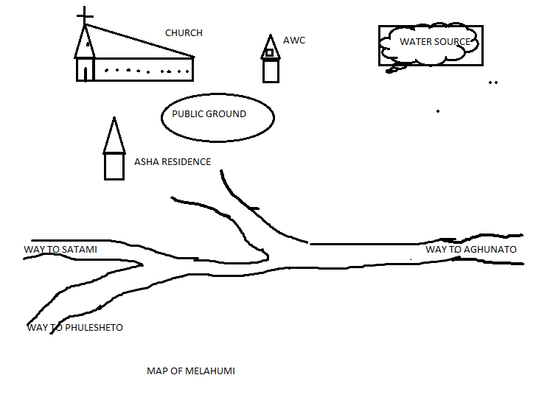
VHAP OF MELAHUMI VILLAGE

Sl. No | Priority issues | Actions to be taken/Done by the villager Local Leaders | Community participation/Role of community | Support/contribution from the village | Support required from health and other departments of line. Dptt. | Timeline
1. | Maternal Health | ANC services to be strengthened and dropout pregnant women tracked and provided ANC through VHND  More outreach activities on immunization sessions should be increased | Encourage every pregnant Women to go for full ANC checkup and to go for institutional delivery  Organize VHND regularly so that missed out Pregnant women can be tracked out | Spread awareness on the importance of ANC checkup and institutional delivery  Cooperate with Health staffs and ASHA during routine immunization and VHND | Manpower should be at place for improvement of health delivery services and  Required medicines and vaccines to be made available at all time  Continue cooperation with Social Welfare Dept. For healthcare deliveries | ongoing

NGOZUBOMI VILLAGE

Ngozubomi village falls under Aghunato CHC which is 12 km away from the Health Centre covering a total population of 480 (As per 2011 census) with 66 Eligible Couples. Main occupation of the village is agriculture. Road connectivity from the village to Health Centre is kaccha. At present the village has one AWC, one ASHA, one GPS and one VHSNC joint account
On 18th Sept 2020 the Block team comprising of MO, Staff Nurse, BPM, BAC went to this village and conducted a focus group discussion on the topic Child Health. The team encouraged the participant to track out all the children and get them immunized as per immunization schedule, discussed on the importance of immunization and its dis-advantages on the children. The team also encouraged ASHA to play an active role and insist her to keep update record of all the eligible children in the village and refer them to ANM for timely immunization for which she will get an incentive for full immunization of each child.
In conclusion it was decided by all the participants that in future days to come they all will play an active role in tracking out each and every child in their village and refer them to ANM for timely, fully and complete immunization.

MAP OF NGOZUBOMI
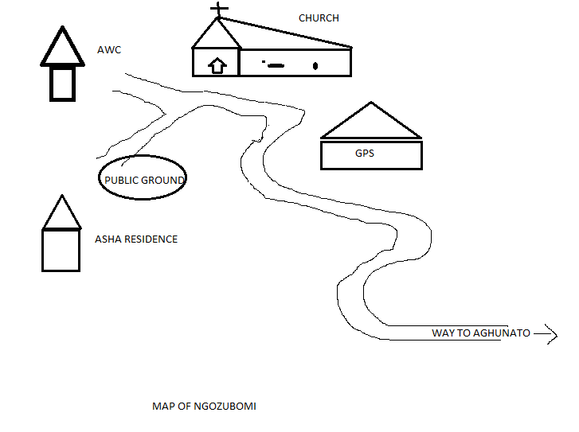

VHAP OF NGOZUBOMI VILLAGE
Sl.No | Priority issues | Actions to be taken/Done by the villager local leaders | Community partipication/ role of community | Support/contributionfrom the village | Support required from health & others departments. | Time line
1. | Child Health | Immunization sessions should be strengthen and increased  Encourage every parents to vaccinate their children as per the given time frame | Create awareness on the importance of immunization through church , school,miking, platform | ASHA, VHCs to track out missed children and refer them to ANM for timely immunization  To Co-operate with Health Staffs during immunization/any outreach activities. | All the required medicines, logistics and vaccines to be made available at all times.  Continue cooperation with Social Welfare Dept. For healthcare deliveries | ongoing

Ghokimi Village Health Action Plan.
Ghokimi village falls under Asukiqa SC with the population of 858 and 148 Households, a distance of 2 Km from the SC and44 Km from the CHC as nearest Referral Health Unit. The main occupation of the village is agriculture. At present the village has one Asha, two AWW and one GPS.
The team comprising of MO, Staff Nurse, BPM& BAC Conducted a Focus Group Discussion on the Topic Child Health. The team encouraged the participant to timely immunized their children as per Immunization schedule, discuss importance of immunization and its Disadvantage. After a thorough Discussion with the VHC’s, VC’s, Youth Leaders, Church leaders, ASHA and AWW’s, an Villagers, we came with a conclusion to participate an take active role in tracking out each and every child in the village to the nearest health unit for timely immunization.
Priority issue | Actions to be taken/done by the village local leaders | community Participation n/role of community | Support / Contribution from the villagers | Support Required from the health & other Department | Time line
Child Health | 1. Asha and AWW to be more active  2.Encourage each and every parents to take their children for timely Immunization. | - Spread /Create awareness on the Importance of child Immunization at Churches , Schools , Through miking etc. | - Cooperation and support the health workers.  - Create awareness on child care and explain the benefit of regular and timely immunization. | - ANM to Conduct VHND monthly and track unvaccinated missed out children for immunization.  - ASHA and AWW to be active in creating awareness on Immunization.  - Provide Sufficient IEC materials to be displayed. | Monthly  basis

Tukuliqa village Health Action Plan.
Tukuliqa village falls under Ghathashi PHC with the population of 341and 44 Households, a distance of 8 Km from the PHC and 34 Km from the CHC as nearest Referral Health Unit.ANC an Family planning is the major issue of the society. For this, SMO,M.O, BPM and ASHA Coordinator hold a Discussion with VHC’s, VC’s, Youth Leaders and Church leaders. In this Discussion, the emphasis was given to early registration, full and timely completion of ANC with PNCand educate them about family planning. The members responded very satisfactorily and assured a hand holding support for which the VHAP was prepared.
The conclusion brought up during the interaction are projected as below :
Priority issue | Actions to be taken/done by the village local leaders | community Participation and role of community | Support / Contribution from the villagers | Support Required from the health & other Department | Time line
Giving less priority for ANC check ups | 1.Conduct VHND regularly.  2.Promote, protect and maintain the Health of both the mother and childduring pregnancy with vaccination.  3.Detect high- risk cases and give them special attention.  4.Remove anxiety and dread associated with delivery.  5. Educate regarding Maternal and Infant Mortality and Morbidity.  6.To teach the mother, elements of Childcare, Nutrition, Vaccination and well being.  7.Sensitized the mother regarding Family Planning by using CuTincluding MTP. | 1.Active participation from the VHC and the Village Councils.  2.Mental preparation : sufficient time and opportunities should be given to all the expectant mothers to have a free and frank talks on all aspects of pregnancy and delivery.  3. Notification of pregnancy to the concern authorities as practice in some parts of the world. | 1.Cooperation and encouragement.  2.Acknoledgement of Health benefits and financial benefits.  3.Educate and give awareness to the Eligible couples. | 1.Timely provision of VHND fund.  2.Timely supply of Medicines(Iron tablets, Calcium tablets and Vitamins) and equipment.  3.Trained personal at the Health Unit.  4.Pregnancy imposes the need for extra calorie and nutrient, therefore financial assistance aided by the Govt. can be given during the pregnancy to meet the increasing demand of the mother.

Manpower Proposal

Proposal- 1. One Doctors.
2. One Regular ANM
3.Three NHM ANM

Based on the triangulation of data from the Facility Survey, IDSP, HMIS and VHAP, the Satakha Block action Plan 2021-2022 has been formulated to strengthen the health delivery system. Ghukiye PHC has been lying without MO for the past few yeare causing enormous difficulties for the people in availing healthcare. The PHC caters to 5 villages and absence of MO has created a huge negative impact among the communities under the coverage areas. This also directly affects the Health indicators in a negative way like HMIS and RCH reporting. People have stop visiting the PHC owing to the absence of MO.
Thakiye Sc is also non functional as no ANM has been replaced after the previous one was transferred out.
Beside the above HUs, Aghuito Sc, Kivikhu Sc and Shoipu SCs cannot render optimum service due to their old age and a single a single ANM at Shoipu SC is finding difficulty in covering 4 villages under her jurisdiction. Thes HR needs are to be urgently address on a priority basis.

FMR Code | Manpower | Target
 | - Medical Officer | - At Ghukiye PHC)
 | - ANM | 1, At Thakiye SC)
 | - Contractual ANM | 3One each at Aghuito, Kivikhu & Shoipu

Activity proposal Framework
Activity propose- Construction
1.One(1) Hokiye Sub-Centre
2.One (1)Ghukiye PHC Major Repair & Renovation

At present the Hokiye sub-centre is being functioning at private building with one room as office cum medical dispensary. The officially allotted sub-centre building was gutted down by fire by a mentally retarded person on 7th March 2011. The plan propose new sub-centre building at Hokiye.
The plan also proposes for a major renovation work at Ghukiye PHC. The PHC is functioning with no proper rooms, without electricity and water supply. The PHC building is very old and is not suitable to function as PHC unless major renovation is carried out. Since most of the rooms are without door and windows.
GHUKIYE PHC

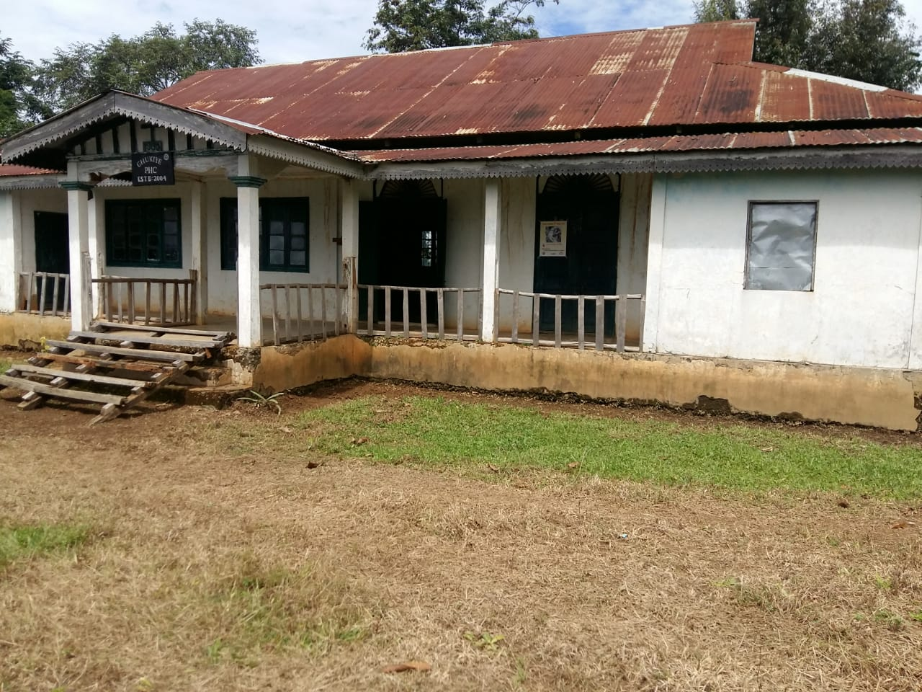

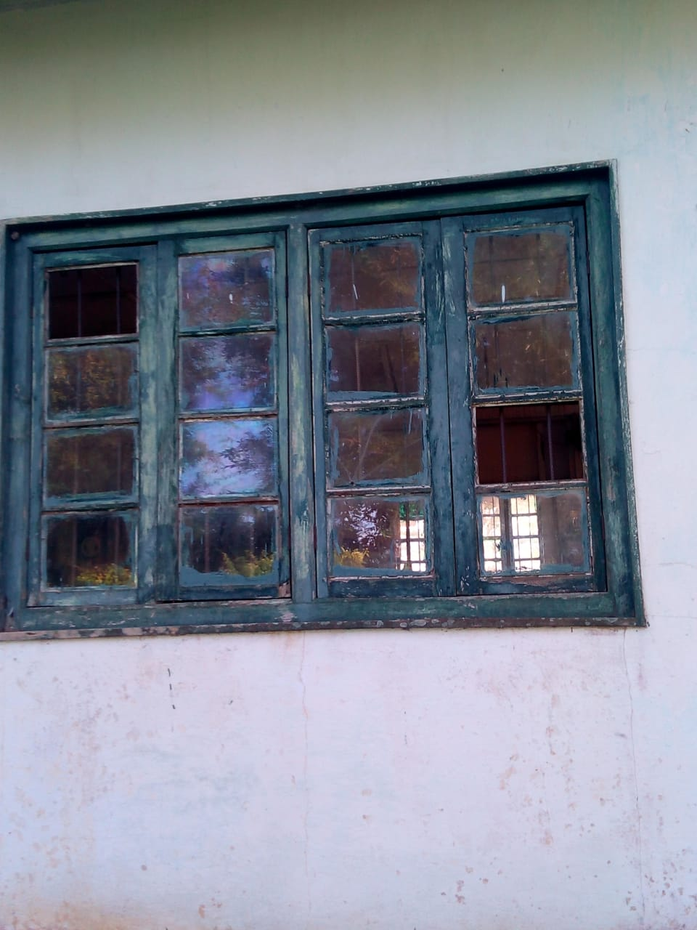

Deliverables

Fundings Proposed
Sl.no | Activity | No.of Units | Unit cost | Total Cost | FMR Code
1 | Construction of Hokiye SC | 1

Sl.no | Activity | No.of Units | Unit cost | Total Cost | FMR Code
1 | Renovation of Ghukiye PHC

Proposal for two wheeler vehicle
Satoi Areas is classified under High Risk Area as most of the roads connected to District Headquarter from villages are Kuccha road, which becomes non-pliable during rainy seasons. The commuters often face the problems of road blockage by landslide or roads washed away by rain water. Vehicles plying on those roads often get stuck in mud which makes it impossible to move on its own, requiring hiring of other additional force to pull out the vehicles many a times commuters on their road have meet accident causing loss of life and property. The road condition of village such as Thakiye, Tsutoho, Khuvuxu and Hokiye is so pathetic that even during dry season vehicles ply with great difficulty.
The Road condition does not favours for four wheeler vehicles therefore the villagers have started using two wheeler vehicle as means of transport as it is light and easy to handle and can ply even in narrow roads.
The plan propose for two wheeler vehicle for transportation of Vaccines and medicines as it will enable to carry out all activities like immunization programme on time and delivery medicines and first aid to the villagers when required.
Deliverables

Funding Proposed

Sl.no | Proposal | No.of Units | Unit cost | Total Cost | FMR Code
1 | Proposal of two wheeler | 1

INTRODUCTION
The National Health Mission (NHM) envisages a bottom up health planning process whereby village health concerns get reflected in the state health plan. The objectives and goals to be achieved under the NHM requires a logical and need based planning at the grass roots and block level to achieve the core objectives underlined under the mission. For this the concept of Health plan was introduced.
Satakha Block consist of 36 Villages with a projected population of 22395 (Projected census 2011). The Block consist of 2(t 24x7 PHC, 1 non 24x7 PHC and eight sub-centres.
The process of preparing VHAP began by conducting Focused Group Discussion by MO i/c Satakha PHC, BPM Asha Co-ordinator. Two villages were chosen for Village Health Action Plan i,e Ikiye village & Xuivi village. Ikiye village was chosen because people have been suffering from skin aliments in the village. Xuivi village has a fairly poor performance in ANC registration as well as resistant to child immunization.
It has been observed that community response to Health services improves considerably when they are actively involved in Health planning. Therefore, keeping this in mind the VHAP was prepared with the active participation of the respective village councils, VHCs, AWW and the villagers.

MAP OF IKIYE VILLAGE

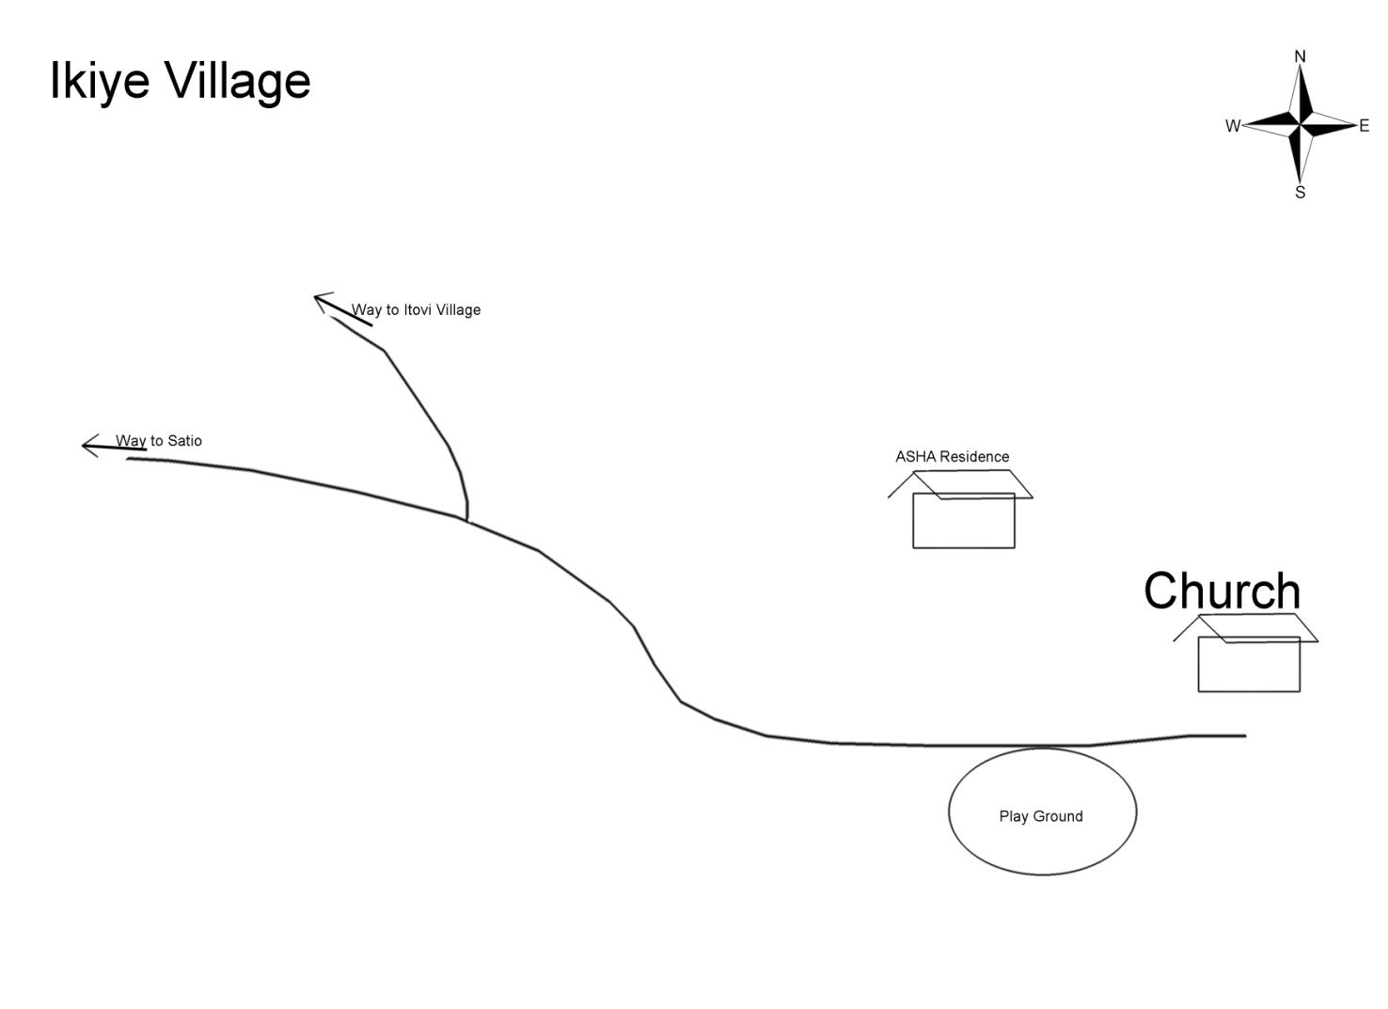

Village Health Action Plan(VHAP)
Ikiye Village

Ikiye Village is located in Satoi tehsil of Zunheboto District Nagaland. It lies below Chanki Mountain and Satoi Mountain range. The Village is bordered by forest range in the North, Tsutha river in the South, Itipu river in the East and Satakha in the west. The climate Varies from 30ºc to 35⁰c in summer and 20⁰c to 5⁰c in winter with humid warm temperature throughout the season.

Ikiye village is blessed with rich flora and fauna. Animals such as rare striped buffoons, reddish striped foxes, deers, bears etc are found. Varied species of timber, bamboos, wild fruits and wild eatable green leaves grows in plenty.

Ikiye village is 13km away from the nearest PHC i,e Satoi PHC. and 2km from its health centre, 68km away from Satakha PHC and 78kmaway from District Headquater. The road is Kaccha which makes difficult to ply during rainy seasons.

With the advancement in medical facilities, basic health issues are taken care up to some extend but the village being surrounded by dense forest and the presence of warm humid climate makes the village a good breeding ground for many vector borne diseases.

Demographic Profile:-
- Population - 193(As per head count)

- Household - 56

- ECR - 10(As per RCH)

- Under five - 27(As per RCH)

- Under one - 2(As per RCH)

To understand the health issues faced by the Ikiye villagers the MO Satoi PHC along with BPM, Asha co-ordinator went to Ikiye village on 05 August 2020 and interacted with the villagers where village council and VHC members as well as AWW were present. During the course of Focus Group Discussion on various health related matters pertaining to their village it was found out that the people have been suffering from skin aliments. On being examined on some patient skin diseases such as scabies and rashes were found out.
The ignorance of the people about the diseases, living unhygienic life style, indifferent attitude towards medicines and lack of medicinal facilities in the village makes such petty issues a serious health problem.
In order to tackle the problem the MO advocates the benefits of staying clean. Since many skin ailments are contracted through close contact with domestic pets and animals around unhygienic environment, the villagers were made to be aware regarding personal hygiene by taking regular bath and also to keep their surrounding and pets clean. that the village would conduct mass social work twice a month to keep the village clean.

Table VHAP of Ikiye Village ,Satakha Block
Sl.No | Priority Issue | What should be done | What Should the Community do | Support the Villagers can provide | Support of the line deptt | Time frame  On going
1 | Scabies and skin rashes | 1.Focus Group Discussion with emphasis on skin aliments.  2.Create awareness camp, distribute posters and pamphlets about various types of skin diseases.  3.Educate and trained the Ashas and the villagers on the preventive measures to be taken to stop the spread. | 1.Spread awareness about the diseases.  2.Spread knowledge how to tackle with those diseases.  3.Conduct mass social work and enforcing strict laws to stay clean. | 1. Co-operate with the health workers.  2.Living hygienic life style. Shading down the indifferent attitude towards medicine.  3.To report to the medical staff about the disease on time. | 1.Try to stop the diseases before it spread to another person.  2.Provide adequate medicinal supply.  3.Identifying the disease and provide appropriate medicine.

MAP OF XUIVI VILLAGE

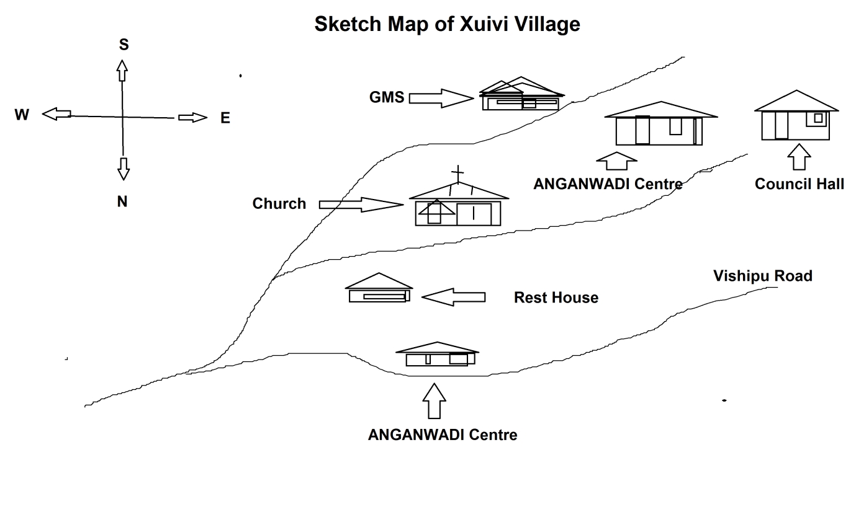

Village Health Action Plan(VHAP)
Xuivi Village

Xuivi Village which falls under Satakha PHC comes under Satakha Block of Zunheboto District. The latitude 25.88 and the longitude 94.44 are the geo-cordinate if Xuivi village. The distance from the village to the sub-centre i.e Kivikhu sub-centre is approximately 14kms and to the Block PHC is approximately 7kms. and to the Dist.HQ.is approximately 30kms. The road is well connected to the S/C, Block PHC and the District HQ. By an all well weathered road. The main occupation of the people is farming and hunting. The village have set up Village Health Committee to look after the sanitation and well being of the people’s health. The village have two Anganwadi centres and one Government Middle School. VHND is conducted every month at Anganwadi centres.

Demographic Profile:-
- Population - 650(As per head count)

- Household - 172(As per census 2011)

- ECR - 21 (As per RCH)

- Under five - 91(As per RCH)

- Under one - 8 (As per RCH)

The MO i/c of Satakha PHC along with the BPM & Ashas Co-ordinator went to Xuivi Village on 01 August 2020 and interacted with the villagers, where village council and VHC members as well as AWWs were present. During the course of FGD on various health related issue, the low rate of immunization and poor ANC of the mother in the village were discussed.

It was found that some parents in-spite of receiving pre-information about the date of immunization do not turn up at the immunization site. So the ASHA and some volunteers have to go house to house to request the parents and bring their children for immunization. But inspite of all the hard efforts of the ASHA Some parents often feel reluctant to give immunization to the children fearing ill effects of medicines in future.

The pregnant mothers often fails for ANC because either they are too busy engaged in their field works or reluctant to approach to the health centres out of shyness or indifferent attitude towards medicines.

Therefore, to improve the ANC and immunization status the key stake holders of the village along with the health workers resolved to spread awareness about the importance and benefits of ANC and immunization. The village too unanimously resolved to co-operate with the health staff during the immunization. The VHAP was thus formulated with the active support of the Village councils, VHC members and the villagers.

Table VHAP of Xuivi Village ,Satakha Block
Sl.No | PRIORITY ISSUES | ACTIONS TO BE TAKEN/DONE BY THE VILLAGER LOCAL LEADERS | COMMUNITY PARTICIPATION/  ROLE OF COMMUNITY | SUPPORT/CONTRIBUTION FROM THE VILLAGE | SUPPORT REQUIRED FROM HEALTH & OTHER DEPARTMENTS | TIMELINE
1  2 | Low Immunization Status .  Poor ANC | 1.Focus group discussion with special emphasis on immunization.  2. Make the village aware that immunization increases the body’s ability to fight 6 fatal diseases.  1.Create the awareness about  “what is ANC’’.  2. Eradicate the taboos towards medicine . | 1. Co-operate with the health workers  2.Ensure that all children including drop-out children receive the full course of immunization.  1.Encourage the pregnant mothers to go for regular ANC.  2. Encourage them to have institutional delivery as it is safe for both the mother and child. | 1. Reach the Immunization site on time.  2. The Village council can announce that it is mandatory for all children to receive immunization.  1.Co-opreate with the Health staff and Ashas during VHND.  2.Support the pregnant woman physically and morally by the family members. | 1Explain the importance of receiving immunization at the right age at the right time.  2.Educate the Villagers that immunization is safe.  1.Provide adequate medicines supplies and latest equipments to the village health centres.  2.Provide proper infrastructure and adequate manpower . | On going  On going

Activity Proposal Framework
Name of Activity: Construction
Activity proposed;Construction of Litami SC Building and VK PHC gate
Whether New or being continued: New
Justification:
The Littami SC under Akuluto block, under Zunheboto district with a total population of 795 as per 2011 census covering two villages viz Littami old and Littami new. It was established in the year 1987.
The physical condition of the SC is deteriorating slowly,the roof,walls,drainage-system,floor,all of these requires repairing or a face lifting.
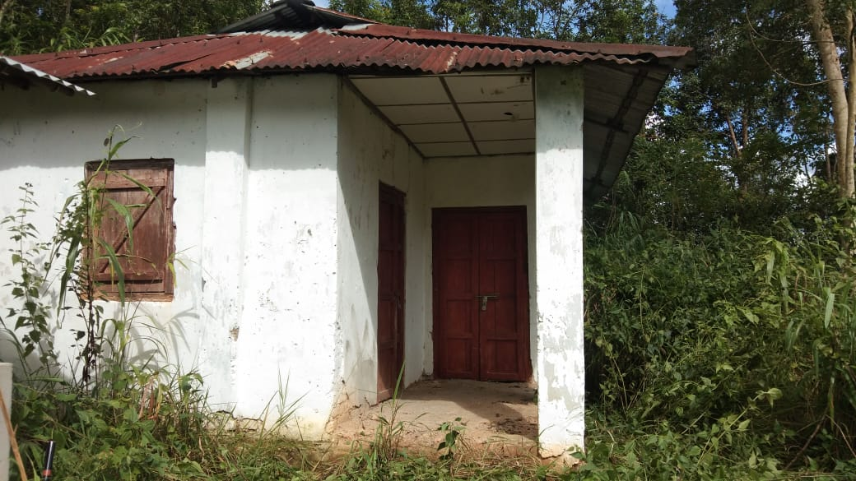
Deliverables:
FMR Code | Activity | Target
 | Sub Center Building Construction | 1

Funding Proposed:
Sl. No. | Activity | No. of Units | Unit cost | Total Cost | FMR Code
 | Sub Center Building Construction | 1

MAPULUMI village Health Action Plan

Mapulumi village comes under Akuluto Block of Zunheboto district, Nagaland. On 9th September2020, the Block Planning team comprising of BPM and Asha-coordinator had a Focus Group Discussion (FGD) with the key stake major holders of the village on various health issues of the villagers to frame the VHAP. It is 16 kilometers away from block Headquarter which has a total population of 522 as per 2011 census. At present there are 69 eligible couples with 7 pregnant women and 73 children below the age group of five years.
The main livelihood of the village is through cultivation. It has 1 Anganwadi center and 1 Govt. Middle school. Though the road condition hasn’t been any better yet the supply of water and sanitation is at a considerate level.
After a thorough out discussion with the VHCs, VCs, Church members as well as the villagers, it came to light that immunization was below expected. So a detailed investigation was made and it was found that the villagers were still unaware of the benefits of immunization. Therefore they were sensitized to create awareness by conducting VHND on regular basis and also through available platforms.

Priority issue | Actions to be taken | What will the community do | Support required from health and other departments | Time frame
1.Immunization | 1.ASHA to focused more on the creating awareness on immunization  2. Health and wellness of the village to be considered in all aspects of village activities. | 1.Active participation of the VHC’s on the immunization day/VHND | 1. Timely release of vaccines and logistics from the department.  2.AWW to be consistent in giving hand holding supports to medical staffs during RI,VHNDs etc. | 1.Ongoing

SKETCH MAP OF MAPULUMI VILLAGE

MAP
OF
MAPULUMI

ADC HQ AKULUTO TOWN NAGHUTO NEW
ASUKHUTO POLYTECHNIC

APPROACH ROAD PWD

SUB-CENTRE
MUKHAMI
GMS TISHI
VALLEY MAPULUMI VILL
VCC GB WATER TANK
GBHHHH

COUNCIL BAPTIST
HALL CHURCH

PASTOR R
AWC FOOT BALL GROUND

HD GB

Izheto village Health Action Plan.
INTRODUCTION
Izheto village falls under VK PHC in Akuluto Block with the population of 204 and 60 Households with a distance of 14.5 km from the PHC . The village comprises of 27 expected Eligible Couples, 3 pregnant women and 5 children below the age of 5 years, as per 2011 population census. The expected Deliveries and Pregnant women is 5 per year . The main occupation of villagers is farming. The village consists of one school and one Anganwadi center. The Planning Team then discussed with the village leaders and elders and found out that ANC was weak. Therefore with the view to promote and create awareness on early registration and timely check up for Ante-Natal Care, they were sensitized about the available services provided by the department. The members responded very satisfactorily and assured a hand holding support for which the VHAP was prepared.

Table:VHAP of Izheto village, Akuluto Block
Priority issue | What should be done | What should the community do | Support the villagers can provide | Support of the line Department | Time frame
ANC Services | 1. Conduct VHND regularly.  2. Promote, protect and maintain the Health of the mother during pregnancy.  3. Detect high- risk pregnancies and give them special attention.  5. Education regarding Maternal and Infant Mortalities. | 1. Active participation from the VHC and the Councils.  2. Support from every section of the people. | 1. Cooperation and encouragement. | 1. Provide timely ANC services and create awareness on personal hygiene and health care. | Ongoing

MAP OF IZHETO VILLAGE

N.H-2
Waiting
Shed

village gate N.H-2
Village
Playground
Village
Councilhall

New Church
Building Foot Path to N.H-2

Village
Graveyard

Church & Anganwadi Center Village
Guest house Church

Asha

British Road

Activity Proposal Framework

Name of Activity: Upgradation to CHC
Activity proposed: Upgradation
Whether New or being continued: New
Justification:
Suruhuto PHC which is the Block Headquarter is the only 24x7 PHC (FRU) in the Block with 1 Medical Officer, 3 GNM , 1 ANM, 1 pharmacist and 1Lab tech with the supporting staffs catering to the entire population of more than 20,000 (expected present population).
The PHC is a six bedded health unit providing Delivery service with functional NBCC. Taking the base from 2019-20(HMIS) report, it has an average OPD of 280-300 per month with institutional delivery of 3-4 per month. The average inpatient head count is 15-20 per month. There was a need for a a kitchen for patients earlier, but during the early part of 2020, with the initiation of HCMC members, the PHC could construct its long needed Kitchen for patient and also the waiting shed (Photo enclosed) through contribution given by the community.

Therefore, In order to give better standard of care to the community and also taking advantage of the community participation and ownership of health concern within the block, the present PHC can be considered eligible to be upgraded to a CHC. This will help the district in many ways to improve health indicators and over all development of health and wellness of the people.
Suruhuto PHC

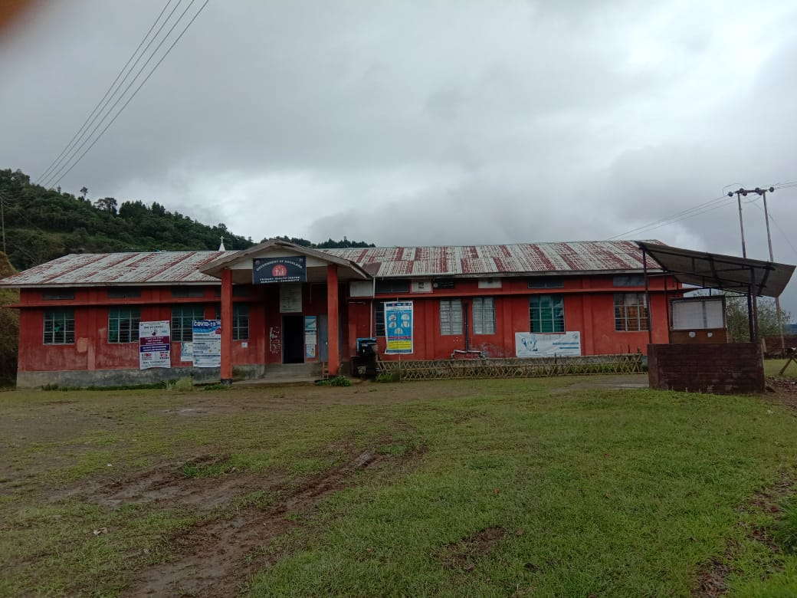

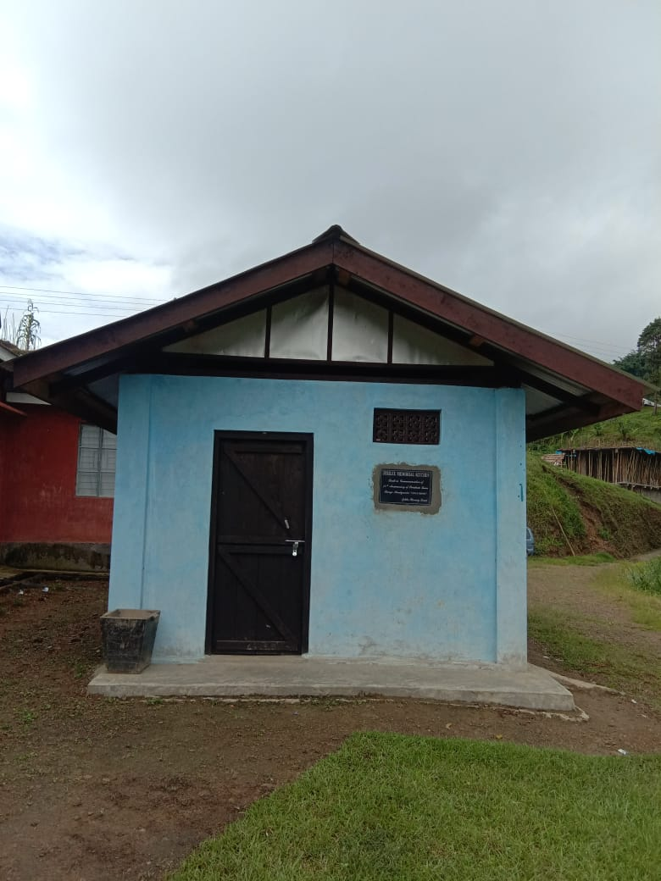
Patients Kitchen
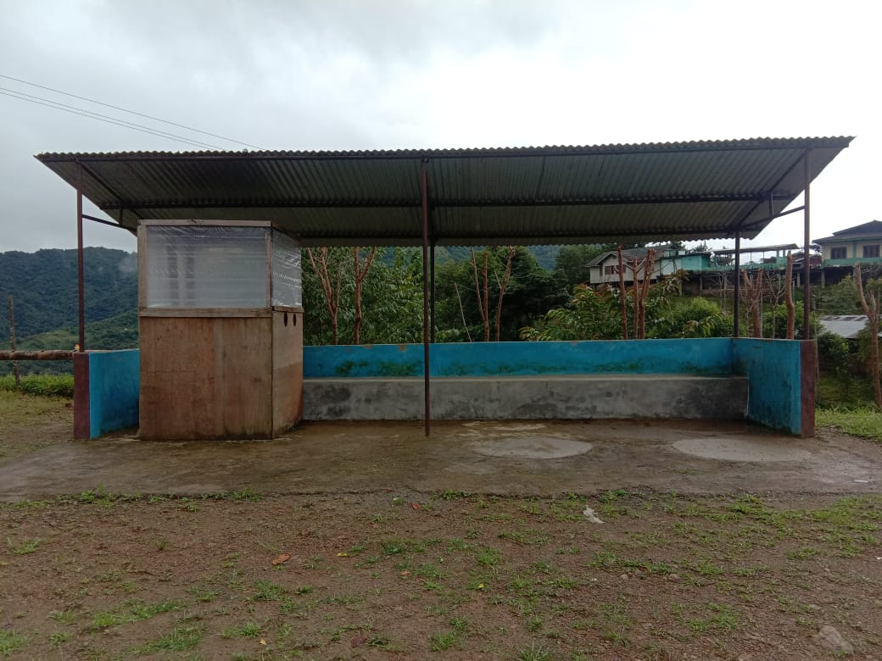 Waiting Shed

Deliverables:
FMR Code | Activity | Target
 | Upgadation to CHC

Activity Proposal Framework
Name of Activity: Tichipami Sub- Centre Building Construction
Activity proposed: Construction
Whether New or being continued: New

Justification:
Tichipami Sub-Centre in Suruhuto Block under Zunheboto District which was established in the year 1982 is one of the oldest Sub-Centre in the Block catering to the needs of the village health care system. It covers three villages namely Tichipami Old and New Village and with the total present population of over 1181(as per population census 2011). The sub Center, since its inception has been functioning in community Building with two small rooms, one as Nurse quarter and one as sub center office cum immunization room, but it has been informed by the community that the present SC building is required to be used for other purpose. Hence, a new IPHS standard SC building along with attached rooms and toilet facility for ANM needs to be erected for Tichipami SC to avoid further inconveniences within the community.

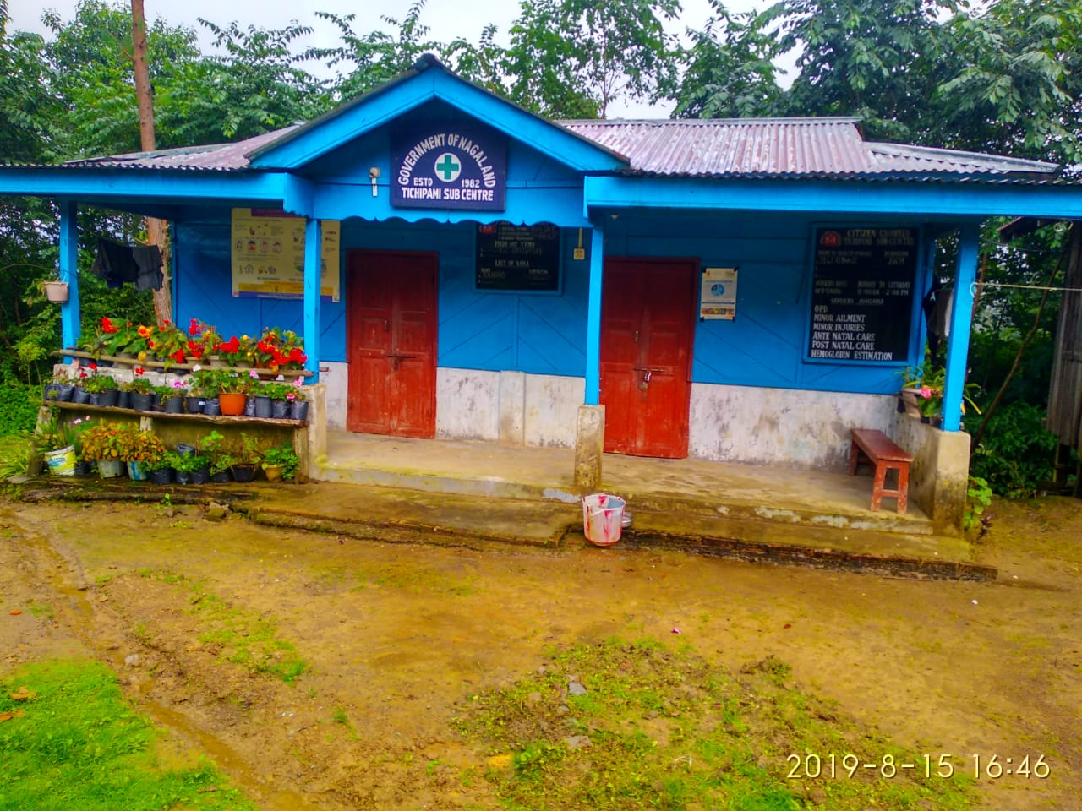Deliverables:
FMR Code | Activity | Target
 | Construction of Sub-Centre building | 2021-22

Funding Proposed:
Sl.No | Activity | No. Of Units | Unit cost | Total cost | MR Code
1 | Construction of Sub Center Building | 1
Activity Proposal Framework
Name of Activity: Construction
Activity proposed: PHC Building
Whether New or being continued: New
Justification:
Asuto PHC located in Asuto Town covering 10 villages as per RCH Portal with the total population of 4280 (as per 2011 census) and is one of the hard to reach area in the district with rugged terrain and facing a lot of challenges. The PHC building is beyond repair (Photo enclosed) and has been functioning at MO’s Quarter for more than 10 years. The community of this area need quality health care services to reduce distance barriers and improve access to quality health care and avoid unnecessary travel time to meet health professional and reduce the cost of patient transfer. A complete major renovation of the existing PHC or alternative a new IPHS standard PHC building is required for Asuto.
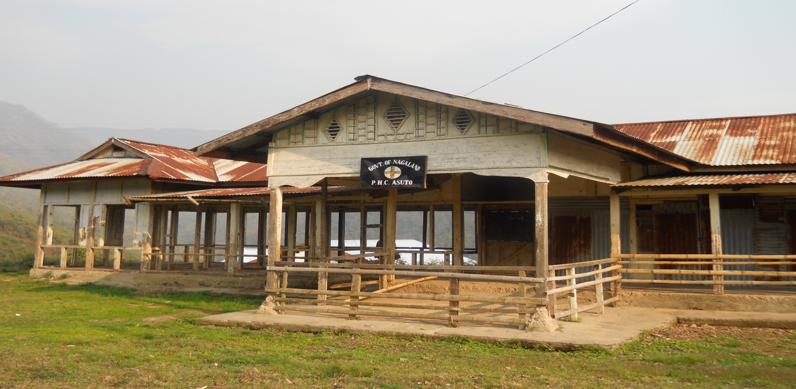
Deliverables:
FMR Code | Activity | Target
 | Construction of PHC Building

Funding Proposed:
Sl.No | Activity | No. Of Units | Unit cost | Total cost | MR Code
1 | Construction of PHC Building | 1
Activity Proposal Framework

Name of Activity: Additional HR
Activity proposed: Additional Contractual ANM
Whether New or being continued: New
Justification:
Tizu island has a population of 2233, having 11 villages which is located in an isolated place with difficult terrain and becomes cut off from the rest of the district for around 6-7 months during monsoon. Due to lack of proper transport and communication, the citizen of this area are much behind other areas in all sectors even in our health care system where the Immunization coverage was less than 35% and the same is of ANC services for the last financial year. Villages under Tizu Island go through one of the most difficult times as far as service deliveries are concerned which affects the overall socio-economic livelihood and health of the residents. Therefore an additional contractual ANM is urgently required at Tizu Island to hand hold the present nurse. Tizu Island with all its physical difficulties in relation to road, distance from the block HQ, seasonal disruptions of roan and communication, it is not humanely possible to single headedly curb all the fields activities within expected timelines. This problem should be considered as an important priority because the ground reality is different from the theoretical assumption.
Deliverables:
FMR Code | Activity | Target
 | Additional ANM

Funding Proposed:
Sl.No | Activity | No. Of Units | Unit cost | Total cost | MR Code
1 | Additional ANM | 1

INTRODUCTION.
Suruhuto Block consist of two PHC’s and 10 Sub-centers, which caters to the need of 18698 (As per 2011 Census) population. It has 34 recognized and 3 unrecognized villages spread far and wide with bad road connectivity.
A survey was carried out in two villages namely Vedami Village and Kiyetha village to assist the Sanitation, living standard, health care and health seeking behavior of th people based on their needs.

Atunukugha Village Health Action Plan.
Atunukugha village lies to the East of the Block with a Population of 142 as per population 2011 Census with total eligible of 17. It is 2 Km away from the nearest Health Unit i.e., Tizu Island SC and 13 Km away from the Suruhuto PHC. With the view to promote the Health Status of the villagers, a team comprising M.O., BPM and ASHA co-ordinator hold a Focus Group Discussion with the VHC’s, village council members, Youth Leaders and Anganwadi Workers. On this Discussion, the members present gave an active participation and accordingly VHAP for Atunukugha Village was taken.
The village is under developed with bad road connectivity and the people living there are ignorant of basic health care. It has one Govt School and one Angwadi center. The main occupation of the village is agriculture. The Village has a constituted Village Health and Sanitation Committee (VHSNC) to look after the health care of the village by conducting VHND on monthly basis with the co-ordination of ANM, ASHA and Anganwadi workers. .
PRIORITY ISSUES | ACTIONS TO BE TAKEN/ DONE BY THE VILLAGER LOCAL LEADERS | COMMINITY PARTICIPATION/ ROLE OF COMMUNITY | SUPPORT/ CONTRIBUTION FROM THE VILLAGE | SUPPORT REQUIRED FROM HEALTH & OTHER DEPARTMENTS | TIMELINE
Immunization & ANC Services | - Sufficient IEC materials to be displayed to create awareness among the community.  - ASHA to be more active | 1 .Active participation of the village leaders.  2. To encourages each and every eligible couple to regularly take the children for immunization. | 1 .cooperation and support to be provided.  2. Encourage and explain the benefits of regular immunization.  3. Create awareness about the child care. | 1. ANM to regularly visit the village for immunization.  2.ASHA and AWW workers to be more active in creating awareness on immunization | Monthly basis

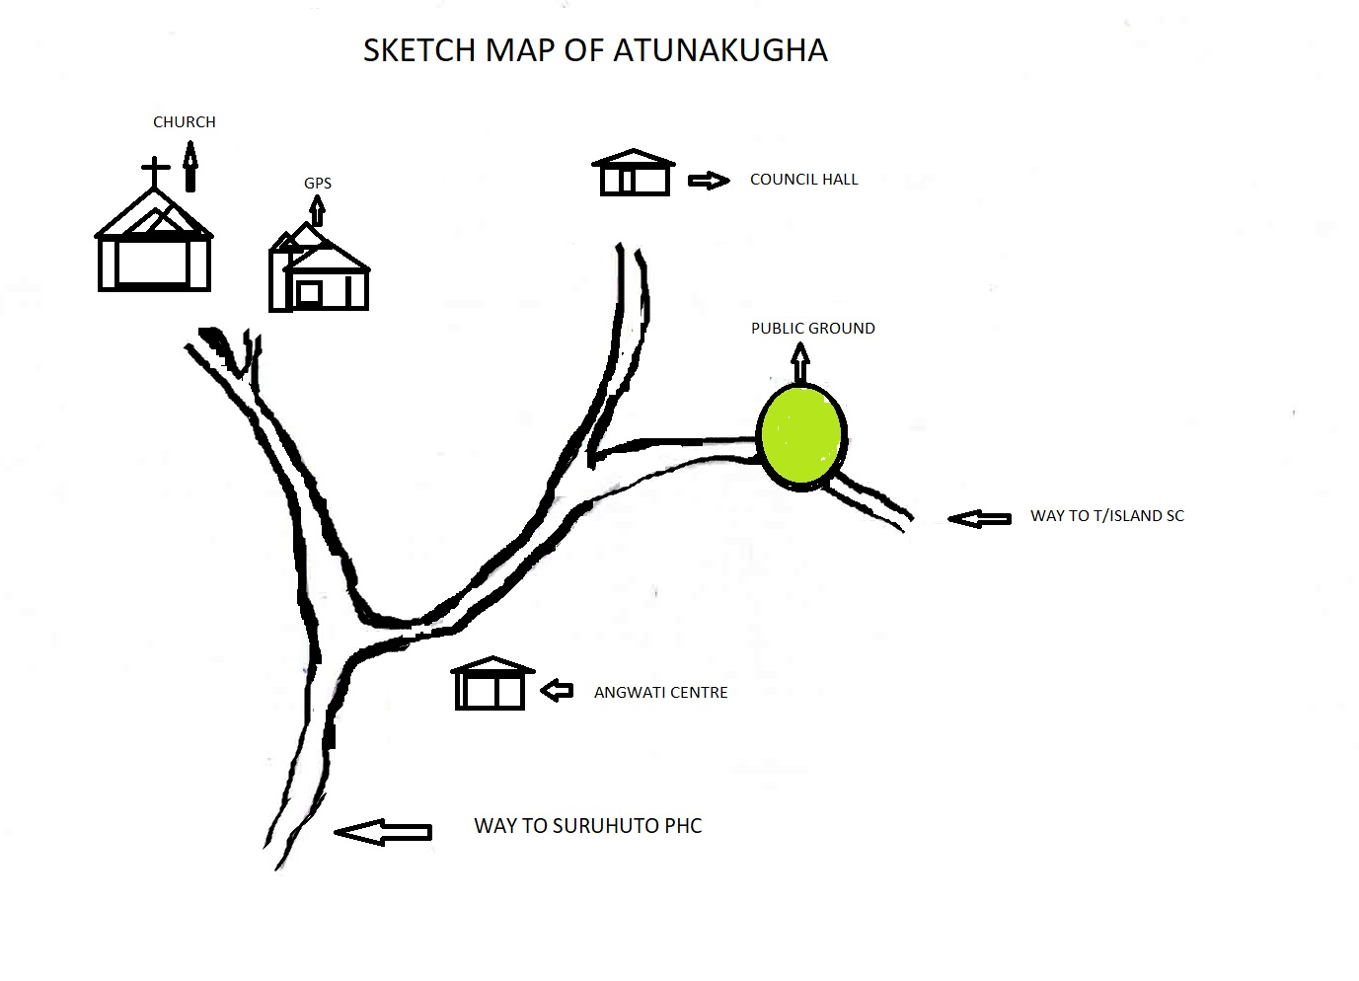

Vedami Village Health Action Plan.
Vedami village falls under Aichi Saghemi SC which lies in the east with the population of 227 as per population census 2011with total eligible couple of 26. It is 3 Km from the SC and 8 Km from the PHC as nearest Referral Health Unit. The road condition is very poor and during monsoon season it becomes non motorable except by foot. It has 1 Govt School and 2 Anganwadi centre’s. Due to lack of proper road and also communication problem, the village lack behind in health care. So our team comprising of MO i/c Suruhuto PHC, BPM and ASHA co-ordinator we meet the VHC’s, VC’s, Youth Leaders, Church leaders, ASHA and AWW’s, and went through out discussion with the members and came out with a conclusion to challenge and tackle the situation in a framed VHAP as bellow :

PRIORITY ISSUES | ACTIONS TO BE TAKEN/ DONE BY THE VILLAGER LOCAL LEADERS | COMMINITY PARTICIPATION/ ROLE OF COMMUNITY | SUPPORT/ CONTRIBUTION FROM THE VILLAGE | SUPPORT REQUIRED FROM HEALTH & OTHER DEPARTMENTS
Diarrheal Disease and Dehydration | 1. Create awareness on sanitation and safe drinking water practices through platforms available in the village. Eg., Churches, Schools etc.  2.Promote use of ORS | 1. Mass social work to clean the village drains and village ponds Quarterly.  2. VC to make provision to connect pipelines to specific located places. | 1. Cooperation during mass social work.  2. Maintain regular cleaning of the drains and ponds. | 1. Ensure availability of drugs and ORS to ASHA’s.  2. Visits to be made by the ANM’s.  3. Ensure IEC logistic on personal hygiene.

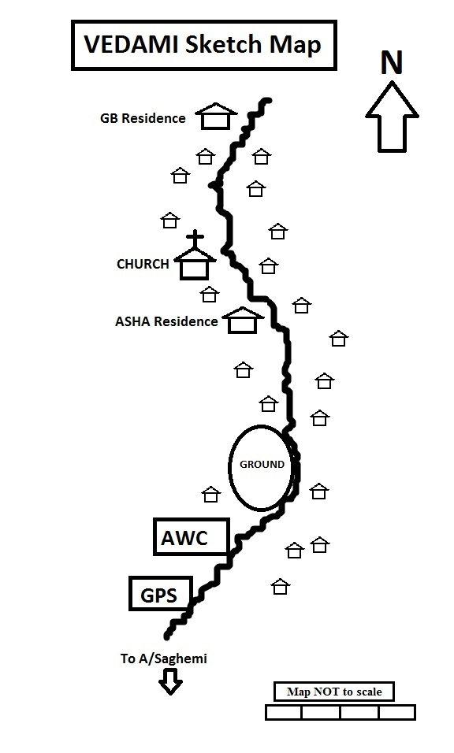

SL. NO. | NAME OF VILLAGE | PAGE NO.
1. | LITSAMI | 1-2
2. | USUTOMI | 3-4

Litsami Village Health Action Plan
INTRODUCTION
Litsami village comes under Zunheboto Sadar Block under Zunheboto district Nagaland. On 9th Septmber 2020 the Block Planning team comprising of Deputy CMO, MO Atoizu PHC, BPM, BAC together with ANM of Asukhuto SC held a Focus Group Discussion (FGD) with the key stake holders on various health issues prevalent in the village to frame the VHAP. It is located 13 Kms from the nearest PHC and 36 Km from the District Headquarter, total population of the village is 503 with an estimated pregnant women 8, estimated under 1 children 7, estimated children 0-5 years 74 and 33 total eligible couple.
The main occupation of the villagers is farming. It has two Anganwadi Centres and a GMS school.
After a thorough discussion with the VHCs, VCs, Church members it came to light that the villagers are prone to diarrhoea. On investigation it was found that basic hygiene and awareness on various vaccine preventable diseases need to be strengthened by the medical department and stakeholders. The Deputy CMO briefed on vaccines preventable diseases.

Table:VHAP of Litsami village, Zunheboto Sadar
Priority issue | Actions to be taken | What will the community do | Support required from health and other departments | Time frame
Reduce Diarrhea cases and strengthen Immunization | Strengthen basic Hygiene, VHND and Immunization Programmes | Support and Co-operate | IEC, Regular VHND and handholding support | Ongoing

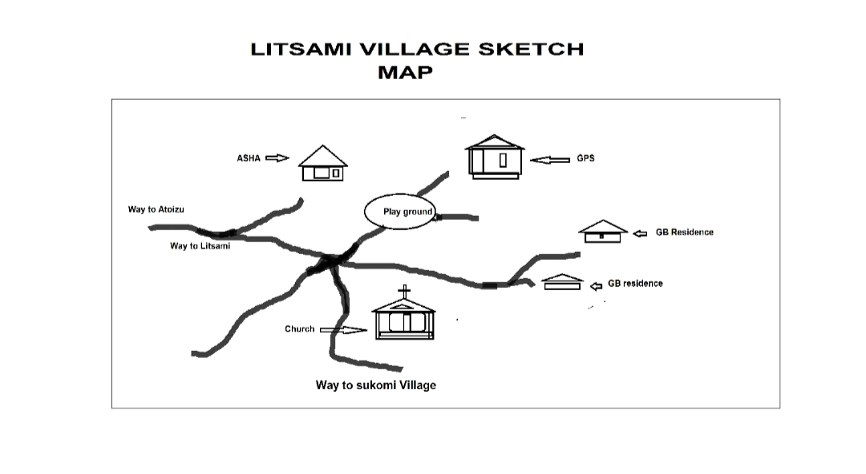

Usutomi Village Health Action Plan.
Introduction
Usutomi village falls under Saptiqa PHC of Zunheboto Sadar Block with a total of population 615, estimated pregnant women is 9, estimated infants 8, total eligible couple 25 and estimated children from 0-5 years is 86. It is located 1Km away from the catering PHC and 37 Kms from the District Headquarter. The main occupation is farming. The village has one school and 2 Anganwadi centres. The Planning Team comprising of Deputy CMO, MO Saptiqa PHC, BPM and BAC had a discussion with the village elders, VHC, VC members and church leaders. The villagers were sensitized on health and safe delivery. Basing on HMIS report it has been observed that home deliveries is a regular trend.
Table: VHAP Roto Old,Zunheboto Sadar
Priority issue | What should be done | What should the community do | Support of the line Department | Time frame
Encourage institutional deliveries | Strengthen ANC,VHND | Support and Co-operate | IEC, Regular VHND and handholding support | Ongoing

Map of Usutomi village

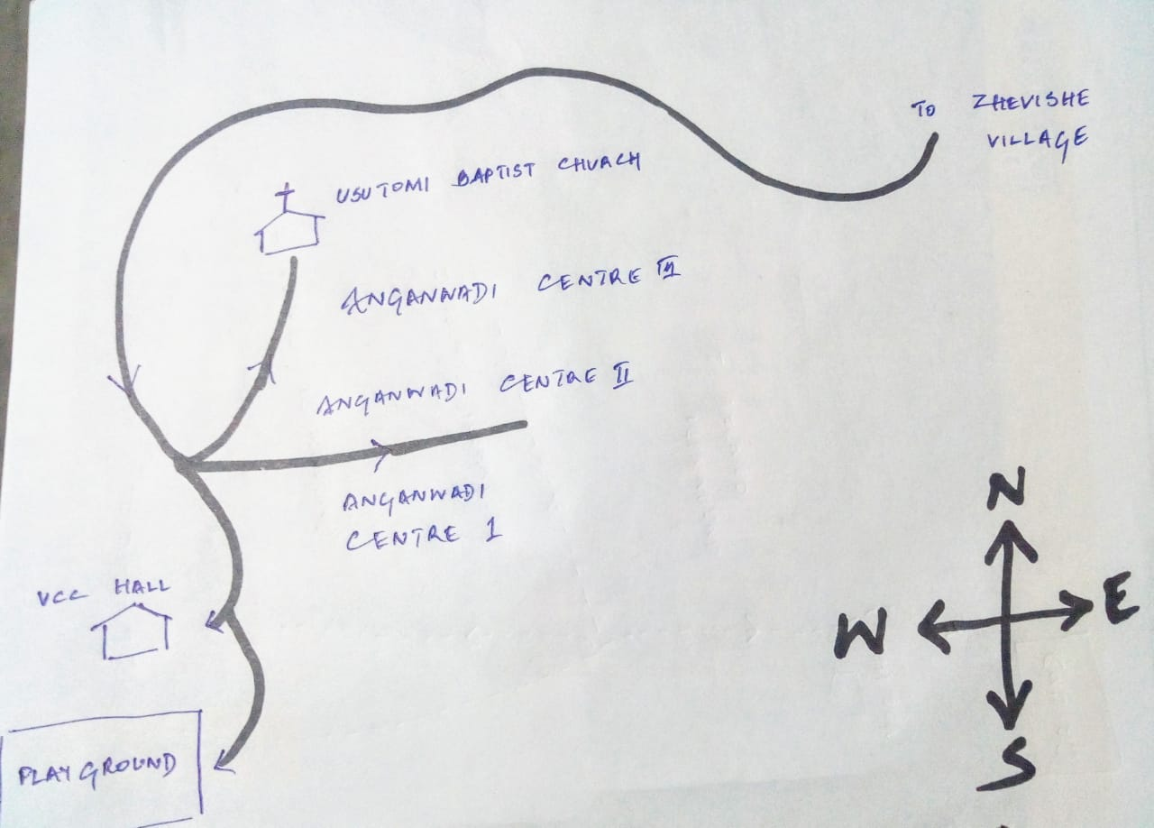

PICTURE GALLERY
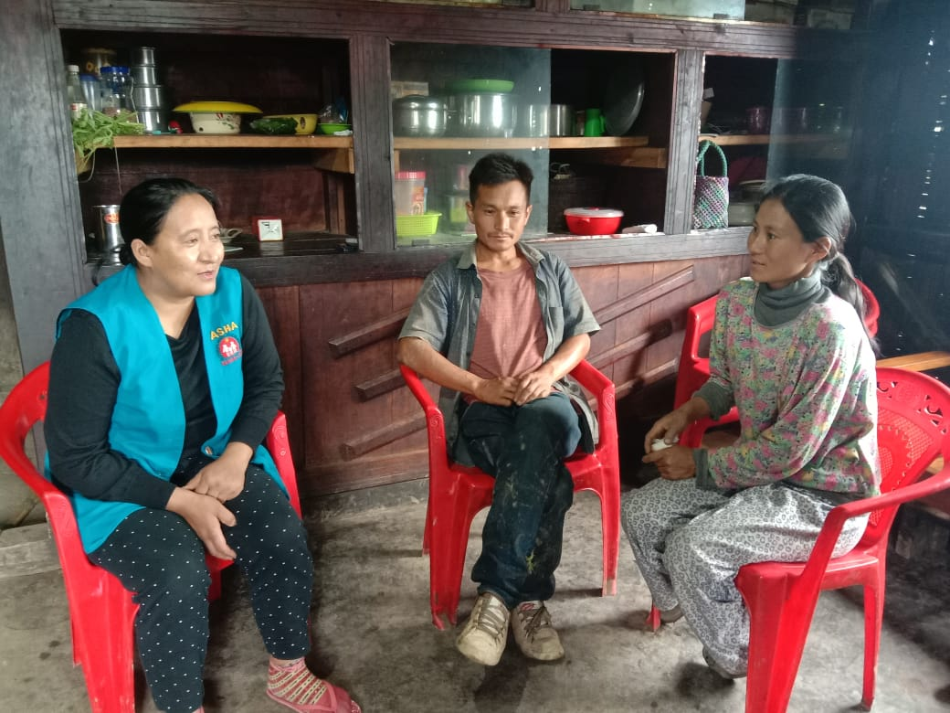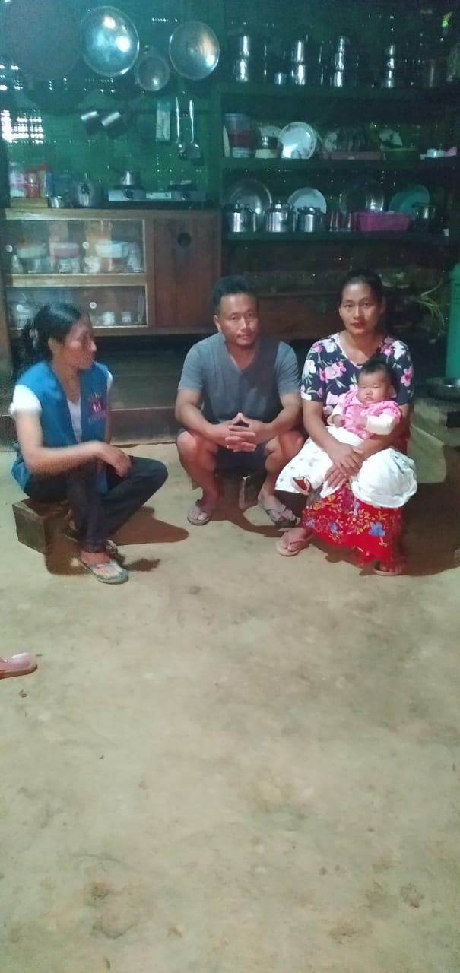
ASHA home visit during family ASHA home visit during breastfeeding fortnight
planning fortnight

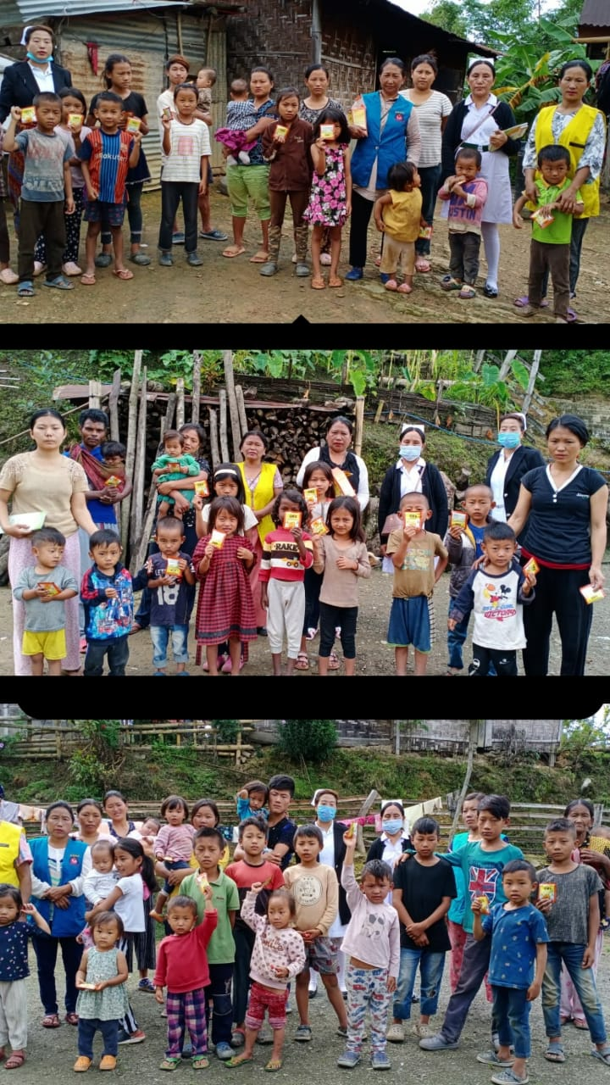
IDCF and VHND under Lizumi Sub- centre

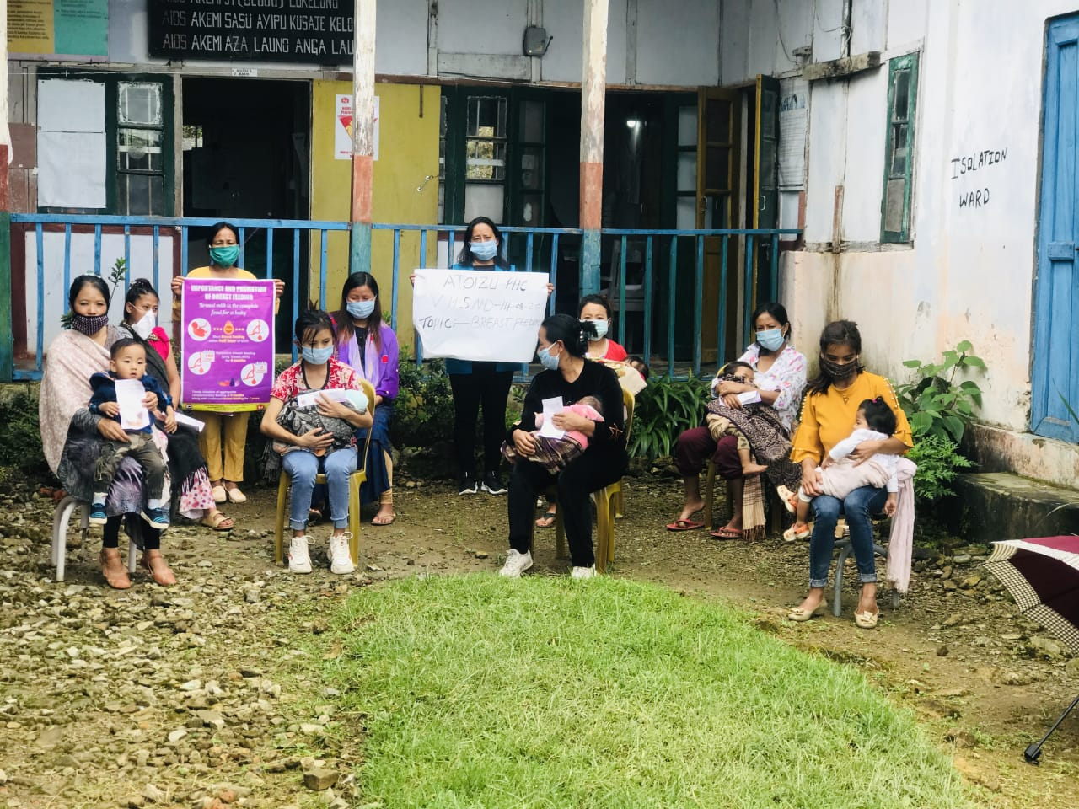
Exclusive Breast feeding fortnight observed at Atoizu PHC

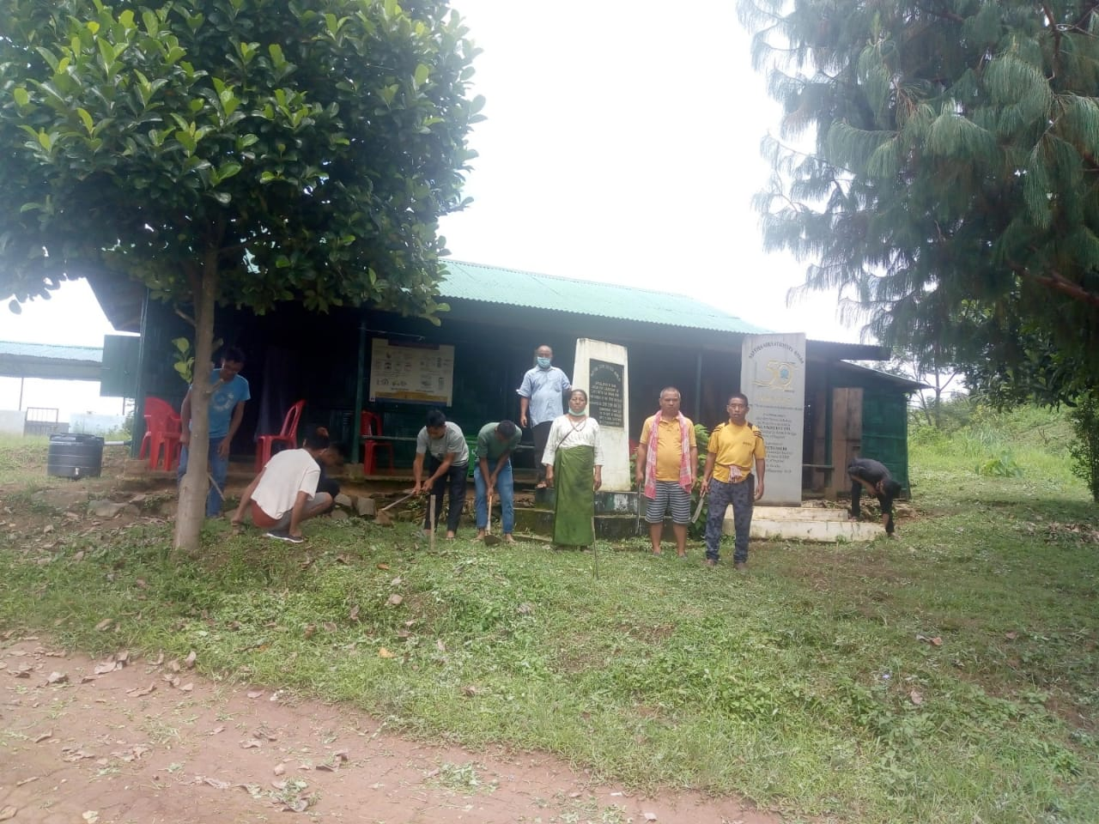
Social work at Saptiqa PHC

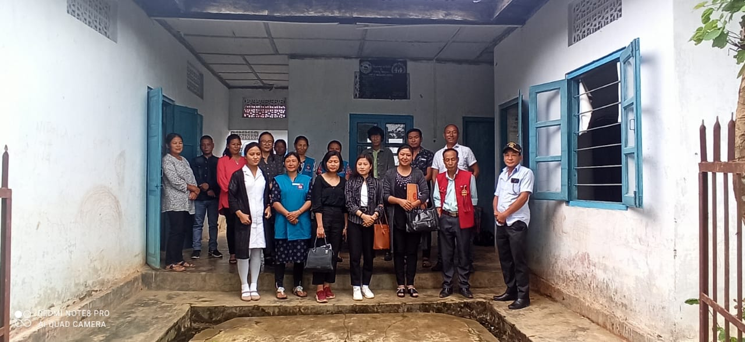
District and Block team monitoring at Akuhaito Sub- Centre

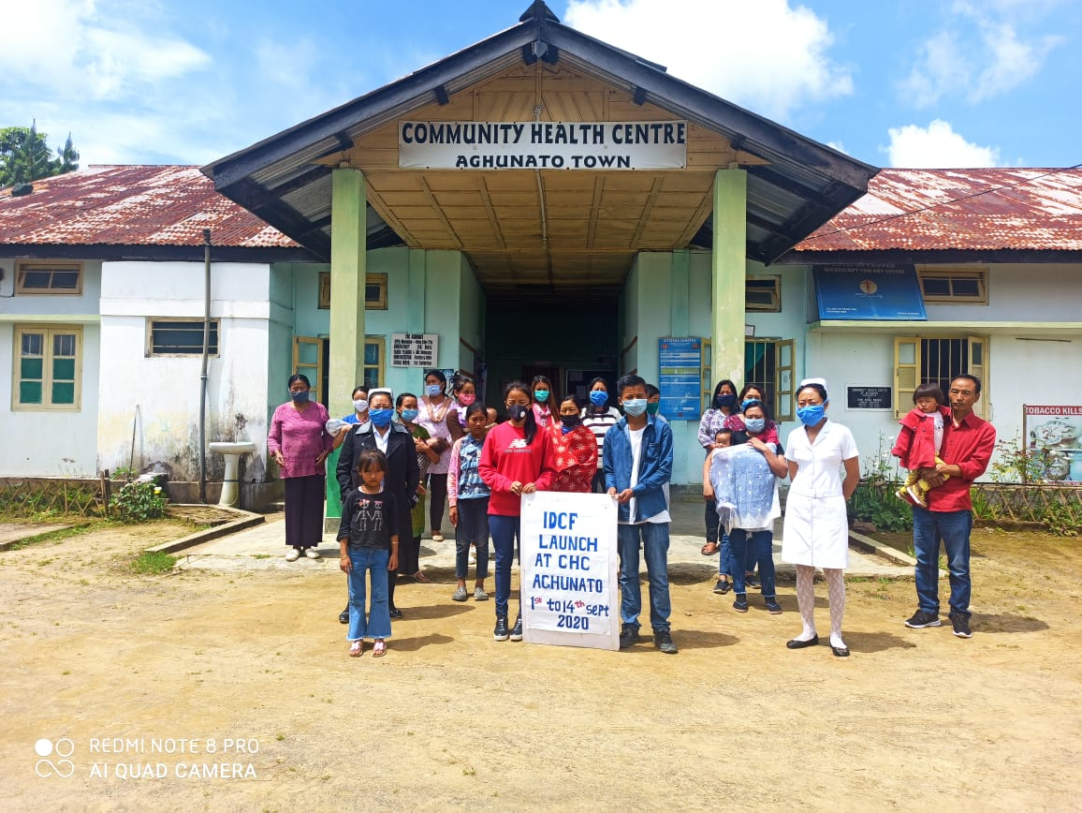

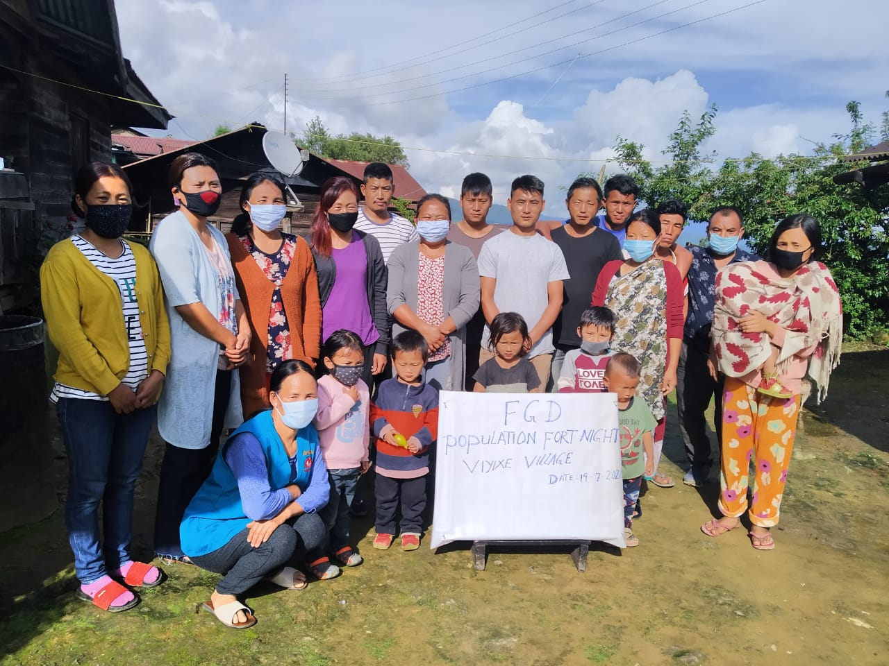
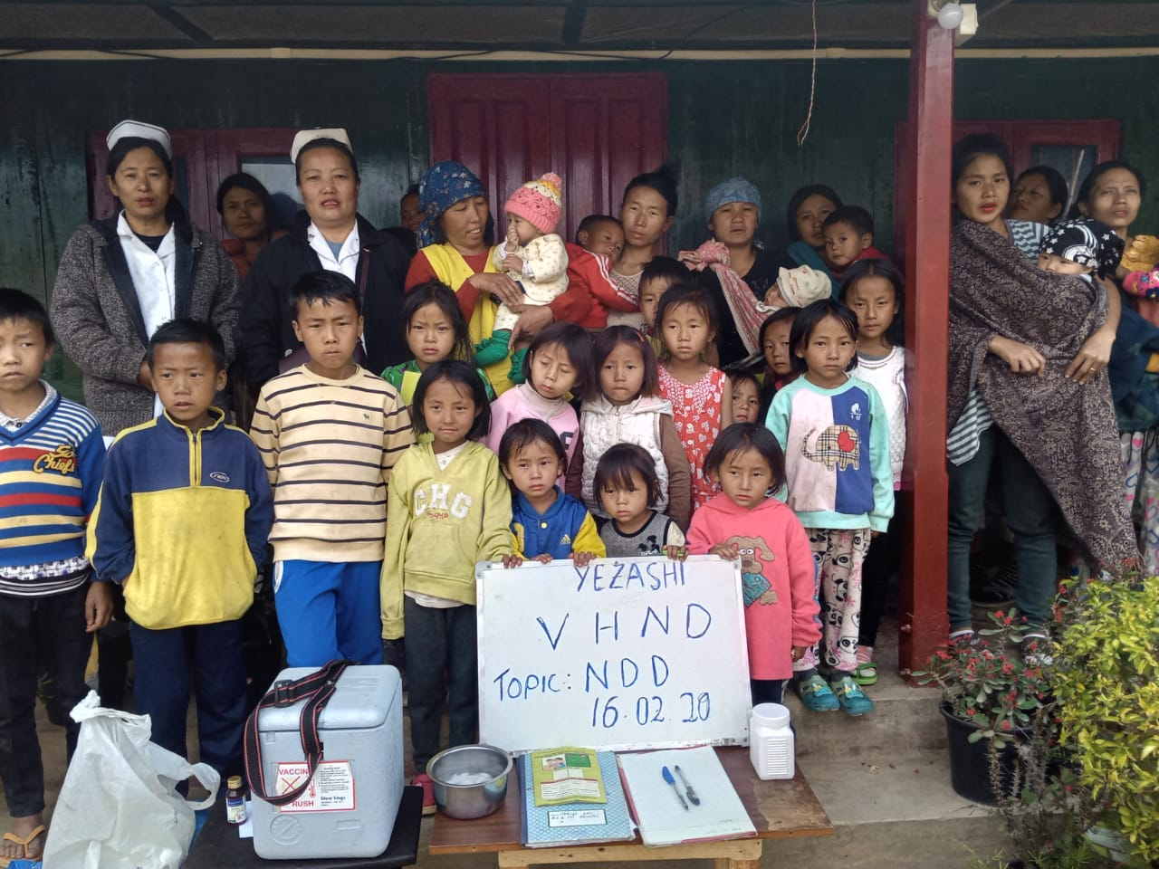

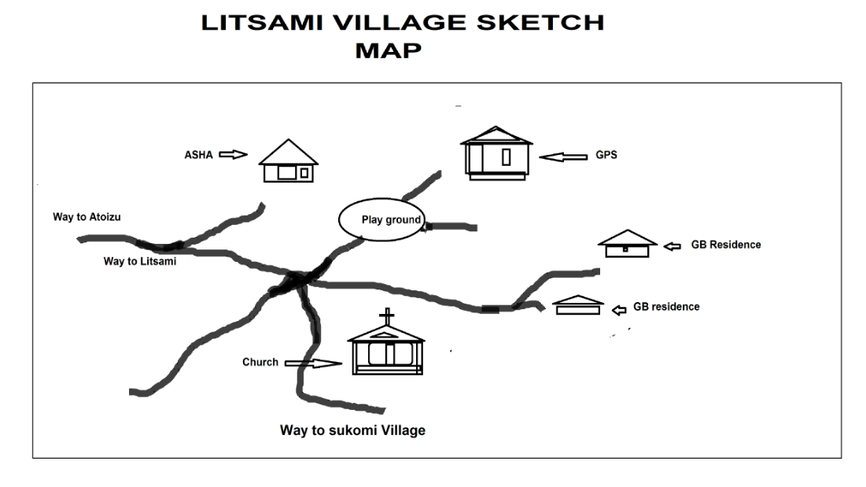

- Roto Old Village Health Action Plan(VHAP)

Introduction -
Roto old village falls under Akuhaito Sub-Centre of Zunheboto Sadar Block having a population of 1262, estimated pregnant women is 21 and estimated children from 0-5 years is 51. It is located 3 kms away from the catering Sub- Centre and 48 kms from the District Headquarter. The main occupation is farming. The village have one school and 3 Anganwadi center. The Planning Team consisting of Deputy CMO, MO Atoizu PHC and BPM made a discussion with the village elders, VHC, VC members and church leaders. The villagers were sensitized on health and sanitation programme as Malaria has been continuously been on the rise in the village.

Table: VHAP Roto Old,Zunheboto Sadar

Priority issue | What should be done | What should the community do | Support of the line Department | Time frame
 | Strengthen VHND and regular blood screening | Support and Co-operate | IEC, Regular VHND and handholding support | Ongoing

- Tsukomi Village Health Action Plan (VHAP)
Introduction -
Tsukomi village is one of the surrounding villages which falls under Aghunato CHC catering a total population of 576 (As per census 2011) and has 40 Eligible Couples at present. Road connectivity from the village to Health Units Aghunato CHC is Kaccha road which is 6 kms away. Main occupation for the village is agriculture. The village has one ASHA, AWC, one GPS, one joint account VHSNC (SBI).The Village conduct VHND/RI as per VHND calendar and micro plan. A Focus Group Discussion (FGD) on the topic Maternal Health was conduct in this village to frame out Village Health Action Plan by the Block team consisting of MO, Staff Nurses, BPM,BAM and BAC.
Based on Monthly HMIS report it was found out that ANC registration from this particular village was found out to be below average, so the team on 10th Nov 2019 went to this village and conducted Focus group Discussion on Maternal Health with the Target Groups (Eligible Couples) including Village Health Committee and chairman’s of the village. The team thanked to all the participants for their presence and encouraged them to play an active role in mobilizing and support to track out each and every pregnant women in the village to go for early ANC registration and to go for institutional delivery for the safety of both mother and child. The team also encouraged the participant to observe VHND regularly as per VHND calendar and timely submission of reports.
Sl.No | Priority issues | Actions to be taken/Done by the villager Local Leaders | Community participation/Role of community | Support/contribution from the village | Support required from health and other departments of line. Dptt. | Timeline
1. | Maternal Health | ANC services to be strengthened and dropout pregnant women tracked and provided ANC through VHND  More outreach activities on immunization sessions should be increased | Encourage every pregnant Women to go for full ANC checkup and to go for institutional delivery  Organize VHND regularly so that missed out Pregnant women can be tracked out | Spread awareness on the importance of ANC checkup and institutional delivery  Cooperate with Health staffs and ASHA during routine immunization and VHND | Proper infrastructure and Manpower should be at place for improvement of health delivery services and  Required medicines and vaccines to be made available at all time  Social Welfare dept. to co-operate with Health dept during outreach activities. | Ongoing

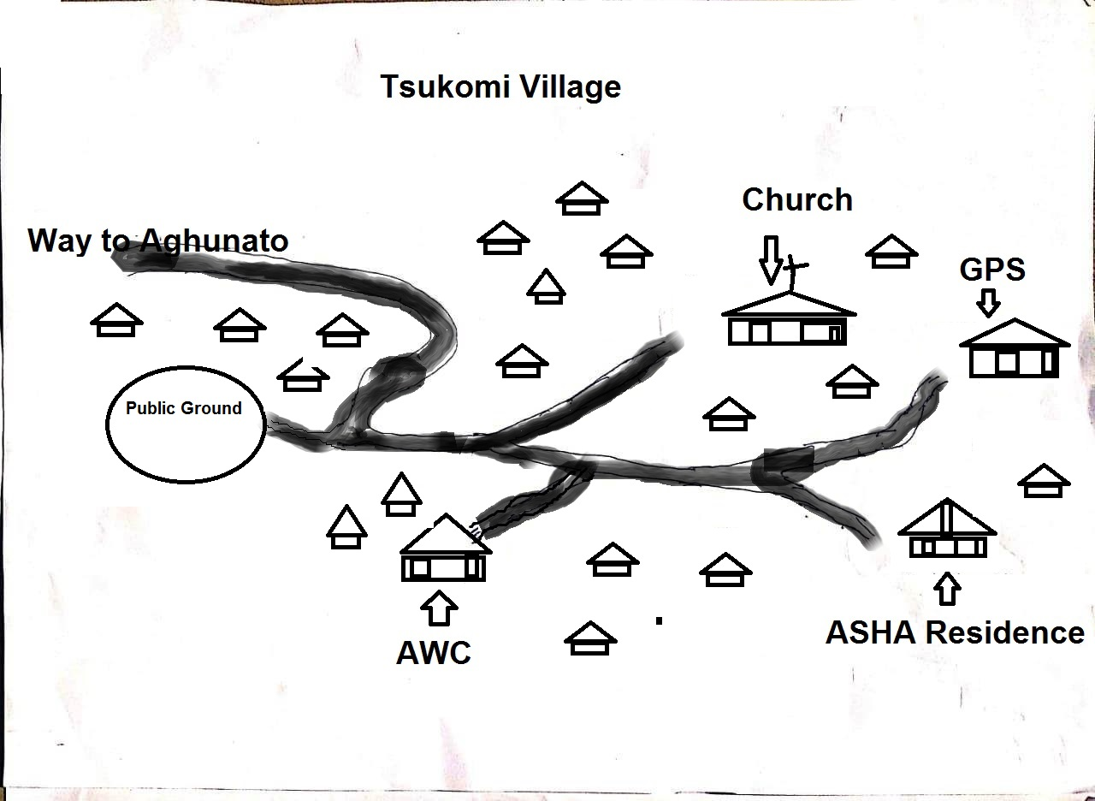

Tsukomi VHAP photo below

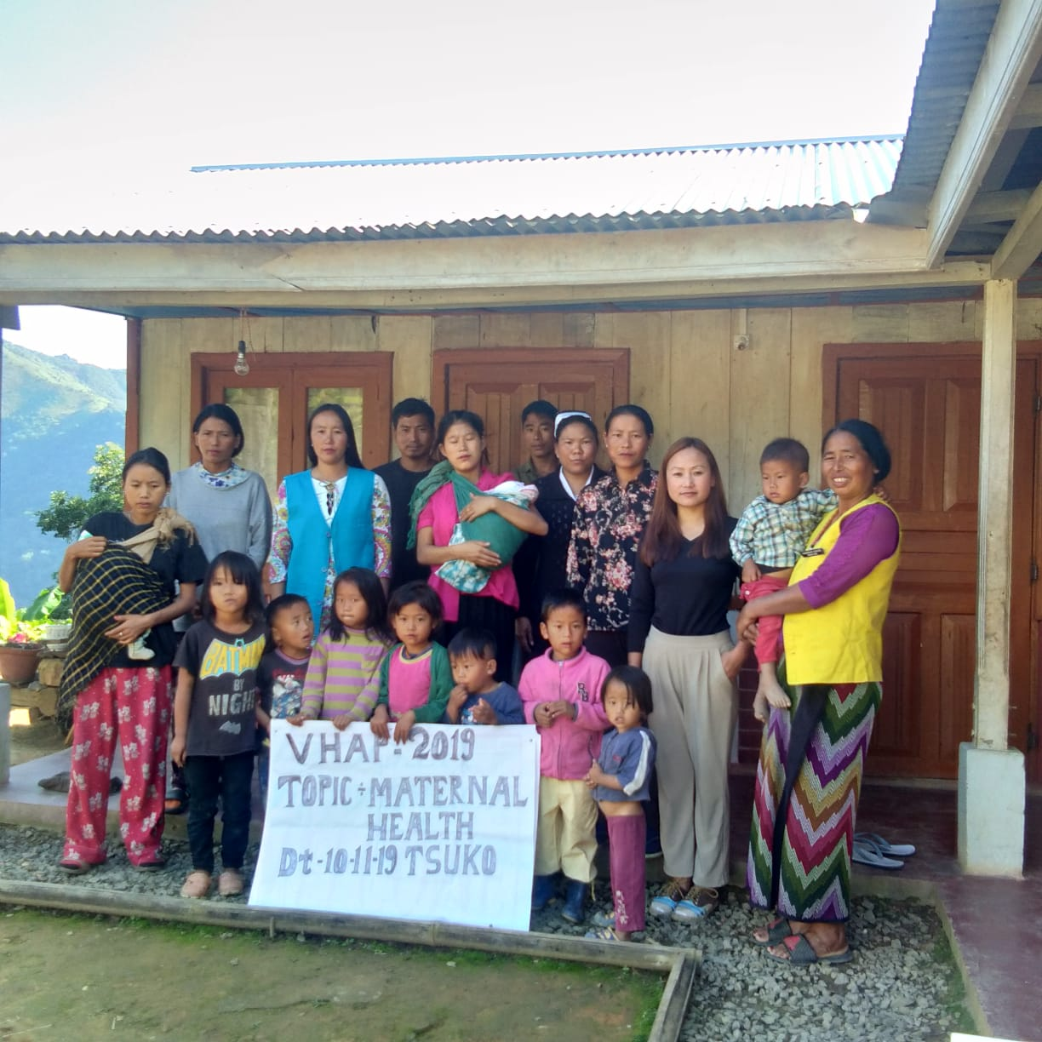

- Ghuvishe Village Health Action Plan (VHAP)
Introduction -
Ghuvishe village falls under Aghunato CHC which is 5 km away from the Health Center covering a total population of 550 (As per 2011 census) with 40 Eligible Couples. Main occupation of the village is agriculture. Road connectivity from the village to Health Center is Kaccha. At present the village has one AWC, one ASHA, one GPS and one VHSNC joint account
On 11th Nov 2019 the Block team comprising of MO, Staff Nurse, BPM, BAC went to this village and conducted a focus group discussion on the topic Child Health. The team encouraged the participant to tracked out all the children and get them immunized as per immunization schedule, discussed on the importance of immunization and its dis-advantages on the children. The team also encouraged ASHA to play an active role and insist her to keep update record of all the eligible children in the village and refer them to ANM for timely immunization for which she will get an incentive for full immunization of each child.
In conclusion it was decided by all the participants that in future days to come they all will play an active role in tracking out each and every child in their village and refer them to ANM for timely, fully and complete immunization.

Sl.No | Priority issues | Actions to be taken/Done by the villager local leaders | Community partipication/ role of community | Support/contributionfrom the village | Support required from health & others departments. | Time line
1. | Child Health | Immunization sessions should be strengthen and increased | Create awareness on the importance of immunization through church and school platform | ASHA, VHCs to track out missed children and refer them to ANM for timely immunization  Co-operate with Health Staffs during immunization | All the required medicines and vaccines to be made available at all times.  Social welfare deptt.to co-operate with health dept.during VHND/RI at grassroot level. | ongoing

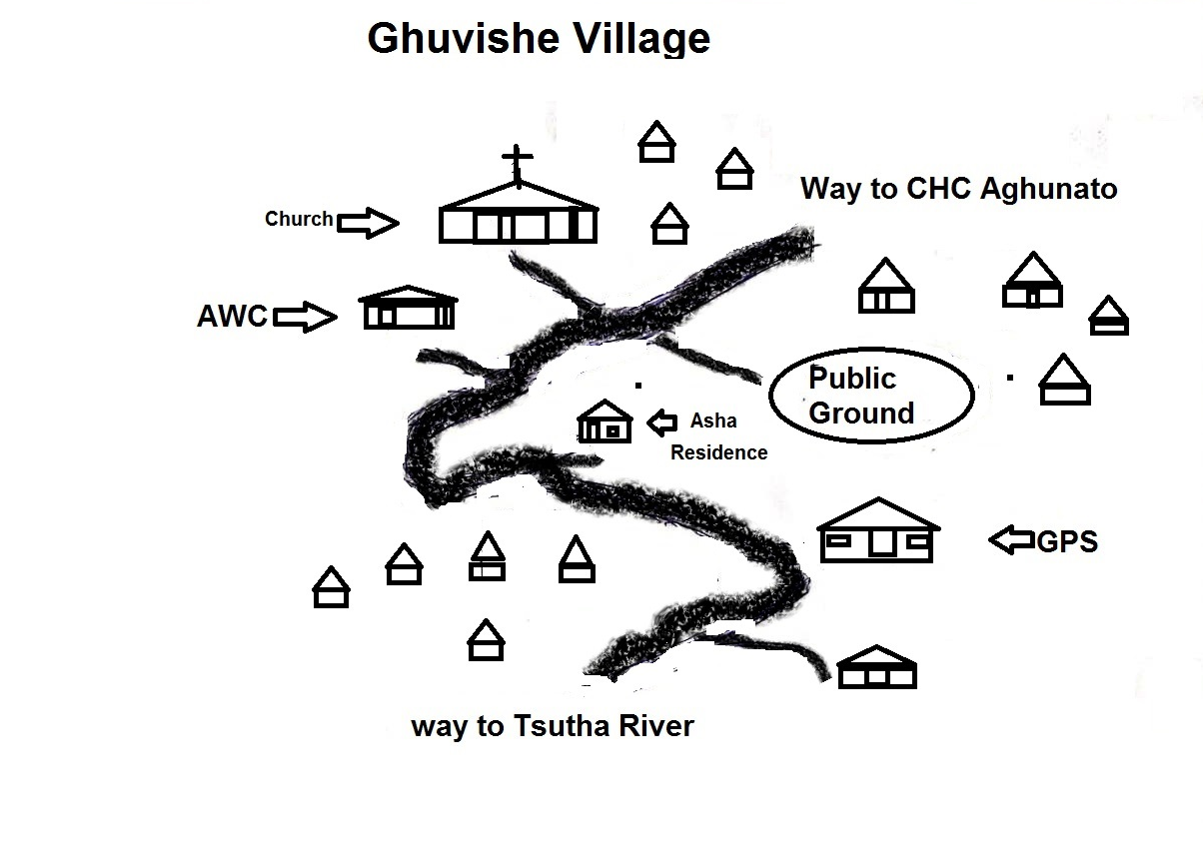

Ghuvishe VHAP Photo below -
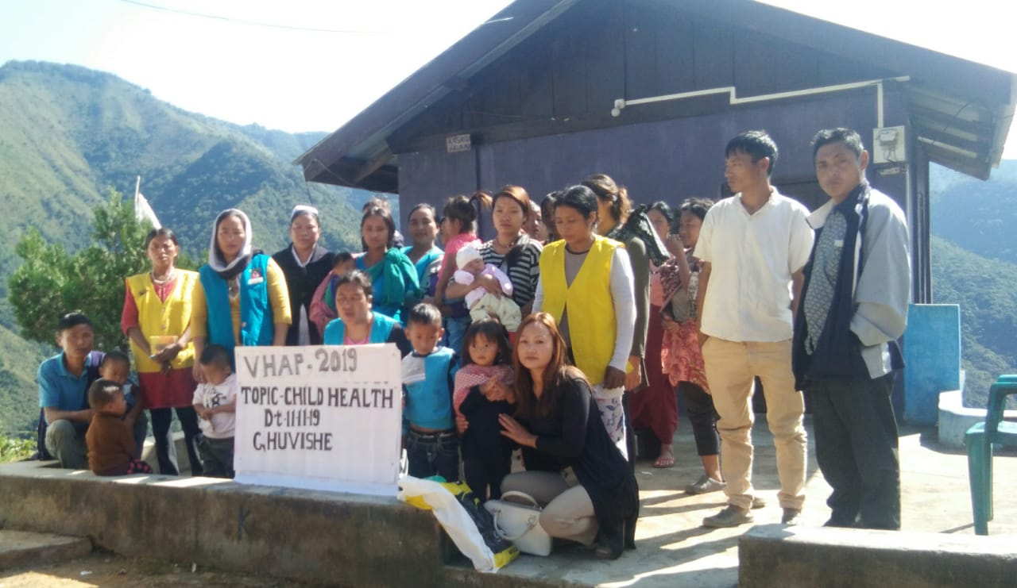

- Tsaphimi Village Health Action Plan (VHAP)
Introduction –
Tsaphimi village falls under Asukiqa SC with the population of 538 and 94 Households, a distance of 5 Km from the SC and44 Km from the CHC as nearest Referral Health Unit. Malaria complaint becomes the major grievance of the society. After a thorough Discussion with the VHC’s, VC’s, Youth Leaders, Church leaders, ASHA and AWW’s, we came with a conclusion to challenge and tackle the situation in a framed VHAP as bellow -
Priority issue | Actions to be taken/done by the villager local leaders | community Participation n/role of community | Support / Contribution from the villagers | Support Required from the health & other Department | Time line
Malaria | 1.Vector controls, the only approach to malarial control.  2.Shortened the lifespan of mosquitoes by Insecticides (to less than 10 days)  3.Create awareness on the breeding habits and time of biting by mosquitoes.  4.Alternative Insecticides to be used if they become resistant to insecticides which are currently used.  5.Radical treatment to abolished the human reservoir of infection. | 1.Create awareness in the month of July – November  2.Active participation in spraying of Insecticides.  3.Encourages each and every households to avail the spraying facility both indoors and outdoors.  4.Educate regarding proper management with anti- malarial drugs. | 1.Regular use of personal protection. (mosquito net, coils etc. )  2.Control mosquito breeding. (Drainage fillings or changing the salt content of oiling, etc.) | 1.Sufficient and timely supply of insecticides, anti malarial drugs, lot reagents and equipments.  2.Budget provision for anti malarial operations.  3.Recruitment of labour for spraying, free supply of mosquito nets, repellents etc.  4.Continuous medical education to the M.O’s and Health provider to prevent dead due to malaria. | 2nd Quarter 2012.

- Tukuliqa Village Health Action Plan (VHAP)

Introduction -
Tukuliqa village falls under Ghathashi PHC with the population of 341and 44 Households, a distance of 8 Km from the PHC and 34 Km from the CHC as nearest Referral Health Unit. ANC an Family planning is the major issue of the society. For this, M.O., BPM and ASHA Co-ordinator hold a Discussion with VHC’s, VC’s, Youth Leaders and Church leaders. In this Discussion, we emphasis was given to early registration, full and timely completion of ANC with PNC An educate them about family planning. The members responded very satisfactorily and assured a hand holding support for which the VHAP was prepared.
The conclusion brought up during the interaction are projected as below :
Priority issue | Actions to be taken/done by the villager local leaders | community Participation n/role of community | Support / Contribution from the villagers | Support Required from the health & other Department | Time line
Decrease ANC | 1.Conduct VHND regularly.  2.Promote, protect and maintain the Health of the mother during pregnancy.  3.Detect high- risk cases and give them special attention.  4.Remove anxiety and draed associated with delivery.  5. Educate regarding Maternal and Infant Mortality and Morbidity.  6.To teach the mother, elements of Childcare and Nutrition.  7.Sensitized the mother regarding Family Planning including MTP. | 1.Active participation from the VHC and the Village Councils.  2.Mental preparation : sufficient time and opportunities should be given to all the expectant mothers to have a free and frank talks on all aspects of pregnancy and delivery.  3. Notification of pregnancy to the concern authorities as practice in some parts of the world. | 1.Cooperation and encouragement.  2.Acknoledgement of Health benefits and financial benefits.  3.Education and awareness to the Eligible couples. | 1.Timely provision of VHND fund.  2.Timely supply of Medicines and equipments.  3.Trained personal at the Health Unit.  4.Pregnancy imposes the need for extra calorie and nutrient, therefore financial assistance aided by the Govt. can be given during the pregnancy to meet the increasing demand of the mother.
- Tukunasa Village Health Action Plan (VHAP)

Introduction-
Tukunasa Village is situated on the western part of Zunheboto District. The village falls under Satakha PHC which comes under Satakha Block of Zunheboto District. The nearest sub-centre i.e Shoipu sub-centre is approximately 14kms away from the village. The distance to Block PHC is approximately 28kms, and to the Dist.HQ. is approximately 50kms. The main economic activity of the people is agriculture and lumbering. At present the main concern of the village is electricity and poor road connectivity. The road is kaccha and narrow and is pliable only during dry season and comes under the category of very hard to reach area. The village have Village Health Committee (VHSNC) which is presided by the chairman. The village have one Anganwadi centre and one Government Primary School. The VHND is conducted every month at Anganwadi centre.
Demographic Profile:-
- Population - 309(Projected census 2011)
- Household -56(As per cencus 2011)
- ECR - 10(As per RCH)
- Under five - 14 (As per Asha head count)
- Under one - 4(As per RCH Portal)

To understand the health issues faced by the Tukunasa villagers the MO Satakha PHC along with BPM & Asha co-ordinator went to Tukunasa village on 11th October 2019 and interacted with the villagers where village council and VHC members as well as AWW were present.
During the interaction various health issues were touched upon but the key issue was the low intake of IFA in the village. It was found that the IFA tablets distributed to women and the IFA syrup given to kids were usually fed to animals. This was due to misconception and ignorance on the part of the villagers. Some stopped taking IFA because they were ignorant about the fact that if stools turn black on taking IFA, it is a normal sign and shows that the body is taking in the iron. Some stopped taking IFA because of burning sensation in the chest which can be prevented if they take IFA after meal.
To dispel their misconceptions and encourage the villagers to take IFA, it was unanimously resolved to create awareness about the importance and benefits of IFA. The villagers also agreed to co-operate with the health staffs and follow their instructions regarding the intake of IFA. Keeping in the mind their ignorance, the VHAP was formulated with the active cooperation of village councils, VHC_{s} and the villagers.

Table VHAP of Tukunasa Village ,Satakha Block –

SL.NO | PRIORITY ISSUES | ACTIONS TO BE TAKEN/DONE BY THE VILLAGER LOCAL LEADERS | COMMUNITY PARTICIPATION/  ROLE OF COMMUNITY | SUPPORT/CONTRIBUTION FROM THE VILLAGE | SUPPORT REQUIRED FROM HEALTH & OTHER DEPARTMENTS | TIMELINE
1 | Low intake of IFA | 1) Educate the villagers about the importance and benefit of IFA  2) Create awareness through health workers Church and schools.  3) Encourage women to take Vitamin-C rich food as it helps in absorption of Iron.  4) Educate the villagers that Anaemia can be prevented by taking IFA. | 1) Understand the benefit of IFA  2) Follow the instructions of the Health Staffs regarding the intake of IFA tablets.  3) Awareness on why children and pregnant women should take IFA. | 1) Spread awareness about the benefits of IFA  2) Co-operate with the health workers.  3) Spread awareness that IFA is not only for pregnant women but for children too. | 1) Provide sufficient IFA tablets.  2) Provide regular Hb test.  3) Encourage the pregnant women and children to take IFA. | Ongoing

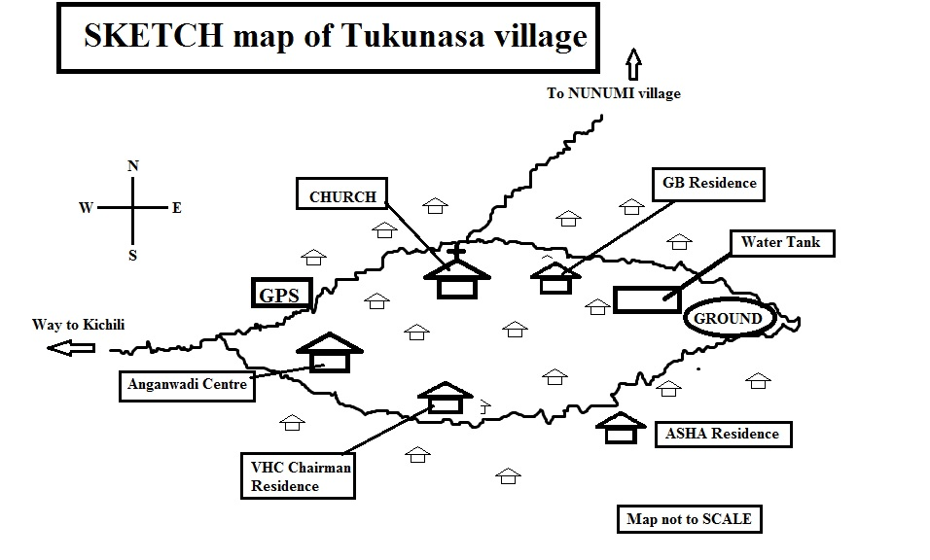

- Xuivi Village Health Action Plan (VHAP)

Introduction -
Xuivi Village which falls under Satakha PHC comes under Satakha Block of Zunheboto District. The latitude 25.88 and the longitude 94.44 are the geo-cordinate if Xuivi village. The distance from the village to the sub-centre i.e Kivikhu sub-centre is approximately 14kms and to the Block PHC is approximately 7kms. and to the Dist.HQ.is approximately 30kms. The road is well connected to the S/C, Block PHC and the District HQ. By an all well weathered road. The main occupation of the people is farming and hunting. The village have set up Village Health Committee to look after the sanitation and well being of the people’s health. The village have two Anganwadi centres and one Government Middle School. VHND is conducted every month at Anganwadi centres.
Demographic Profile:-
- Population -879(Projected census 2011)
- Household - 172(As per census 2011)
- ECR - 21 (As per RCH Portal)
- Under five - 40 (As per Asha head count)
- Under one - 13 (As per RCH portal)

The MO i/c of Satakha PHC along with the BPM & Ashas Co-ordinator went to Xuivi Village on 12 October 2019 and interacted with the villagers, where village council and VHC members as well as AWWs were present. During the course of FGD on various health related issue, the low rate of immunization and poor ANC of the mother in the village were discussed.
It was found that some parents in-spite of receiving pre-information about the date of immunization do not turn up at the immunization site. So the ASHA and some volunteers have to go house to house to request the parents and bring their children for immunization. But inspite of all the hard efforts of the Ashas some parents often feel reluctant to give immunization to the children fearing ill effects of medicines in future.
The pregnant mothers often fails for ANC because either they are too busy engaged in their field works or reluctant to approach to the health centres out of shyness or indifferent attitude towards medicines.
Therefore, to improve the ANC and immunization status the key stake holders of the village along with the health workers resolved to spread awareness about the importance and benefits of ANC and immunization. The village too unanimously resolved to co-operate with the health staff during the immunization. The VHAP was thus formulated with the active support of the Village councils, VHC members and the villagers.
Table VHAP of Xuivi Village,Satakha Block
Sl.No | PRIORITY ISSUES | ACTIONS TO BE TAKEN/DONE BY THE VILLAGER LOCAL LEADERS | COMMUNITY PARTICIPATION/  ROLE OF COMMUNITY | SUPPORT/CONTRIBUTION FROM THE VILLAGE | SUPPORT REQUIRED FROM HEALTH & OTHER DEPARTMENTS | TIMELINE
1  2 | Low Immunization Status .  Poor ANC | 1.Focus group discussion with special emphasis on immunization.  2. Make the village aware that immunization increases the body’s ability to fight 6 fatal diseases.  1.Create the awareness about  “what is ANC’’.  2. Eradicate the taboos towards medicine . | 1. Co-operate with the health workers  2.Ensure that all children including drop-out children receive the full course of immunization.  1.Encourage the pregnant mothers to go for regular ANC.  2. Encourage them to have institutional delivery as it is safe for both the mother and child. | 1. Reach the Immunization site on time.  2. The Village council can announce that it is mandatory for all children to receive immunization.  1.Co-opreate with the Health staff and Ashas during VHND.  2.Support the pregnant woman physically and morally by the family members. | 1Explain the importance of receiving immunization at the right age at the right time.  2.Educate the Villagers that immunization is safe.  1.Provide adequate medicines supplies and latest equipments to the village health centres.  2.Provide proper infrastructure and adequate manpower . | On going

- Lumithsami Village Health Action Plan (VHAP)

Introduction -
Lumithsami village comes under Akuluto Block of Zunheboto district, Nagaland. On9th November2019, the Block Planning team comprising of BPM and Asha-coordinator had a Focus Group Discussion(FGD) with the key stake major holders of the village on various health issues of the villagers to frame the VHAP. It is 2 kilometers away from block Headquarter which has 127 households with the total population of 522 as per 2011 census. At present there are 88 eligible couples with9 pregnant women and 45 children below the age group of five years.
The main livelihood of the village is through cultivation. It has three Anganwadi centers and 1 Govt. Middle school. Though the road condition hasn’t been any better yet the supply of water and sanitation is at a considerate level.
After a thorough out discussion with the VHCs, VCs,Church members as well as the villagers, it came to light that immunization was below expected . So a detailed investigation was made and it was found that the villagers were still unaware of the benefits of immunization. Therefore they were sensitized to create awareness by conducting VHND on regular basis and also through available platforms.

Table:VHAP of Lumithsami village, Akuluto Block
Priority issue | Actions to be taken | What will the community do | Support required from health and other departments | Time frame
1.Immunization | 1.ASHA to focused more on the creating awareness on immunization  2.Health and wellness of the village to be considered in all aspects of village activities. | 1.Active participation of the VHC’s on the immunization day/VHND | 1.Timely release of vaccines and logistics from the department.  2.AWW to give hand holding supports to medical staffs during RI,VHNDs etc. | 1.Ongoing

- Izheto Village Health Action Plan (VHAP)

Introduction -
Izheto village falls under VK PHC in Akuluto Block with the population of 204and 60 Households with a distance of 14.5 km from the PHC . The village comprises of 27 expected Eligible Couples ,3 pregnant women and 5 children below the age of 5 years, as per 2011 population census. The expected Deliveries and Pregnancy is 5. The main occupation of villagers is farming. The village consists of one school and one Anganwadi center. The Planning Team then discussed with the village leaders and elders and found out that ANC was week. Therefore with the view to promote and create awareness on early registration and timely check up for Ante-Natal Care, they were sensitized about the available services provided by the department. The members responded very satisfactorily and assured a hand holding support for which the VHAP was prepared.

Table:VHAP of Izheto village, Akuluto Block
Priority issue | What should be done | What should the community do | Support the villagers can provide | Support of the line Department | Time frame
ANC Services | 1.Conduct VHND regularly.  2. Promote, protect and maintain the Health of the mother during pregnancy.  3. Detect high- risk cases and give them special attention.  5. Education regarding Maternal and Infant Mortality . | 1. Active participation from the VHC and the Councils.  2. Support from every section of the people. | 1. Cooperation and encouragement. | 1.Provide timely ANC services and create awareness on personal hygiene and health care. | Ongoing

- Kiyetha Village Health Action Plan (VHAP)
Kiyetha village lies to the East of the Block with a Population of 233 as per population 2011 Census with total eligible of 22. It is 3 Km away from the nearest Health Unit i.e., Yehemi SC and 8 Km away from the Suruhuto PHC. With the view to promote the Health Status of the villagers, a team comprising M.O., BPM and ASHA co-ordinator hold a Focus Group Discussion with the VHC’s, village council members, Youth Leaders and Anganwadi Workers. On this Discussion, the members present gave an active participation and accordingly VHAP for Kiyetha Village was taken.
The village is under developed with bad road connectivity and the people living there are ignorant of basic health care. It has one Govt School and one Angwadi center. The main occupation of the village is agriculture. The Village has a constituted Village Health and Sanitation Committee (VHSNC) to look after the health care of the village by conducting VHND on monthly basis with the co-ordination of ANM, ASHA and Anganwadi worker with the yearly VHND fund allocated through VHNC account by the department. And by sensitization the villagers through VNHD program, the ANC and Immunization is of average but still need to go ahead.

PRIORITY ISSUES | ACTIONS TO BE TAKEN/ DONE BY THE VILLAGER LOCAL LEADERS | COMMINITY PARTICIPATION/ ROLE OF COMMUNITY | SUPPORT/ CONTRIBUTION FROM THE VILLAGE | SUPPORT REQUIRED FROM HEALTH & OTHER DEPARTMENTS | TIMELINE
Diarrheal Disease and Dehydration | 1. Create awareness on sanitation and safe drinking water practices through platforms available in the village. Eg., Churches, Schools etc.  2.Promote use of ORS | 1. Mass social work to clean the village drains and village ponds Quarterly.  2. VC to make provision to connect pipelines to specific located places. | 1. Cooperation during mass social work.  2. Maintain regular cleaning of the drains and ponds. | 1. Ensure availability of drugs and ORS to ASHA’s.  2. Visits to be made by the ANM’s.  3. Ensure IEC logistic on personal hygiene. | Ongoing

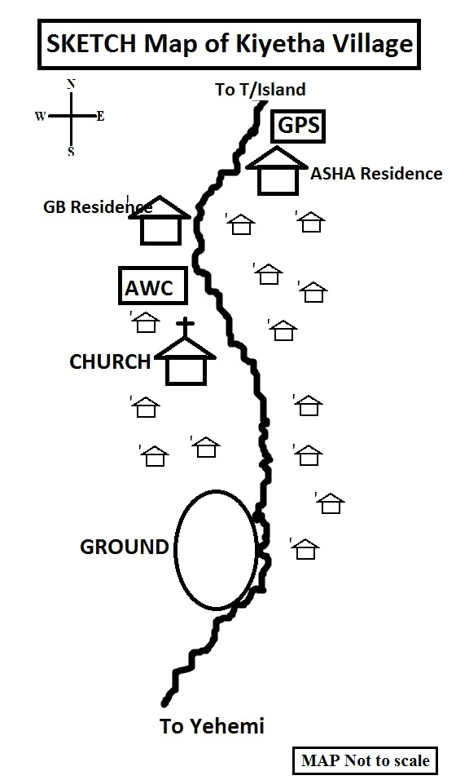

- Vedami Village Health Action Plan.
Vedami village falls under Aichi Saghemi SC which lies in the east with the population of 227 as per population census 2011with total eligible couple of 26. It is 3 Km from the SC and 8 Km from the PHC as nearest Referral Health Unit. The road condition is very poor and during monsoon season it becomes non motor able except by foot. It has 1(one) Govt School and (two) Anganwadi centre’s. Due to lack of proper road and also communication problem, the village lack much behind in health care. So our team comprising of MO i/c Suruhuto PHC, BPM and ASHA co-ordinator we meet the VHC’s, VC’s, Youth Leaders, Church leaders, ASHA and AWW’s, and went through out discussion with the members and came out with a conclusion to challenge and tackle the situation in a framed VHAP as bellow :
PRIORITY ISSUES | ACTIONS TO BE TAKEN/ DONE BY THE VILLAGER LOCAL LEADERS | COMMINITY PARTICIPATION/ ROLE OF COMMUNITY | SUPPORT/ CONTRIBUTION FROM THE VILLAGE | SUPPORT REQUIRED FROM HEALTH & OTHER DEPARTMENTS | TIMELINE
Immunization & ANC Services | 1. Sufficient IEC materials to be displayed to create awareness among the community.  2.ASHA to be more active | 1 .Active participation of the village leaders.  2. Encourages each and every eligible couple to regularly take the children for immunization. | 1.cooperation and support to be provided.  2. Encourage and explain the benefits of regular immunization.  3. Create awareness about the child care. | 1. ANM to regularly visit the village for immunization.  2.ASHA and AWW workers to be more active in creating awareness on immunization | Monthly basis

